Uploads of JUHI

# Question: What is automation documentation?

No file uploaded because only text was provided.

# Question: Why is it important in software processes?

**Row 1, Col 3: camera_capture.png**



**Row 2, Col 3: 23170_JuhiProject_Report.pdf**

Page 1



Page 2



Page 3



Page 4

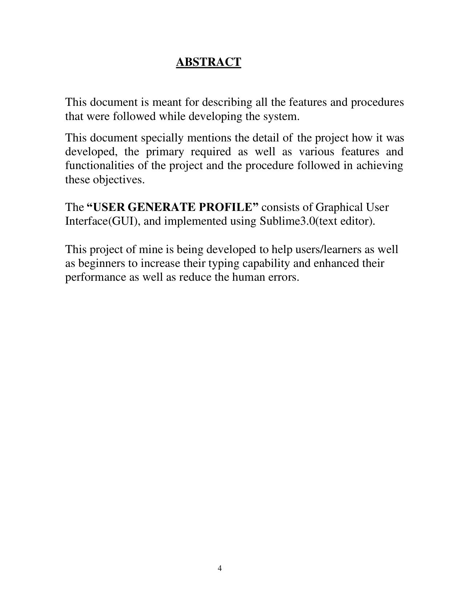

Page 5



Page 6

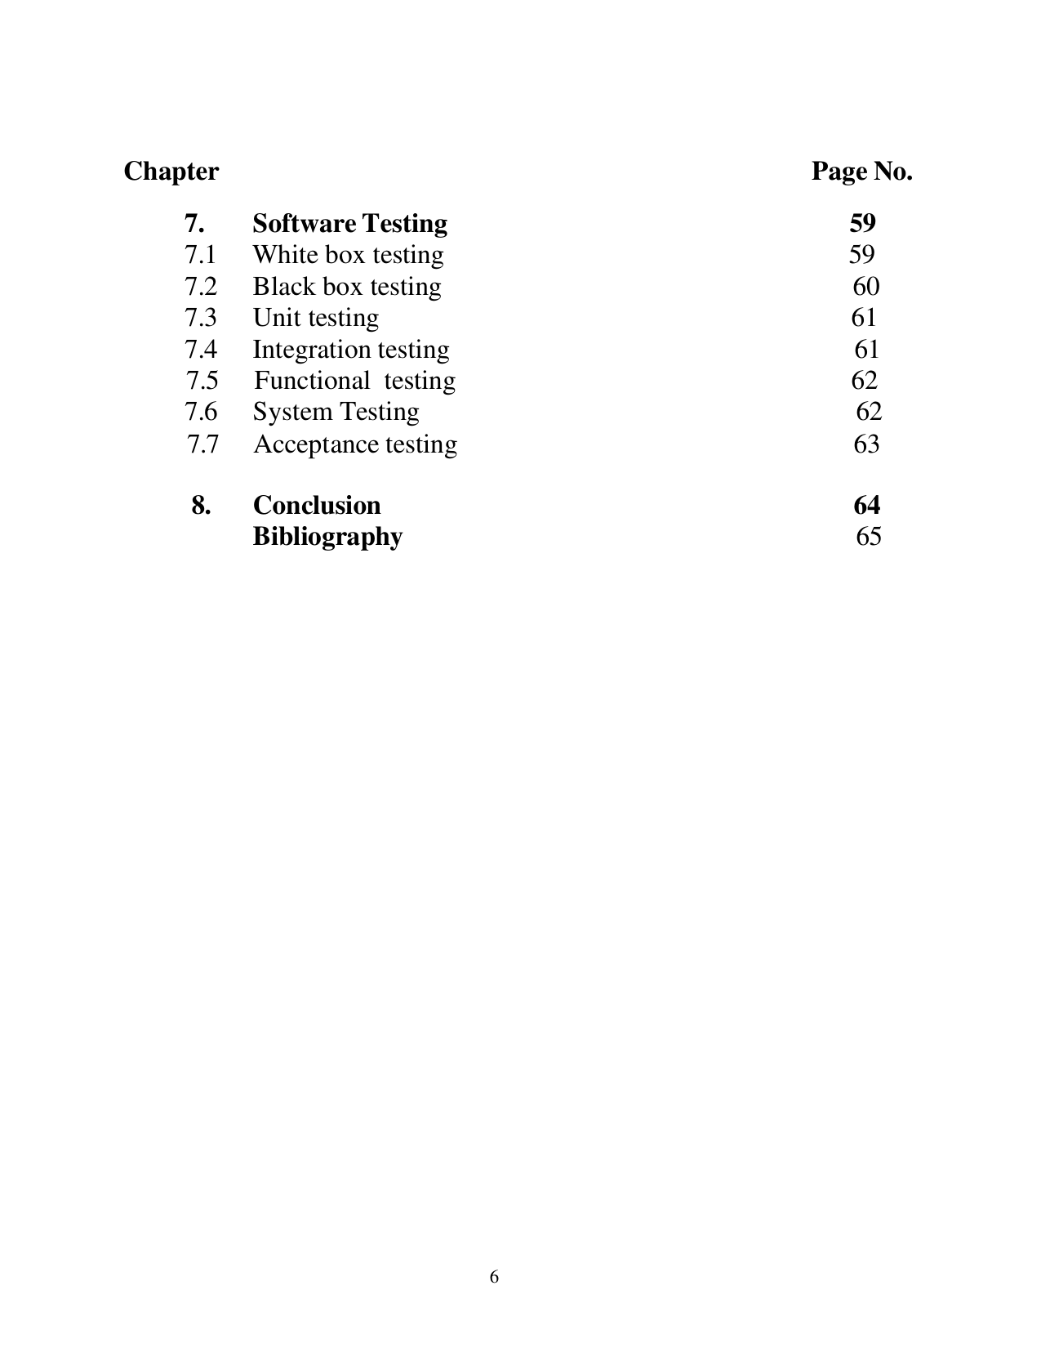

Page 7

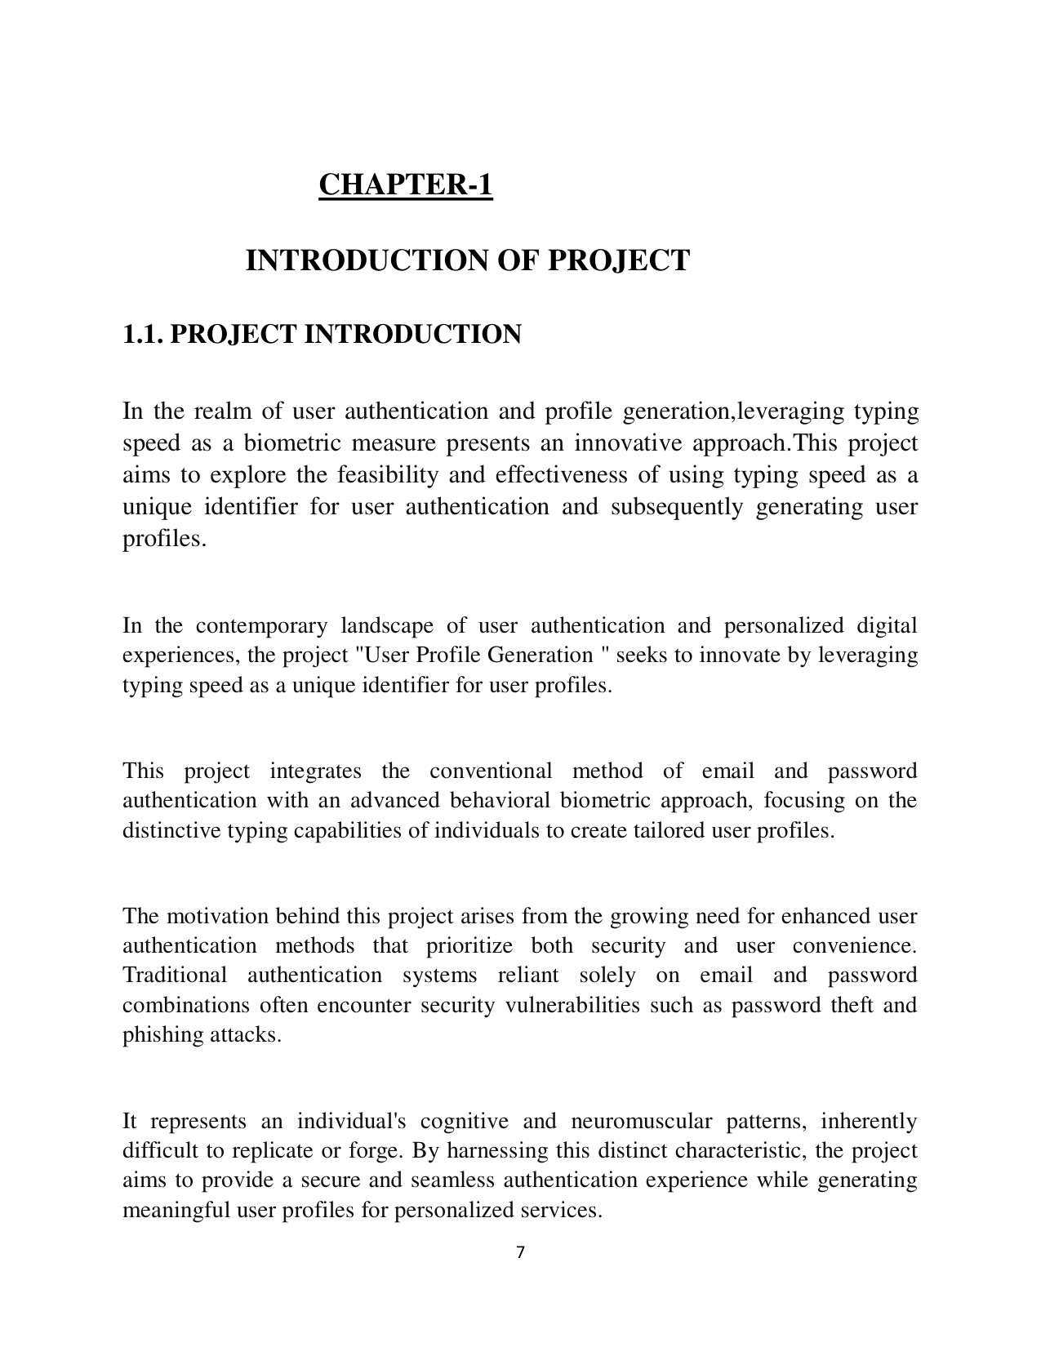

Page 8

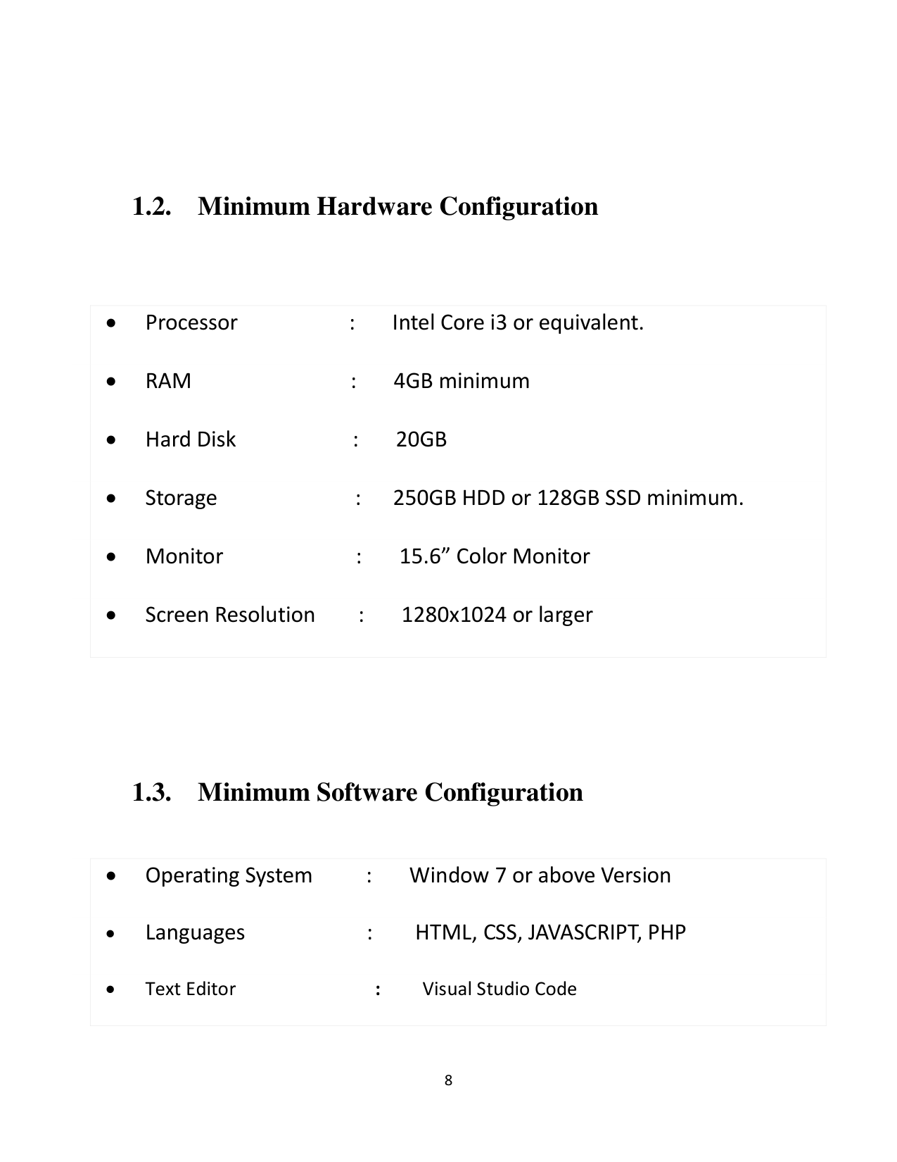

Page 9

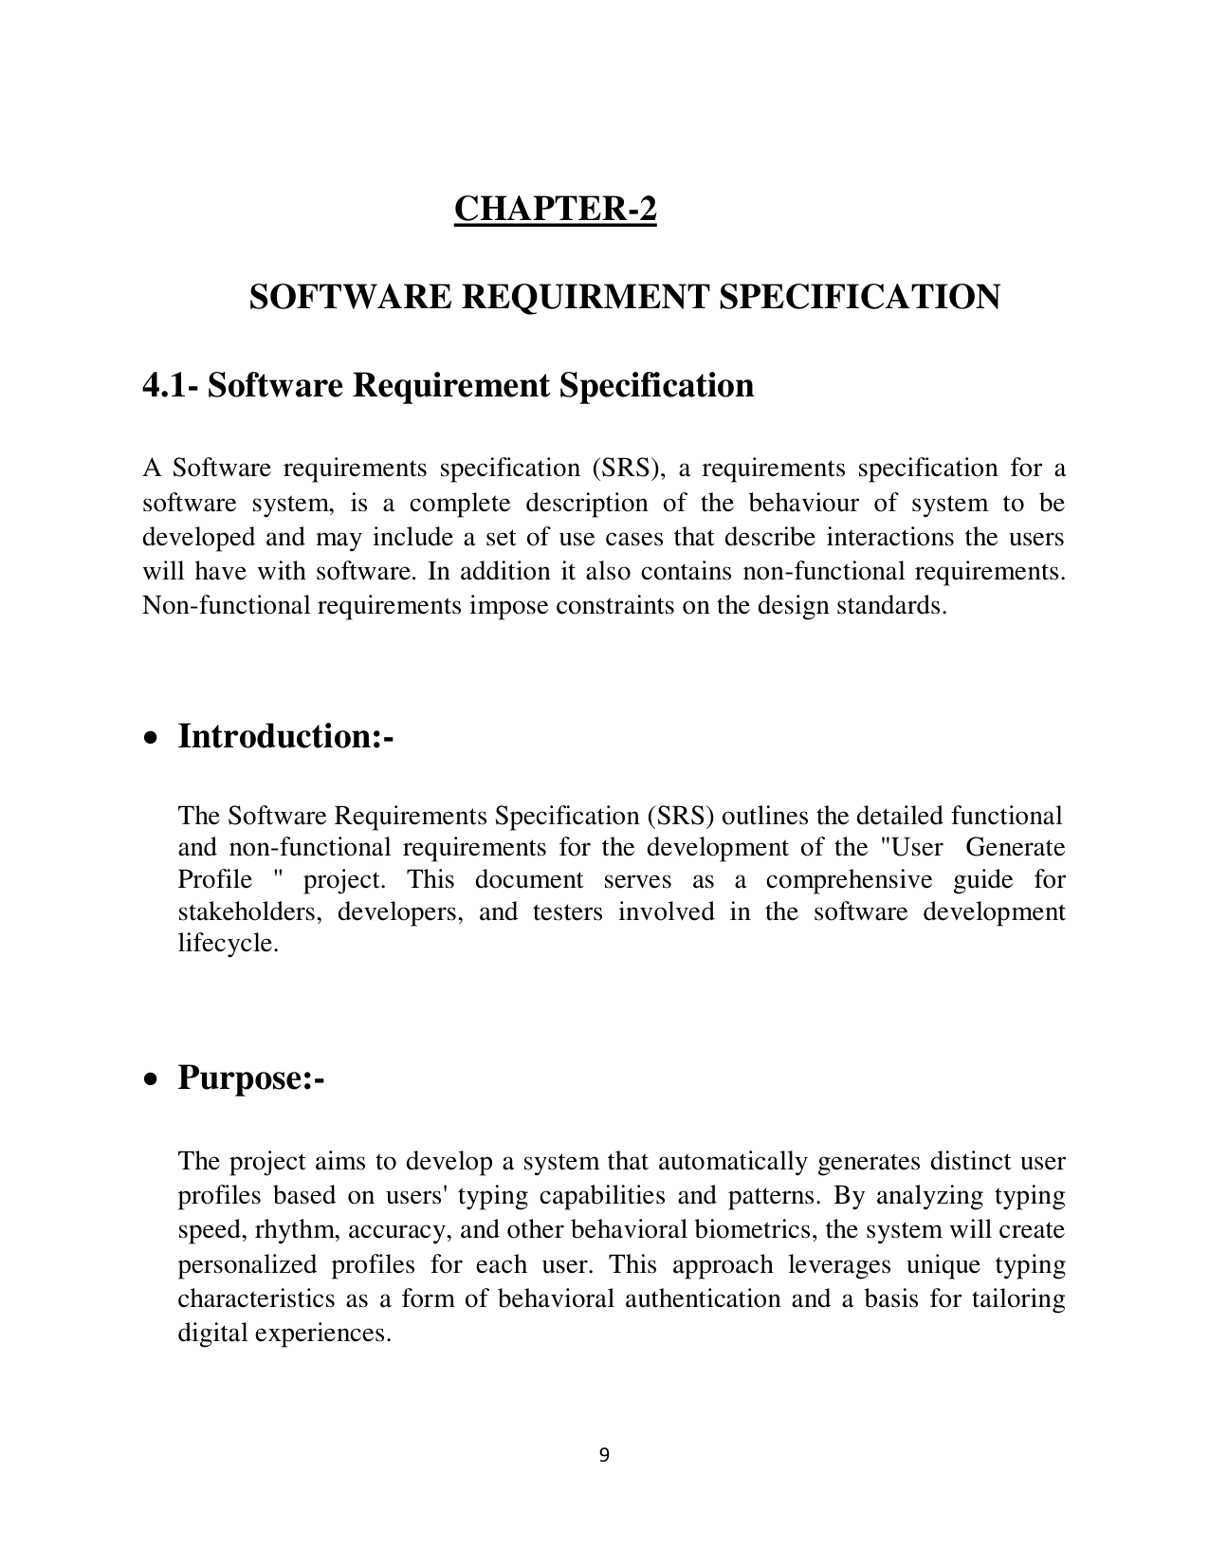

Page 10

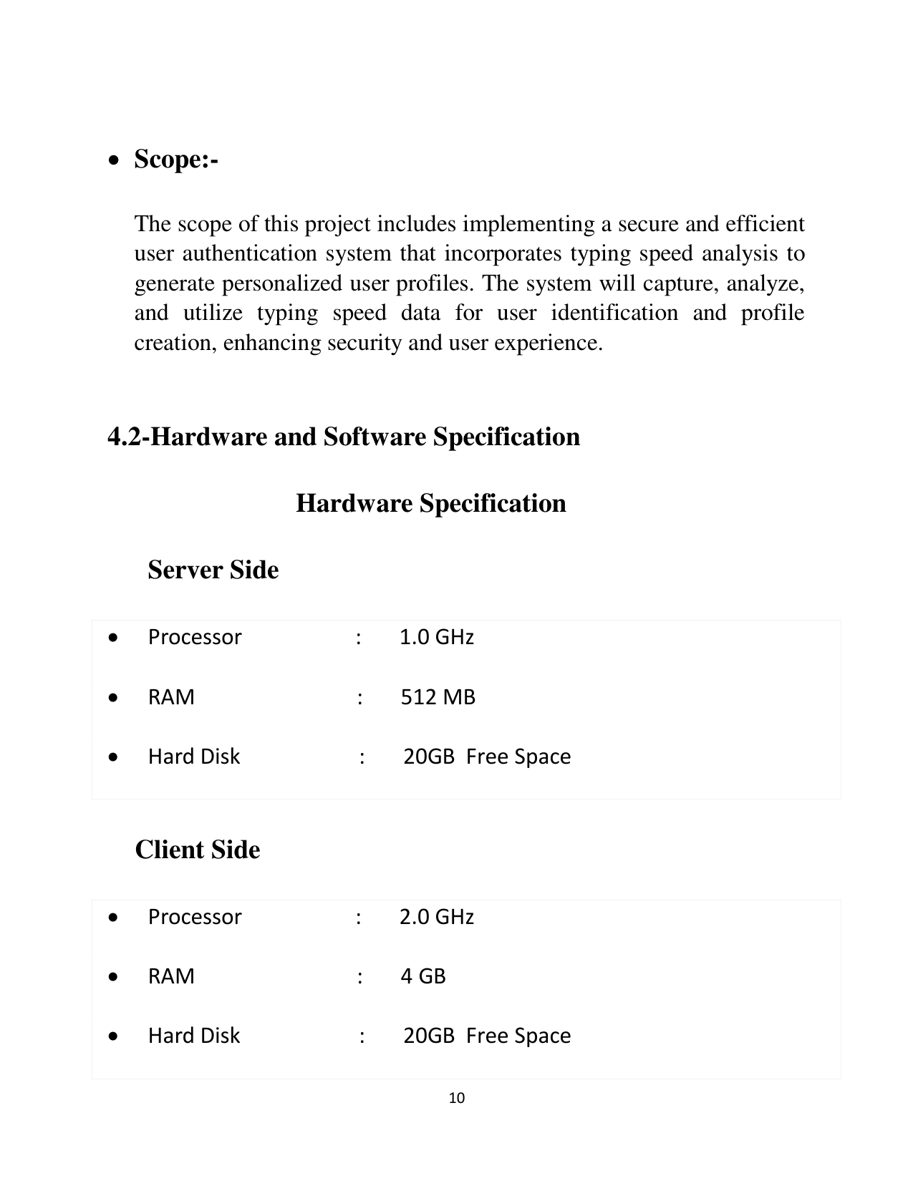

Page 11

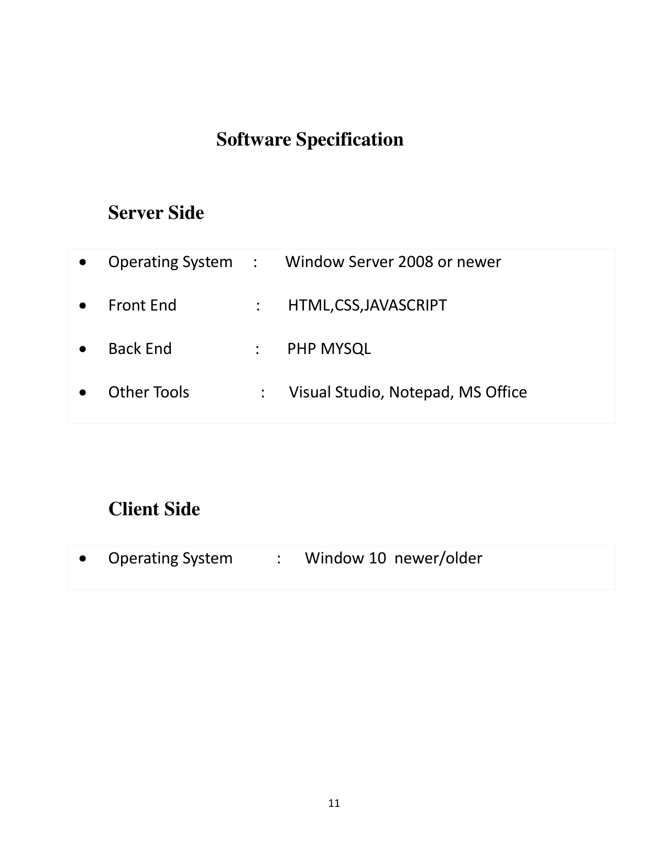

Page 12

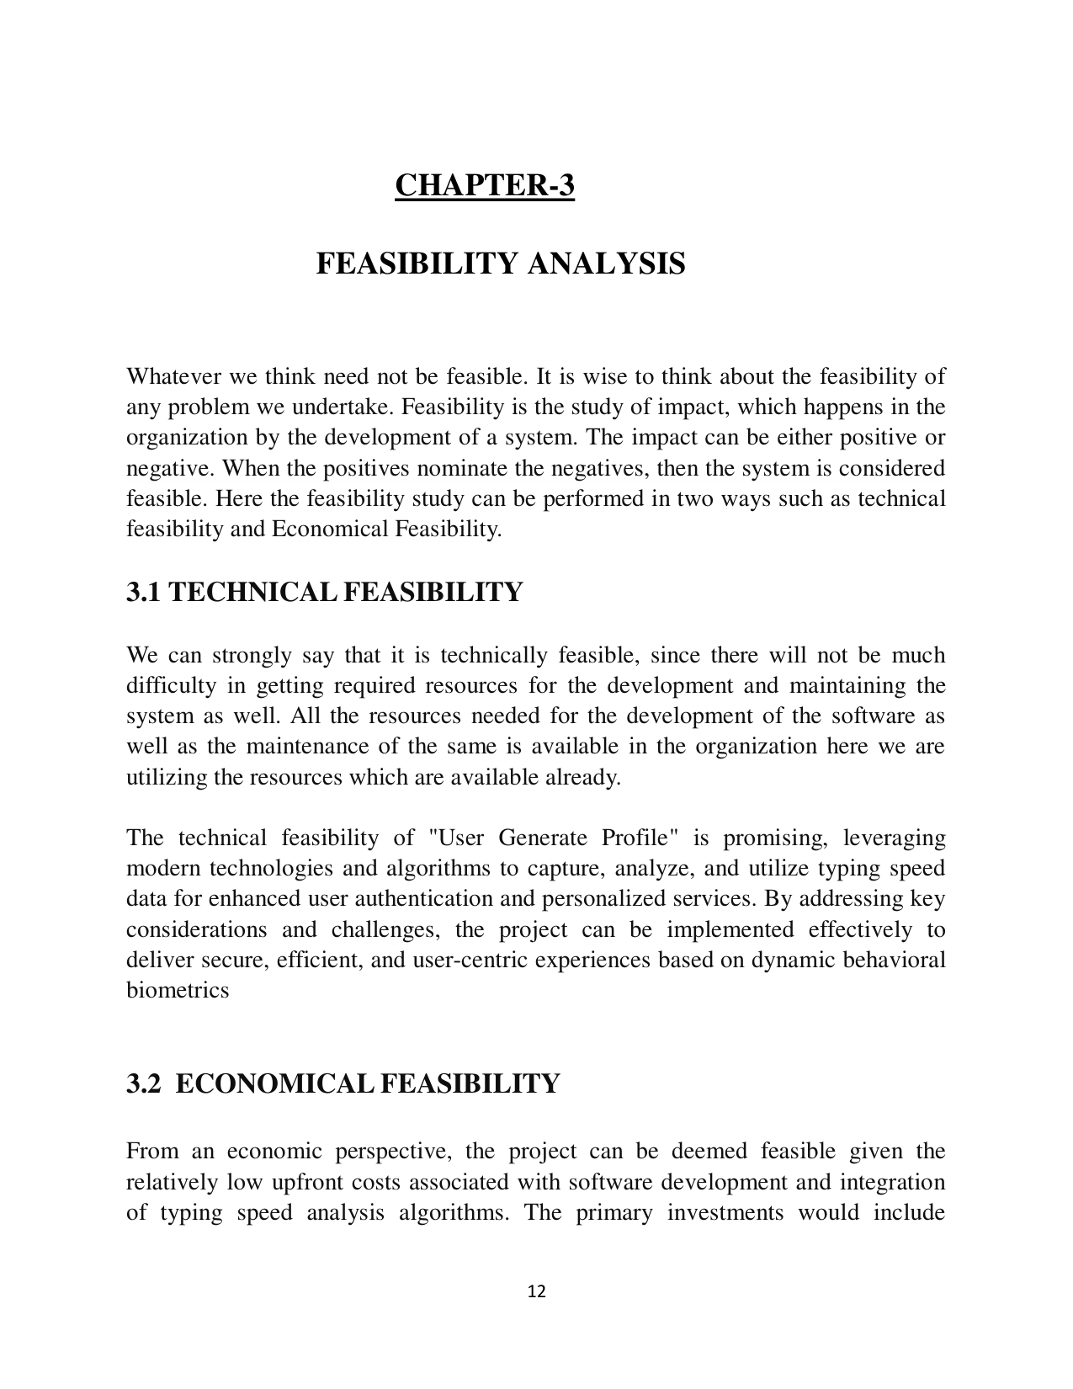

Page 13

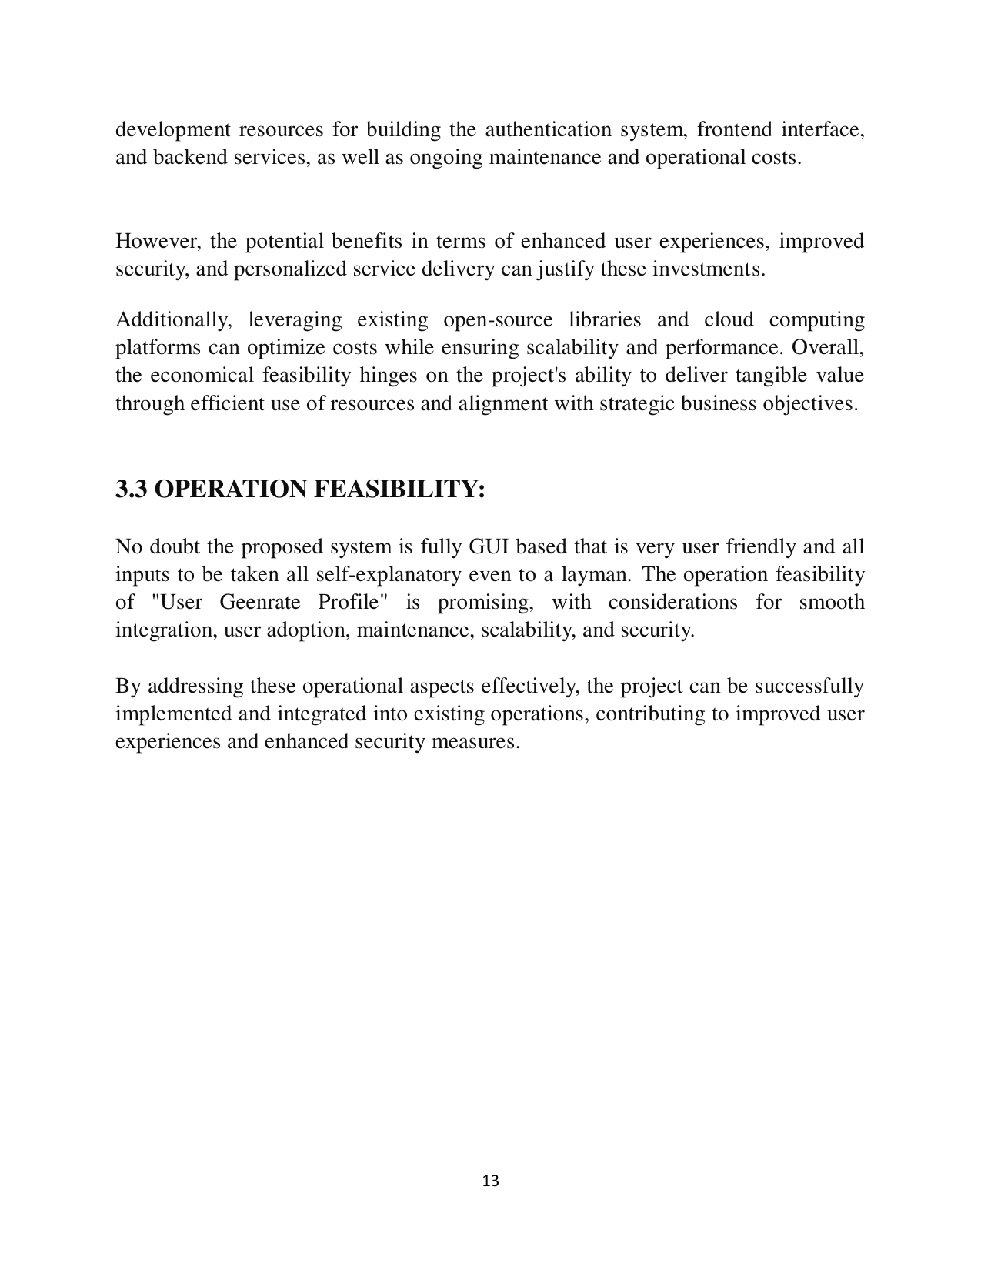

Page 14

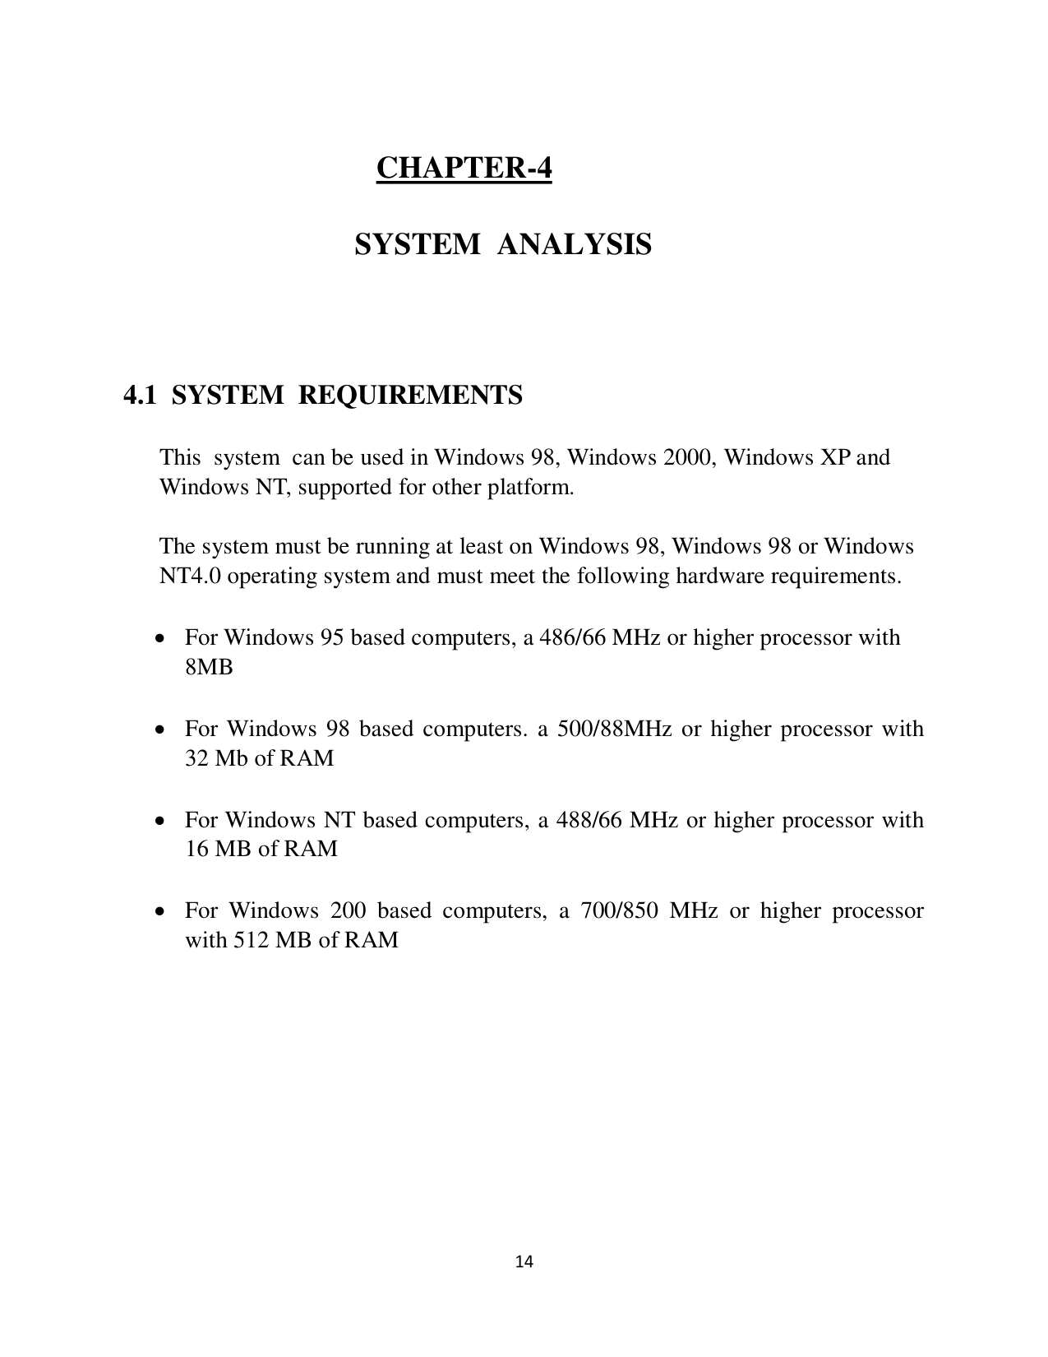

Page 15



Page 16

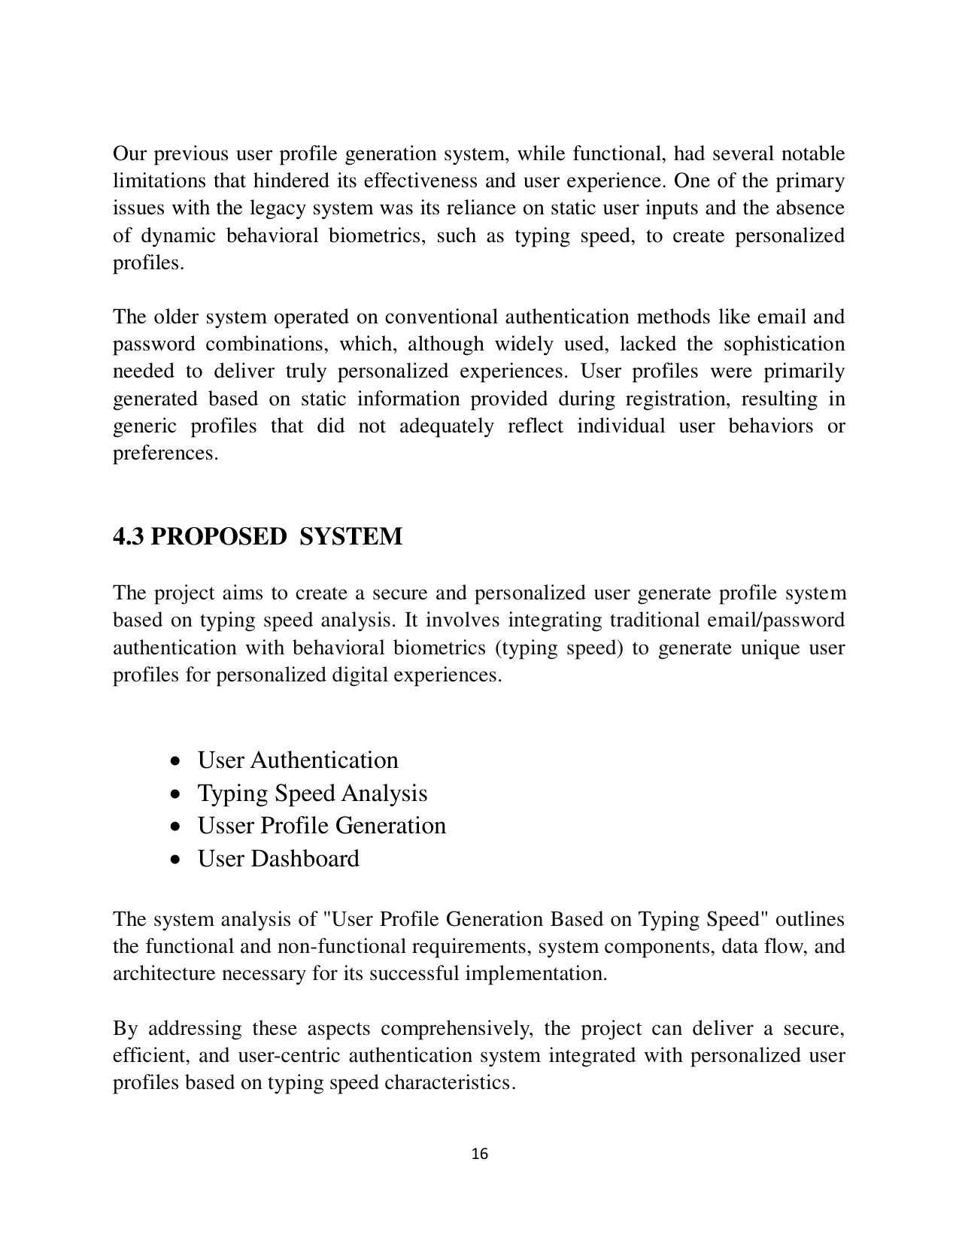

Page 17



Page 18

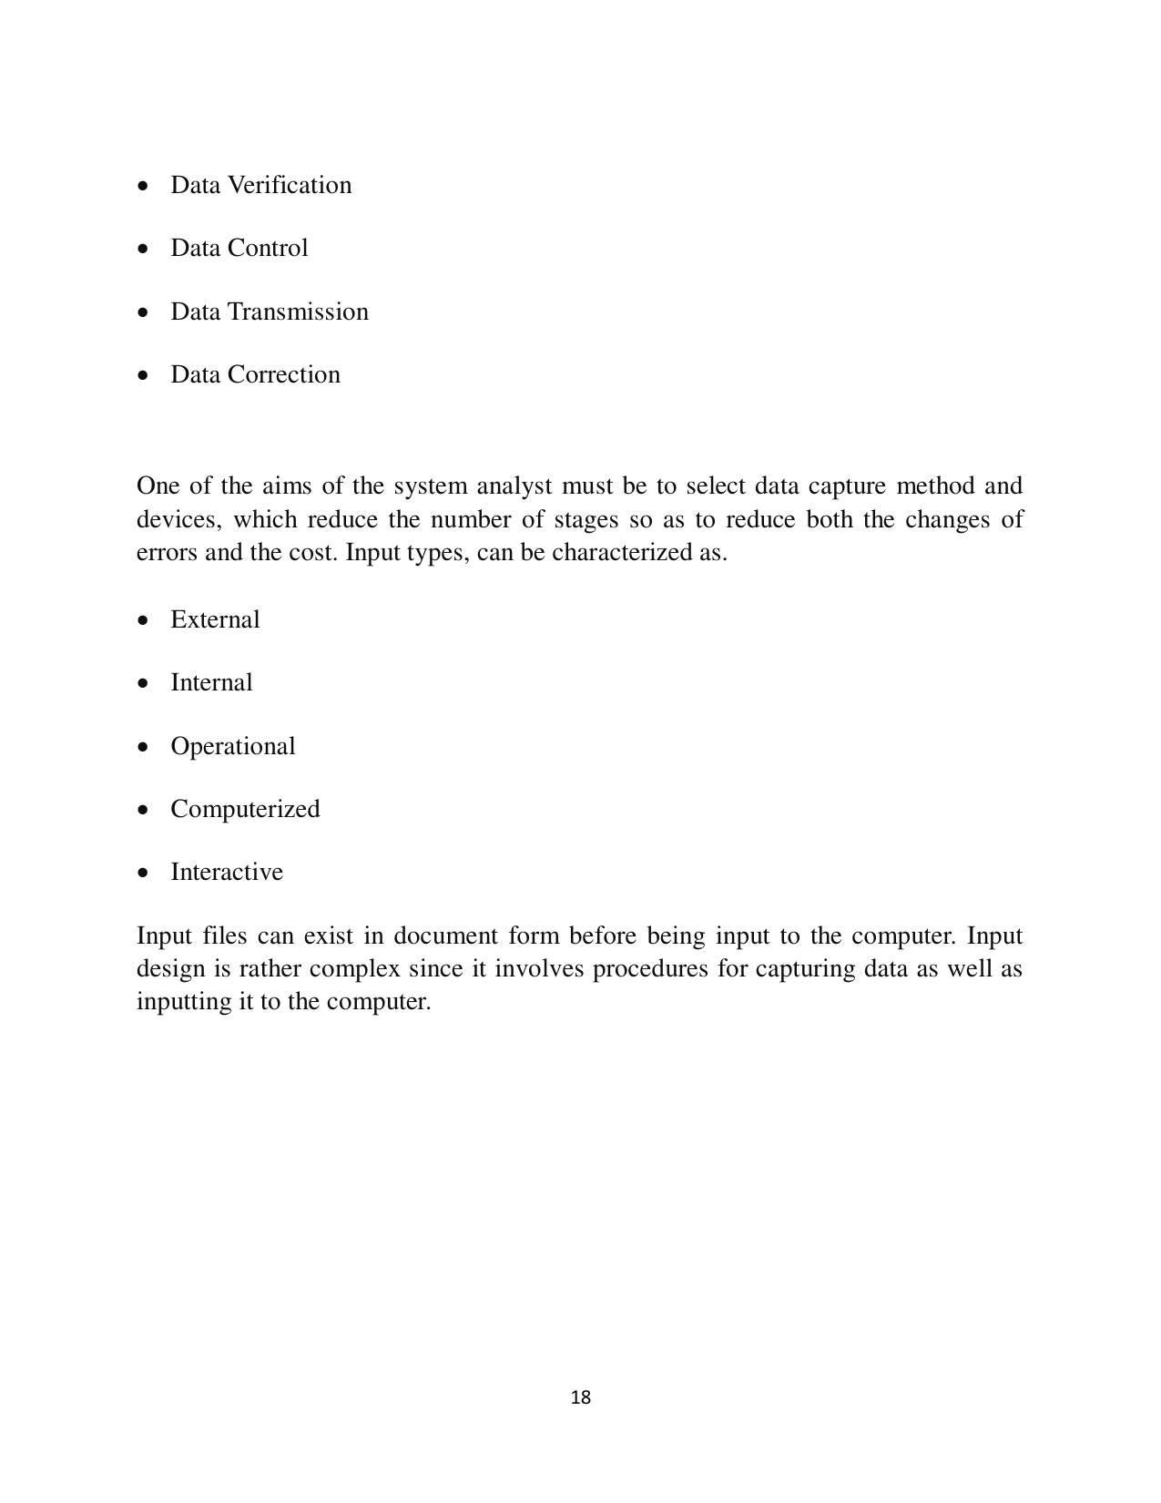

Page 19

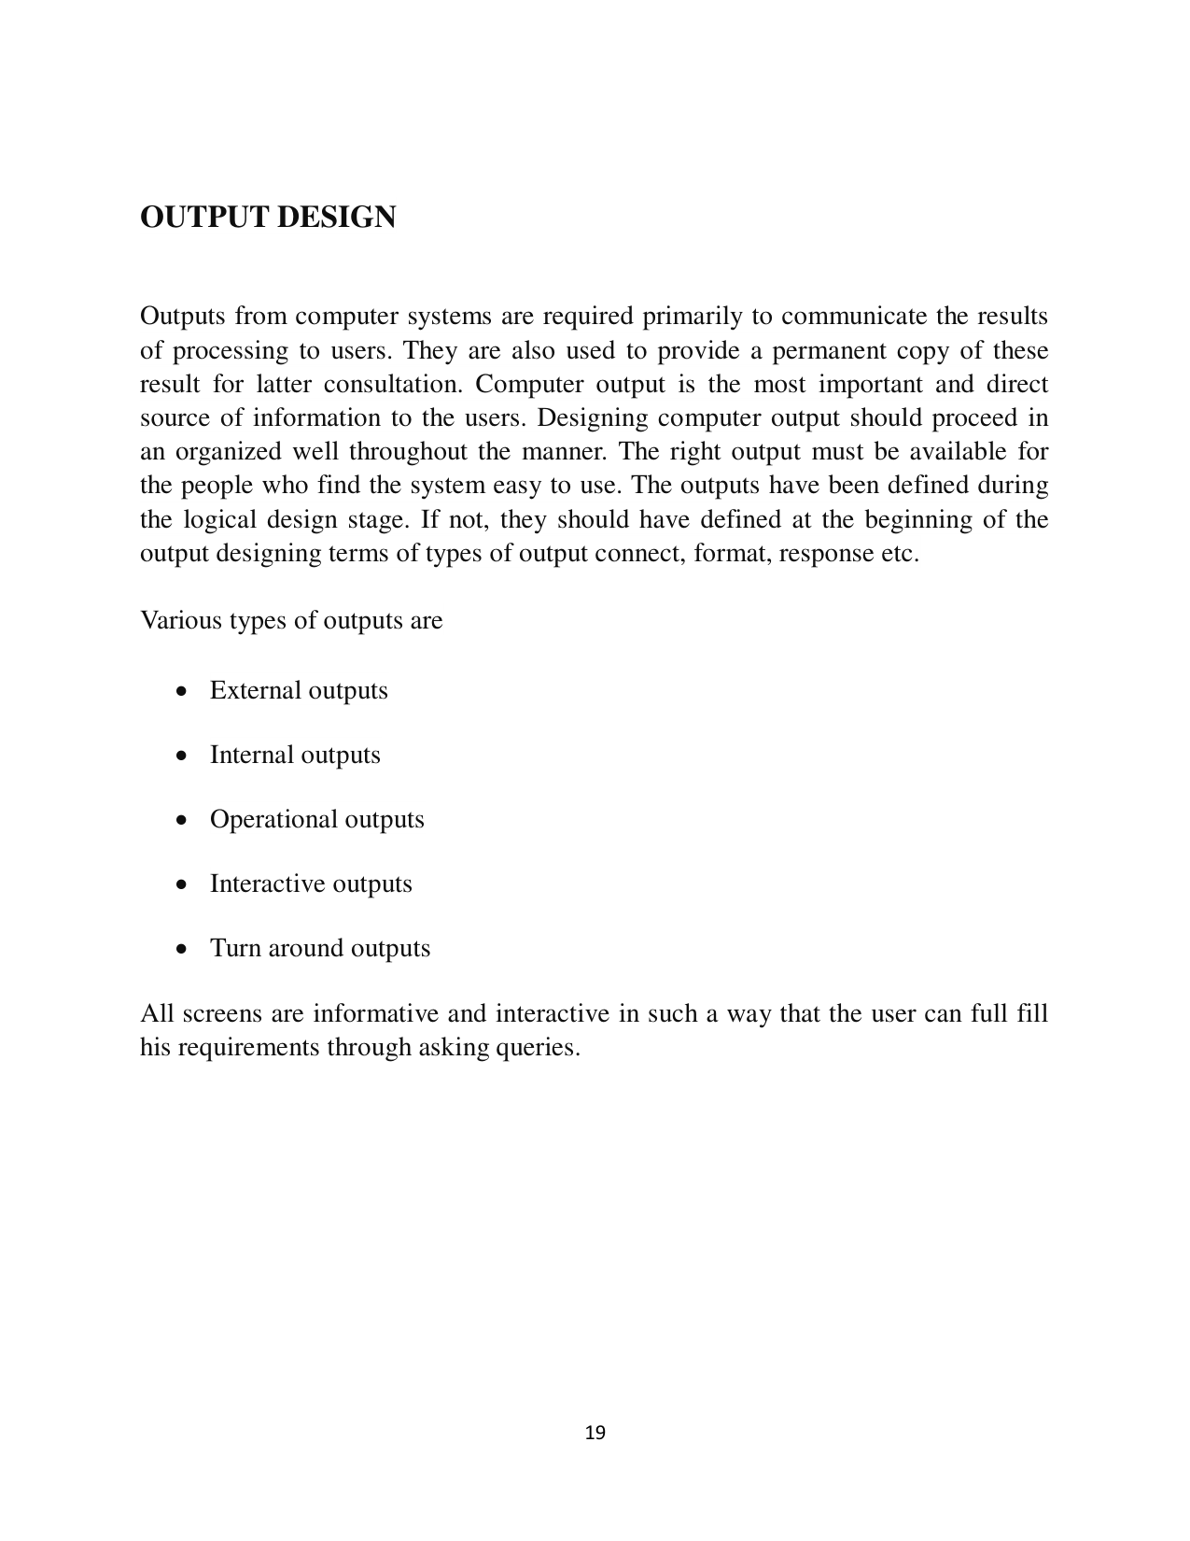

Page 20

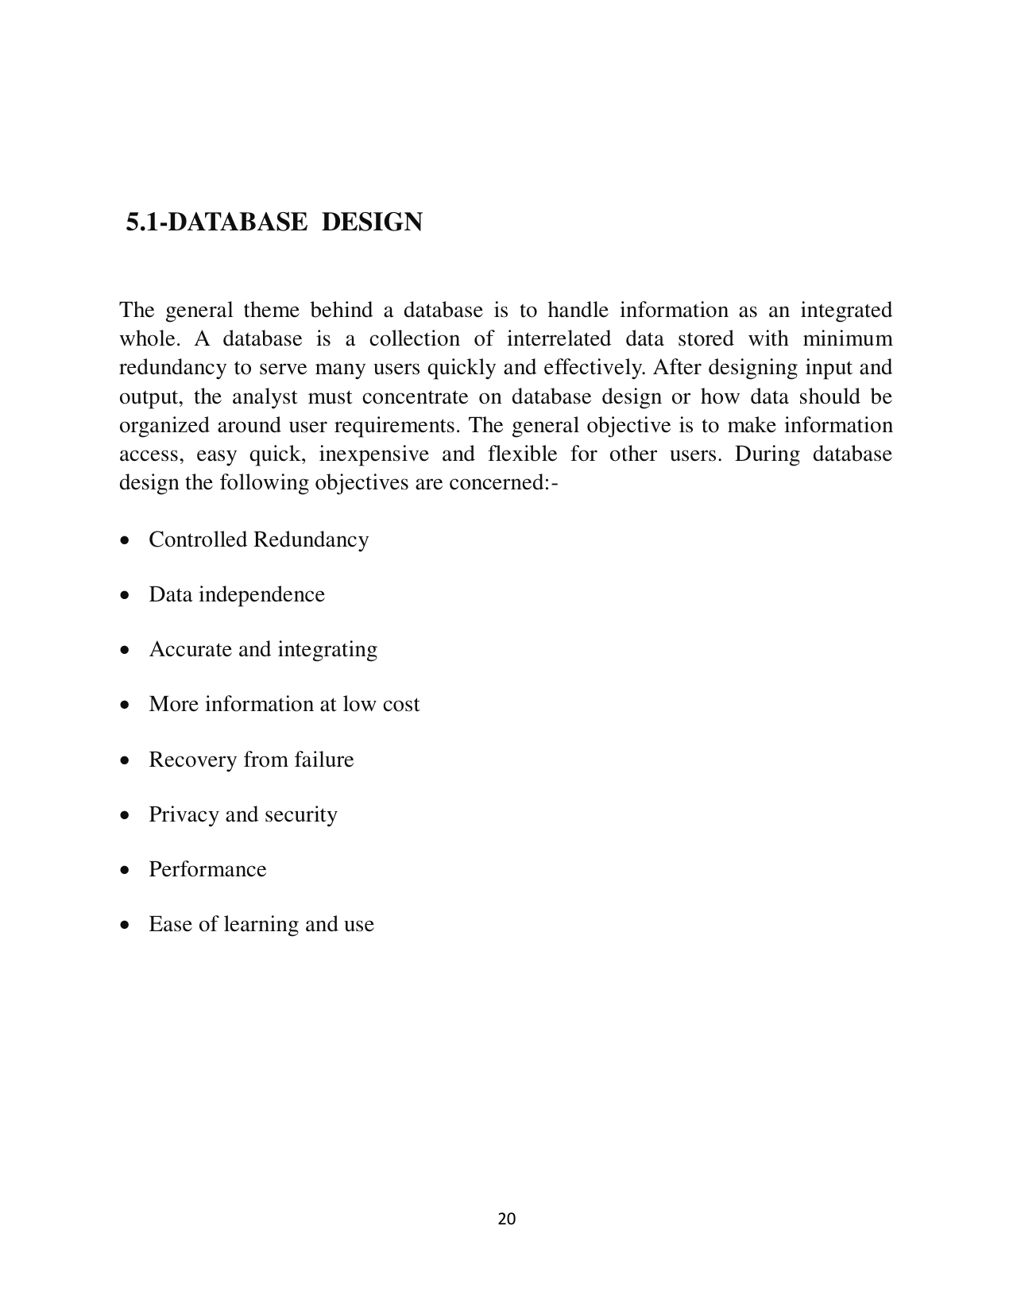

Page 21

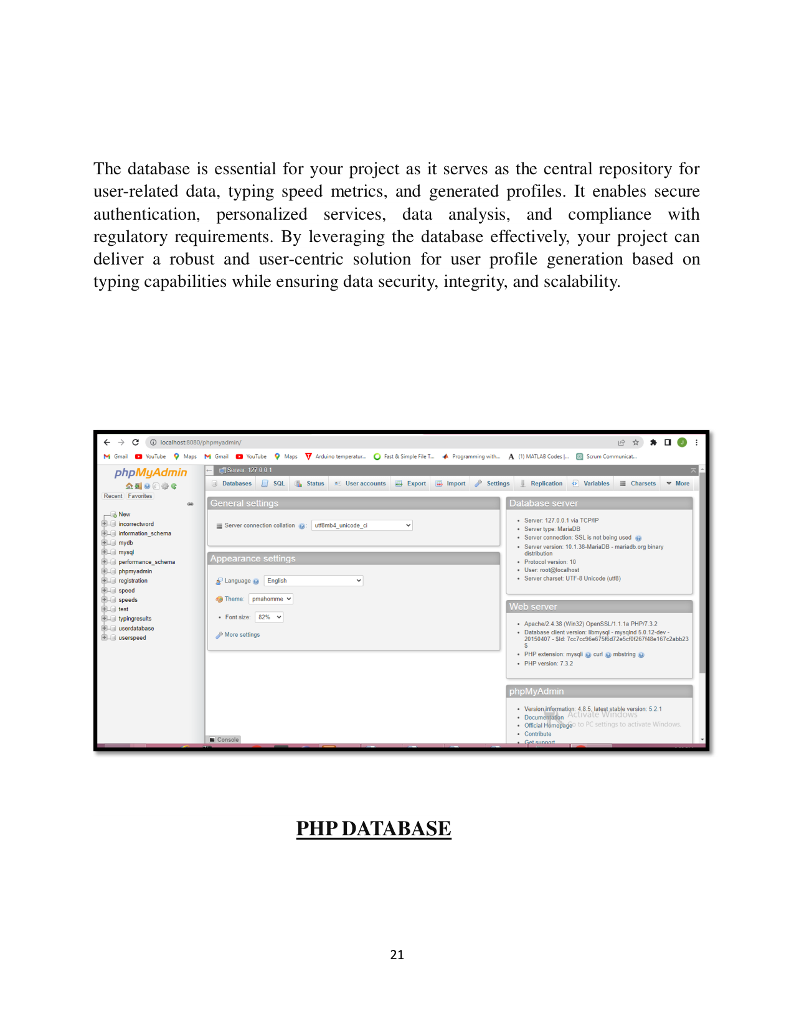

Page 22

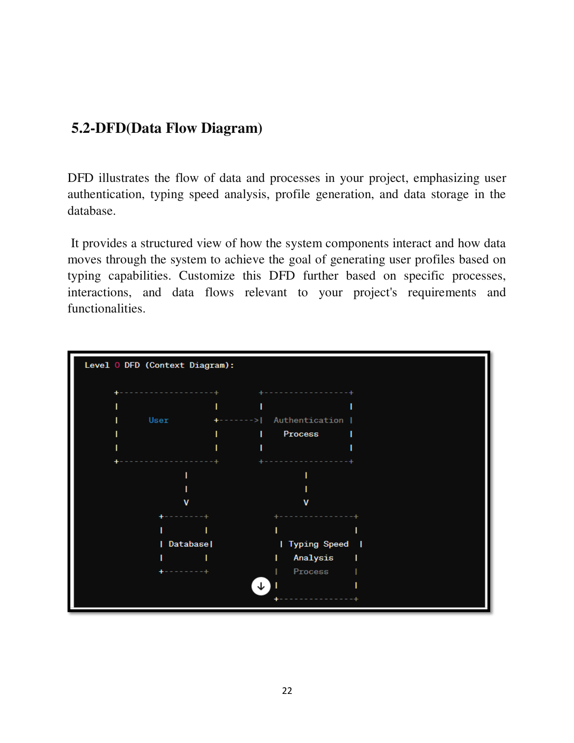

Page 23

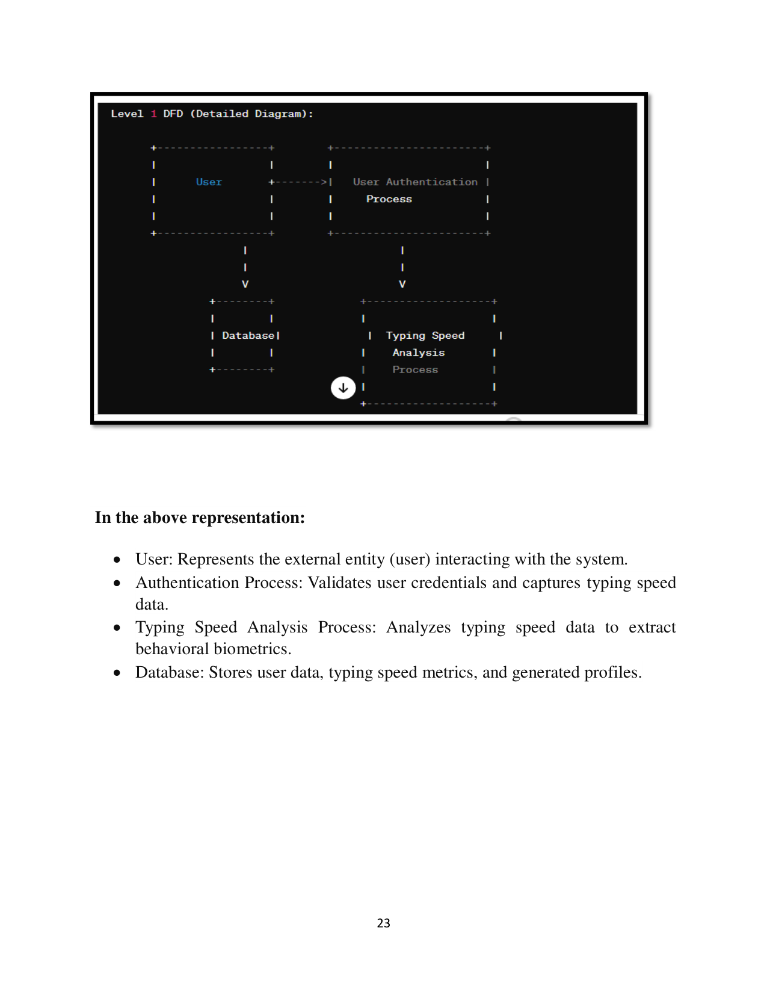

Page 24

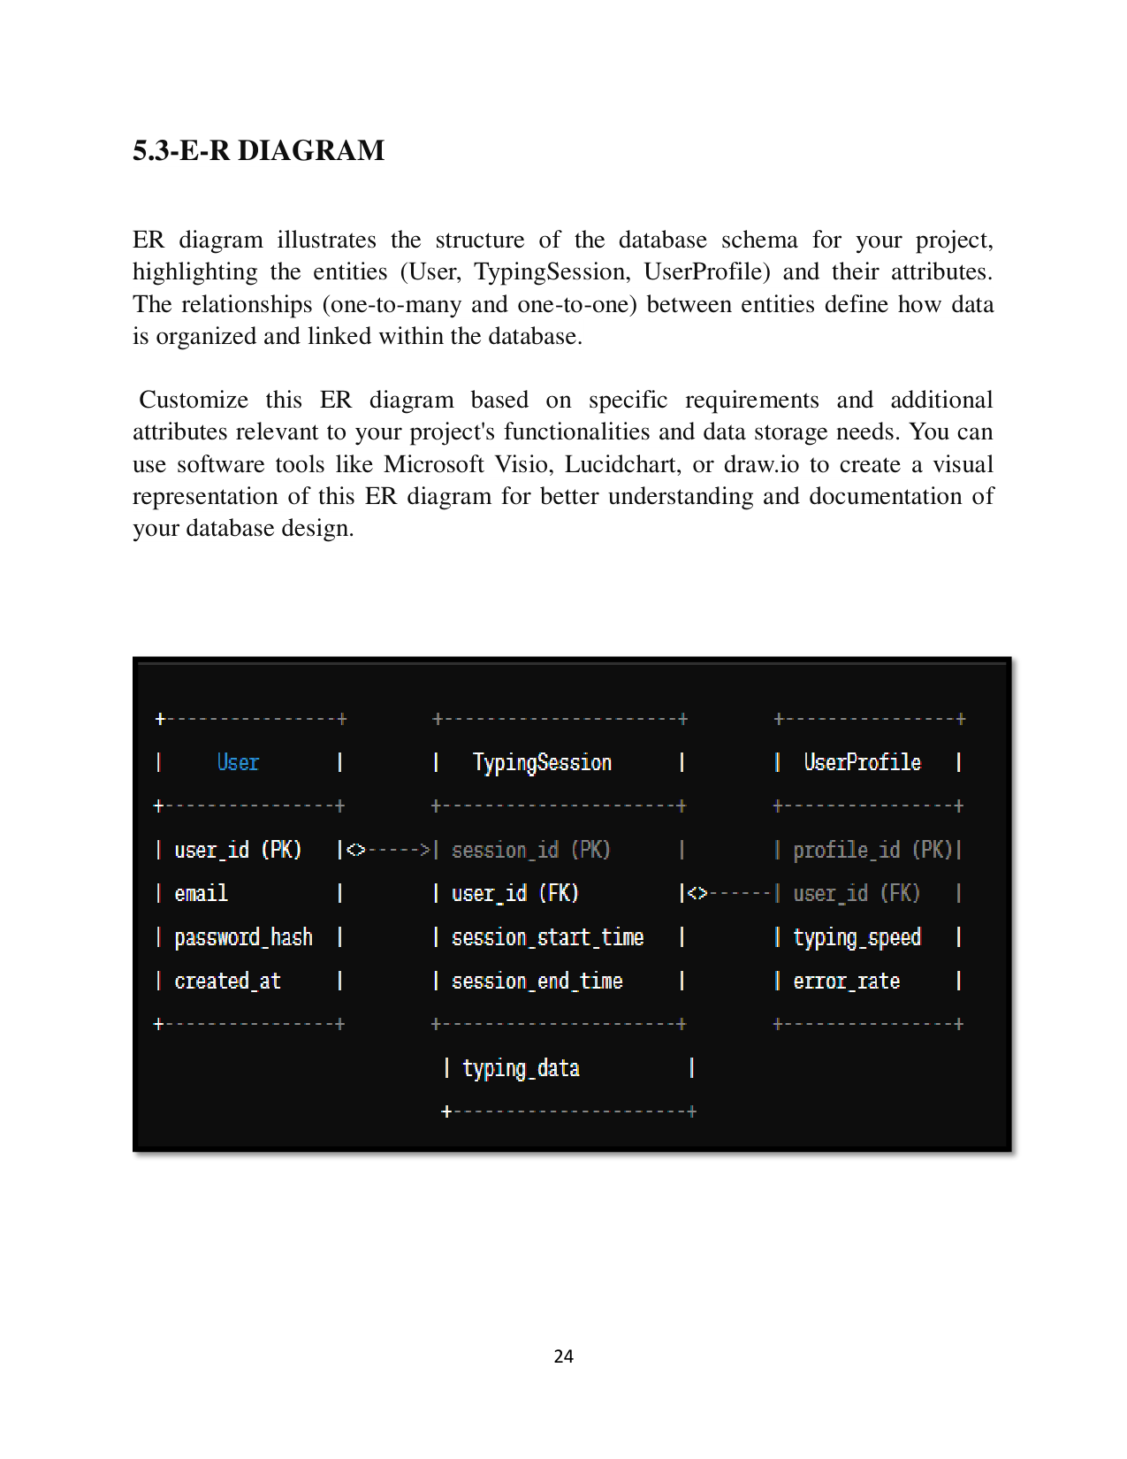

Page 25

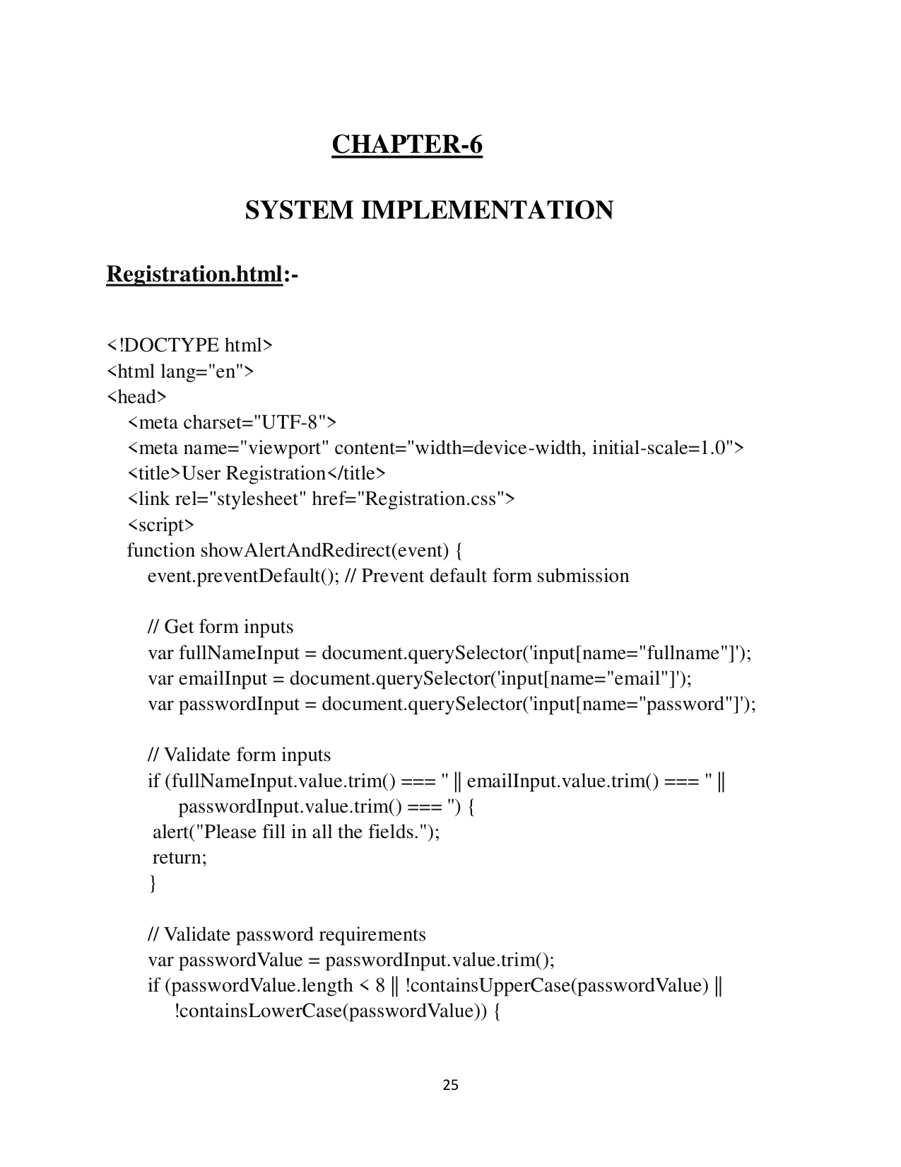

Page 26

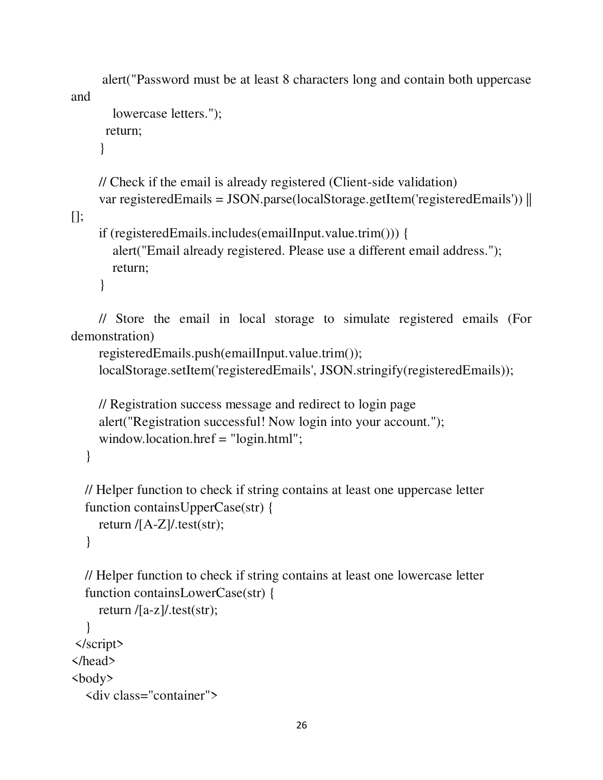

Page 27

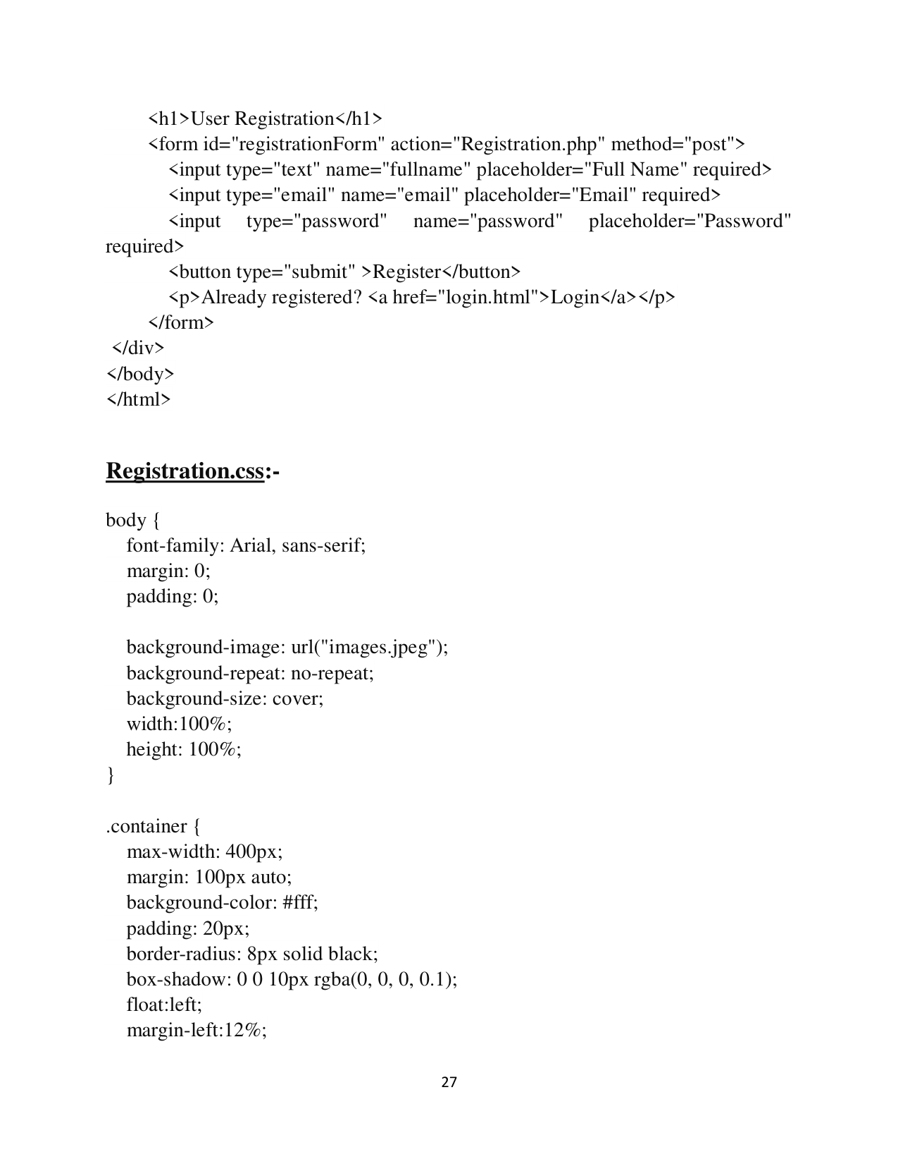

Page 28

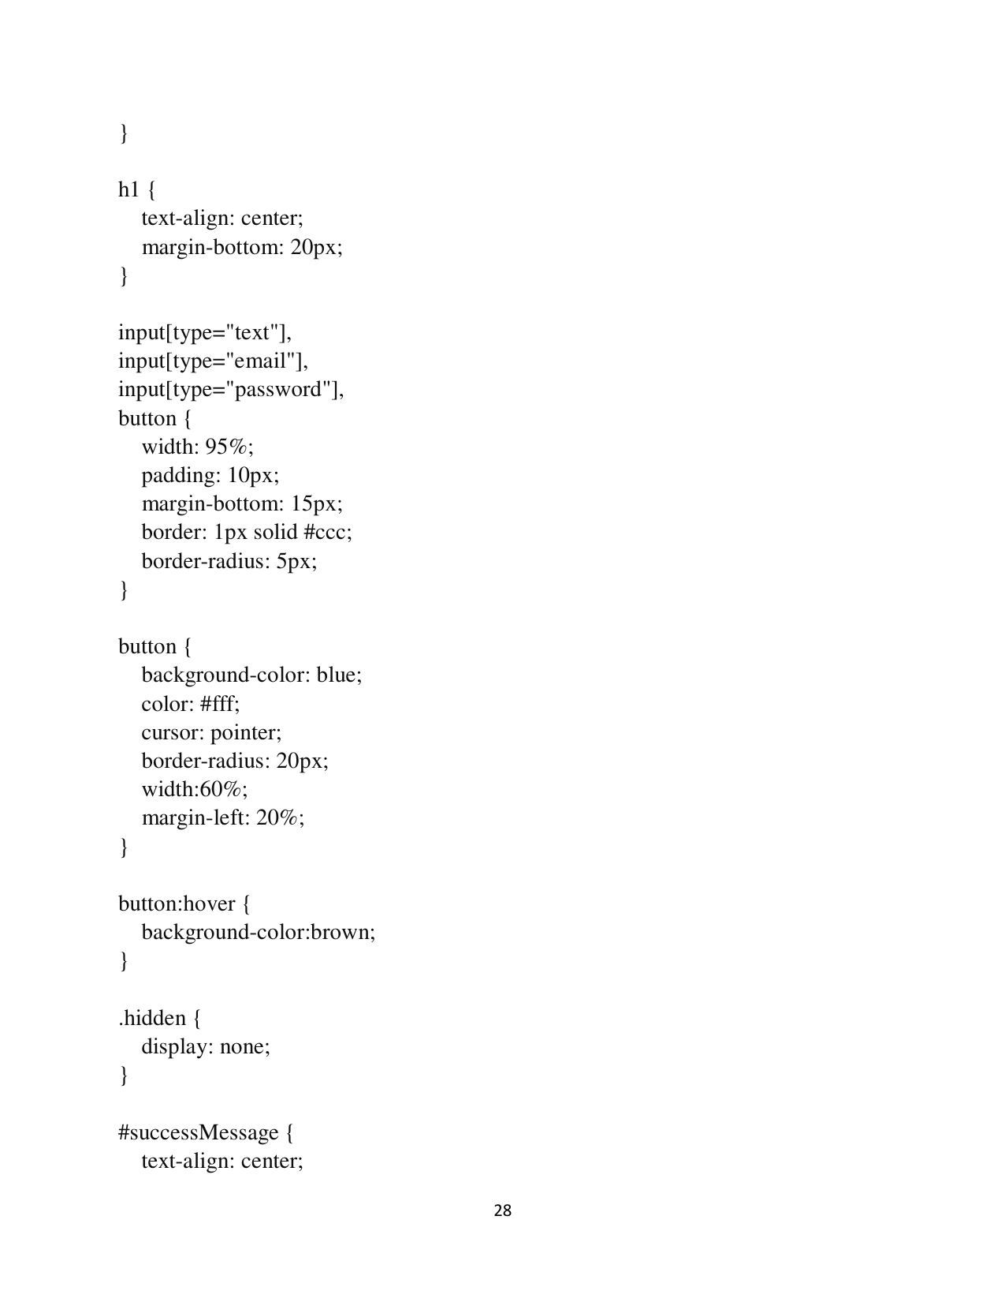

Page 29

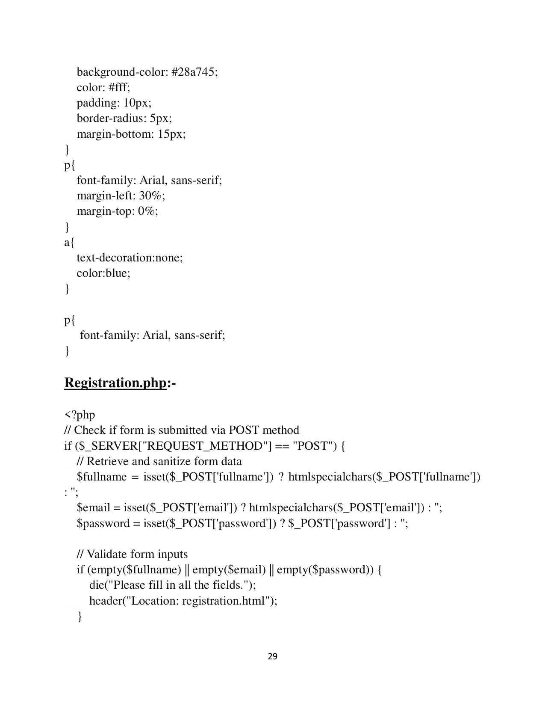

Page 30

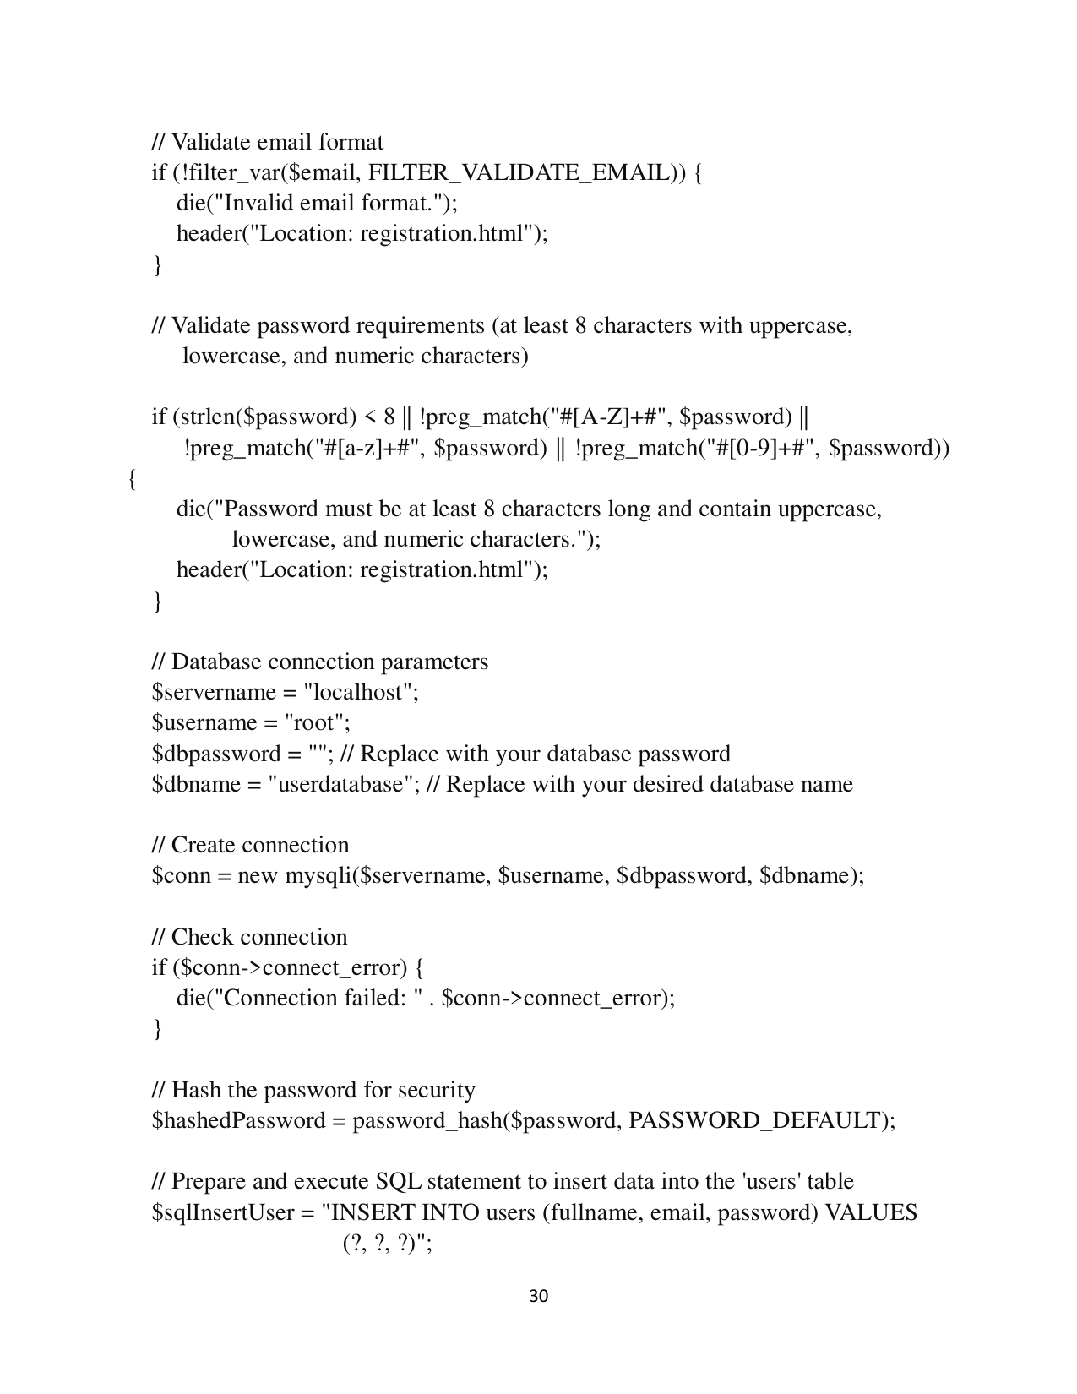

Page 31

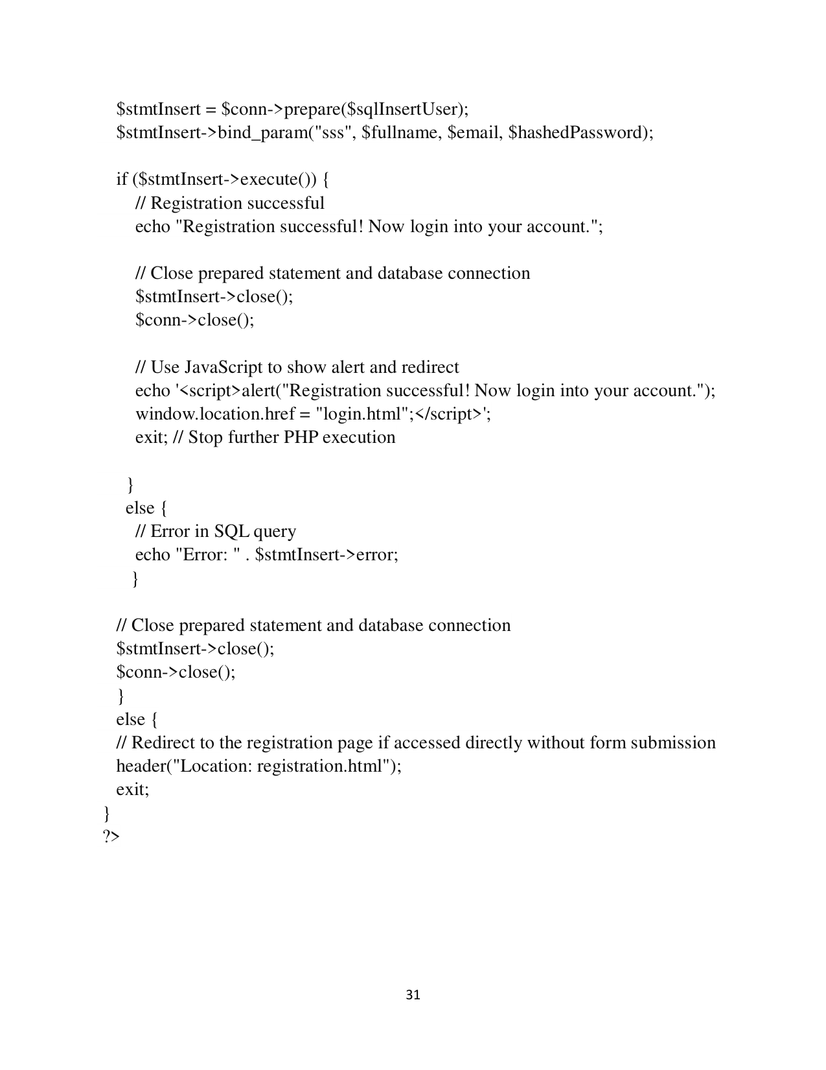

Page 32

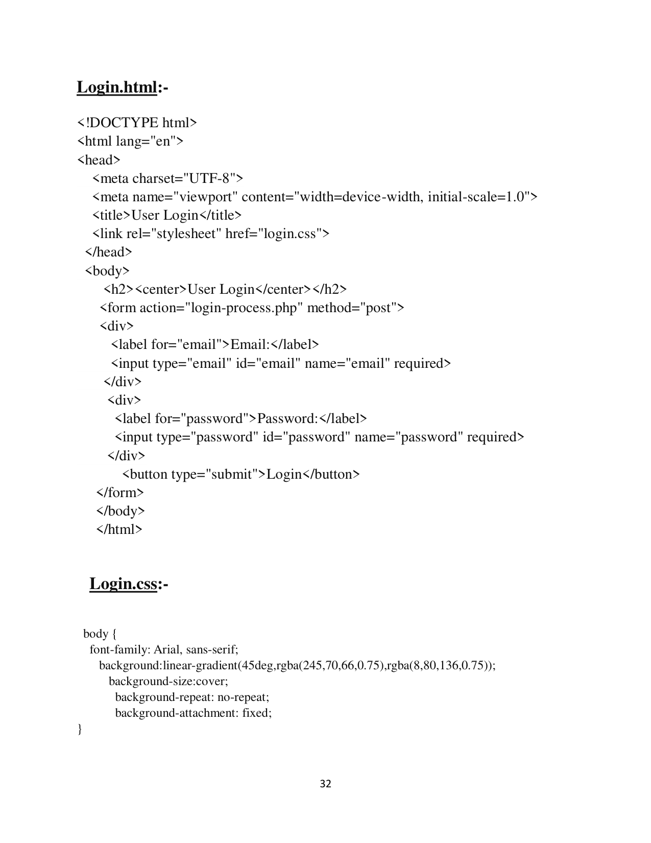

Page 33

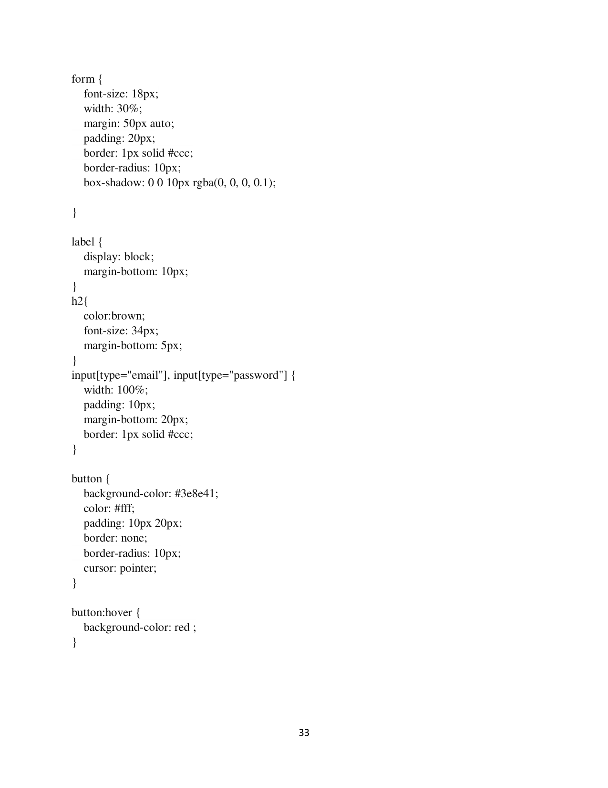

Page 34

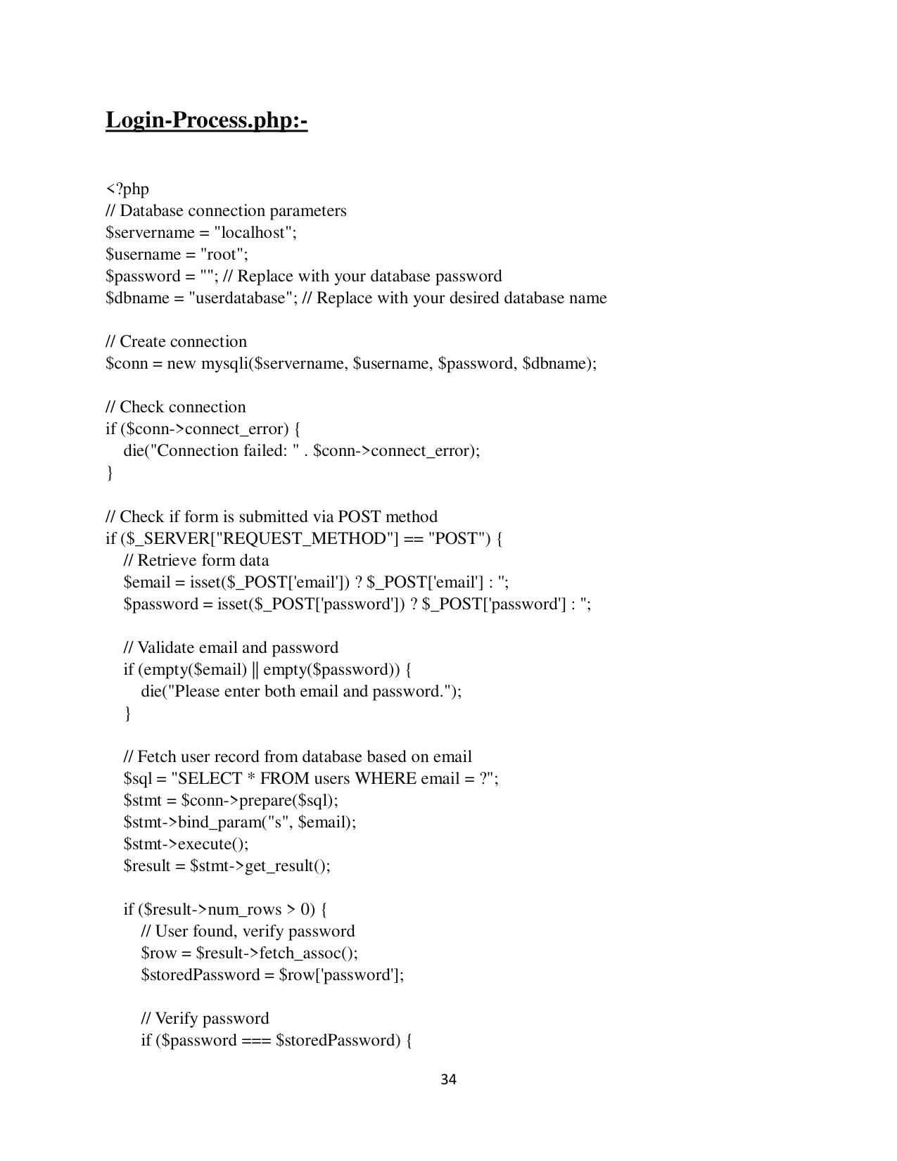

Page 35

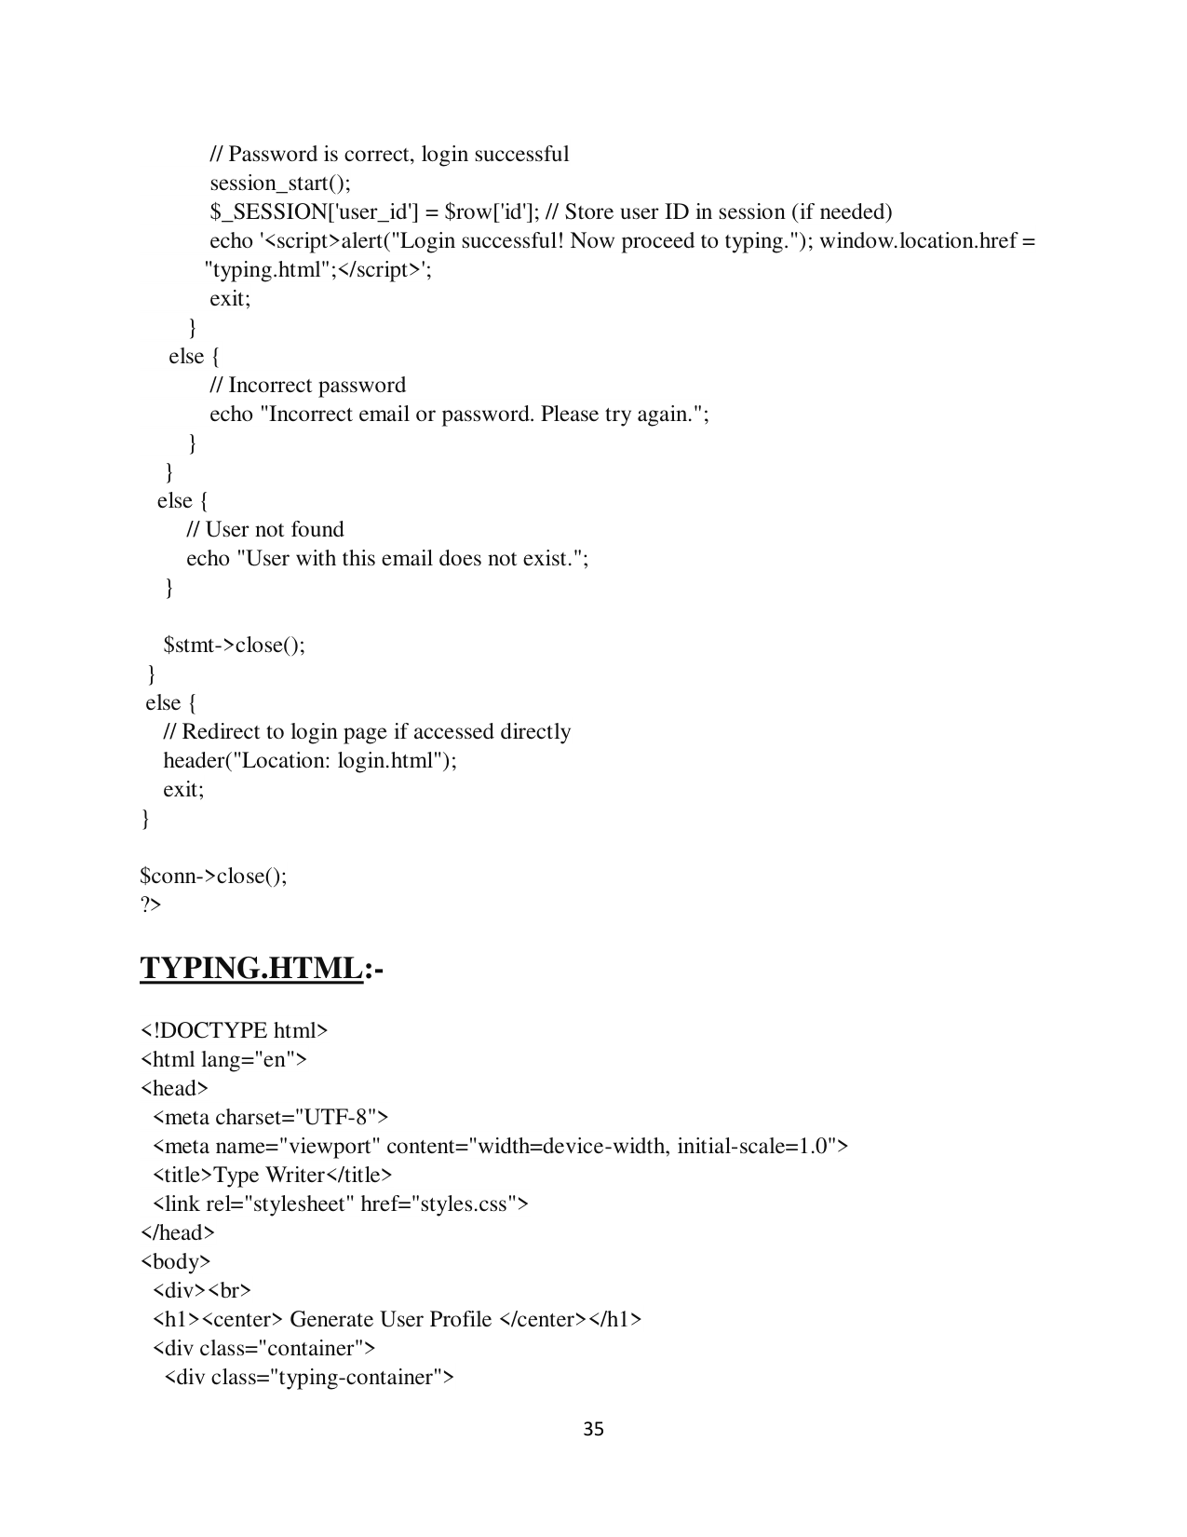

Page 36

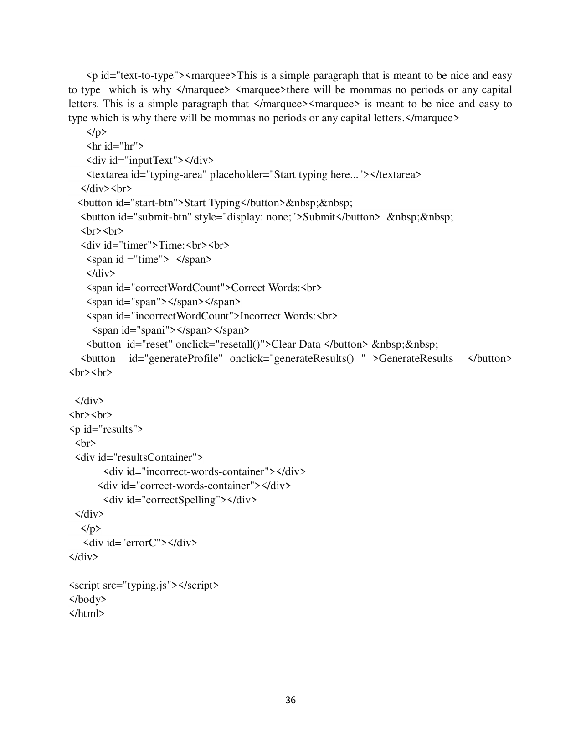

Page 37

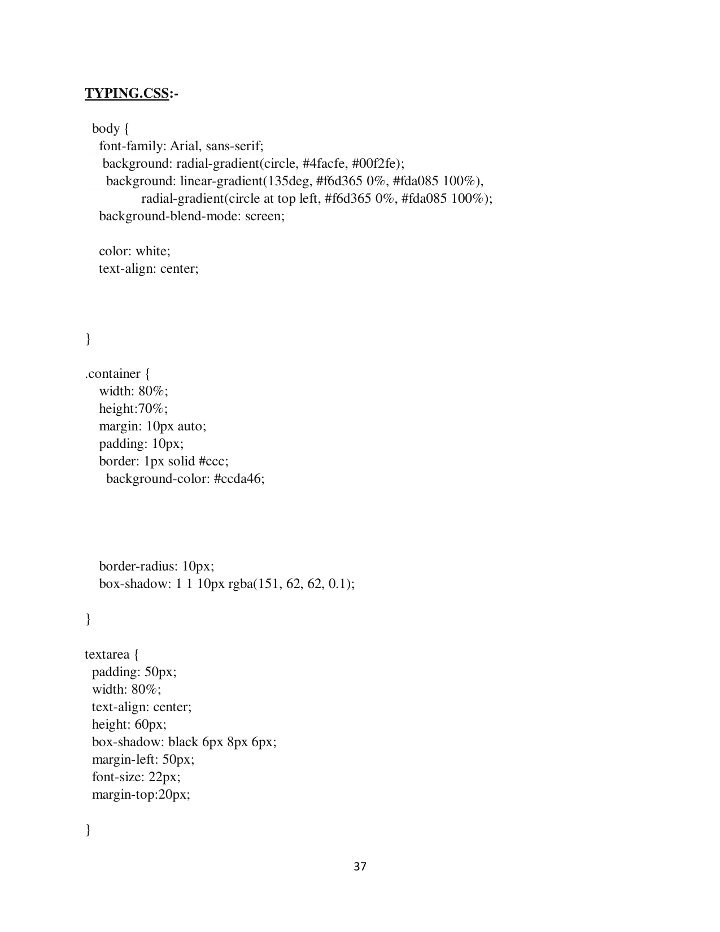

Page 38

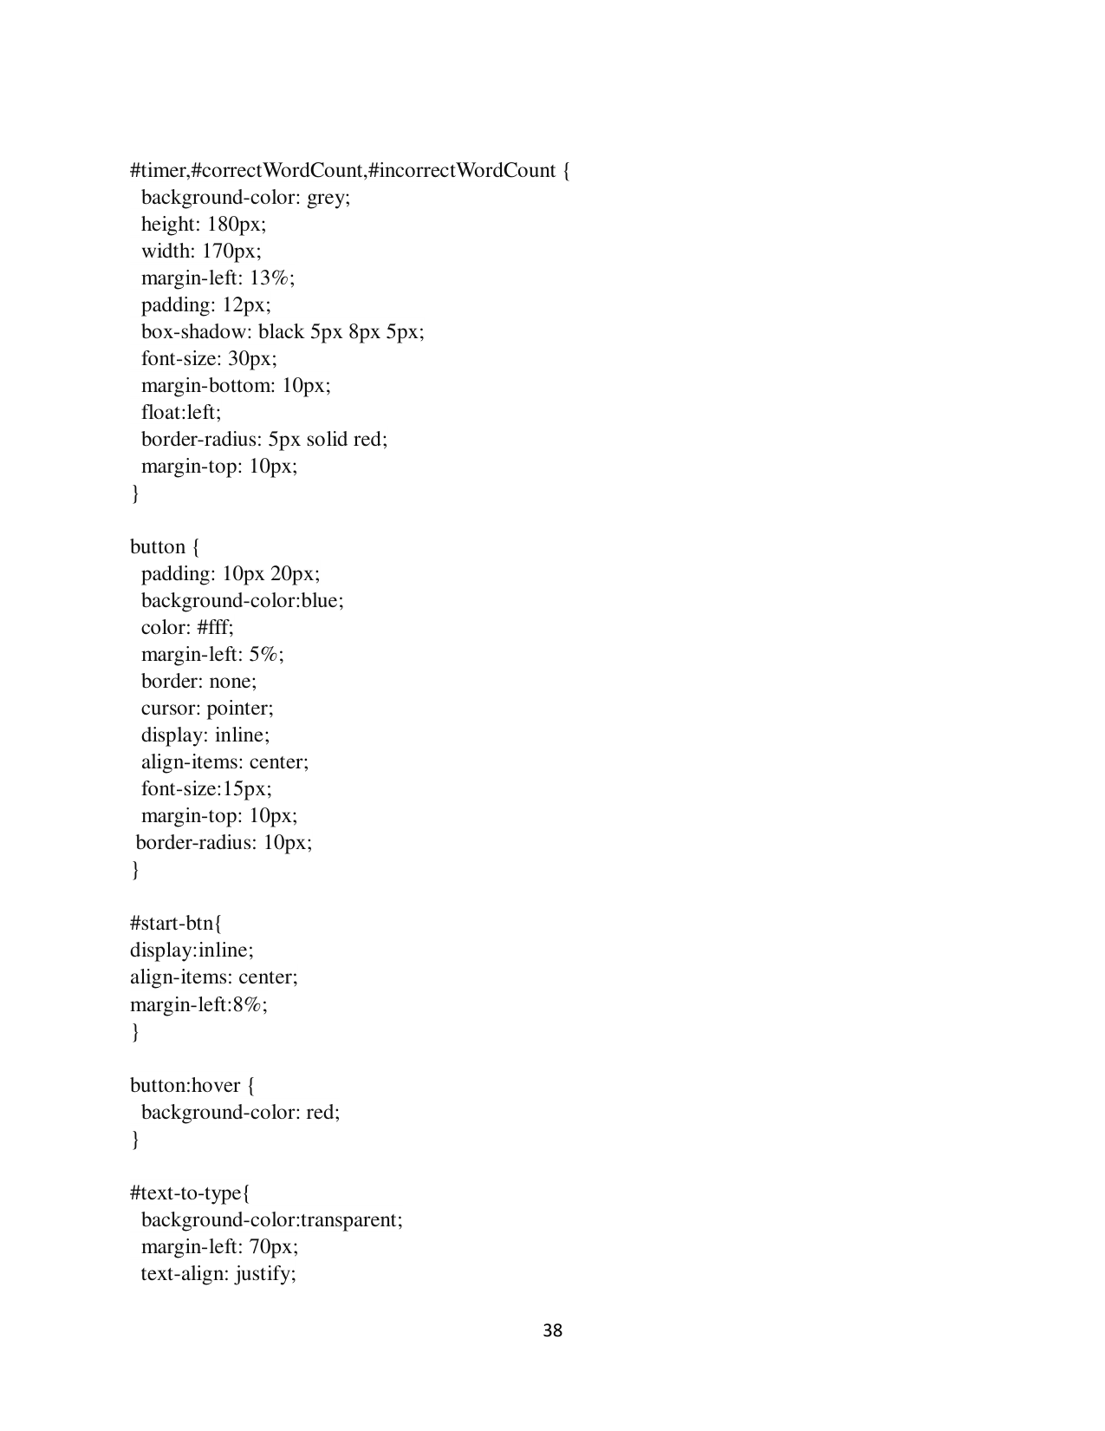

Page 39

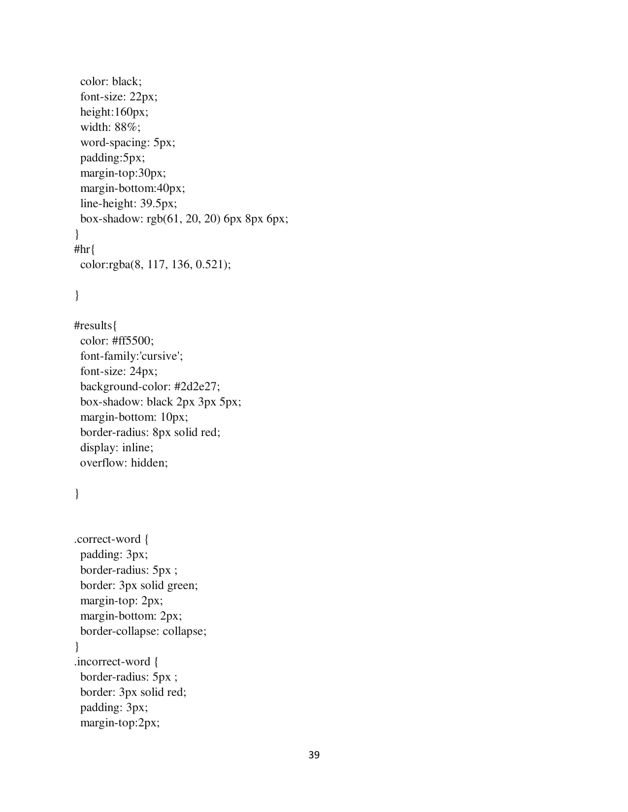

Page 40

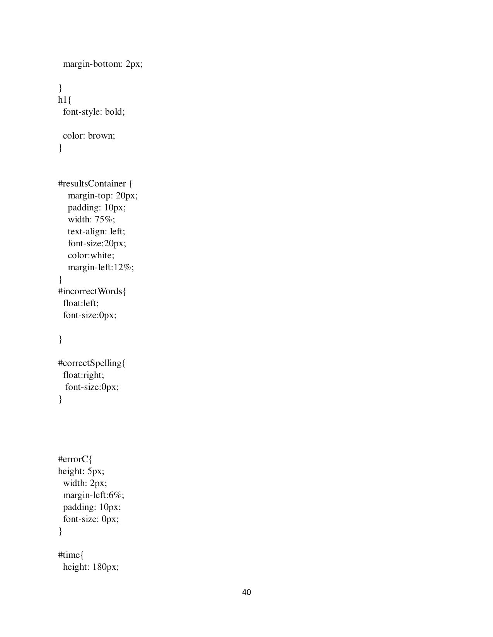

Page 41

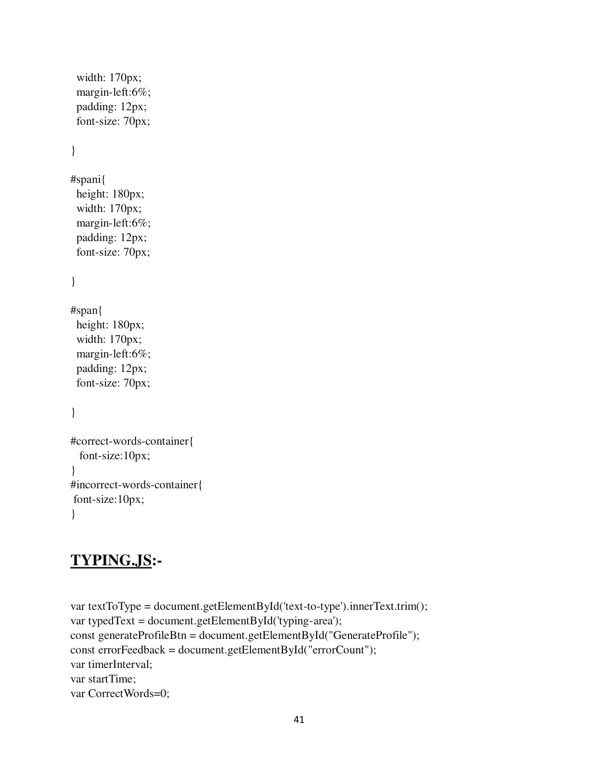

Page 42

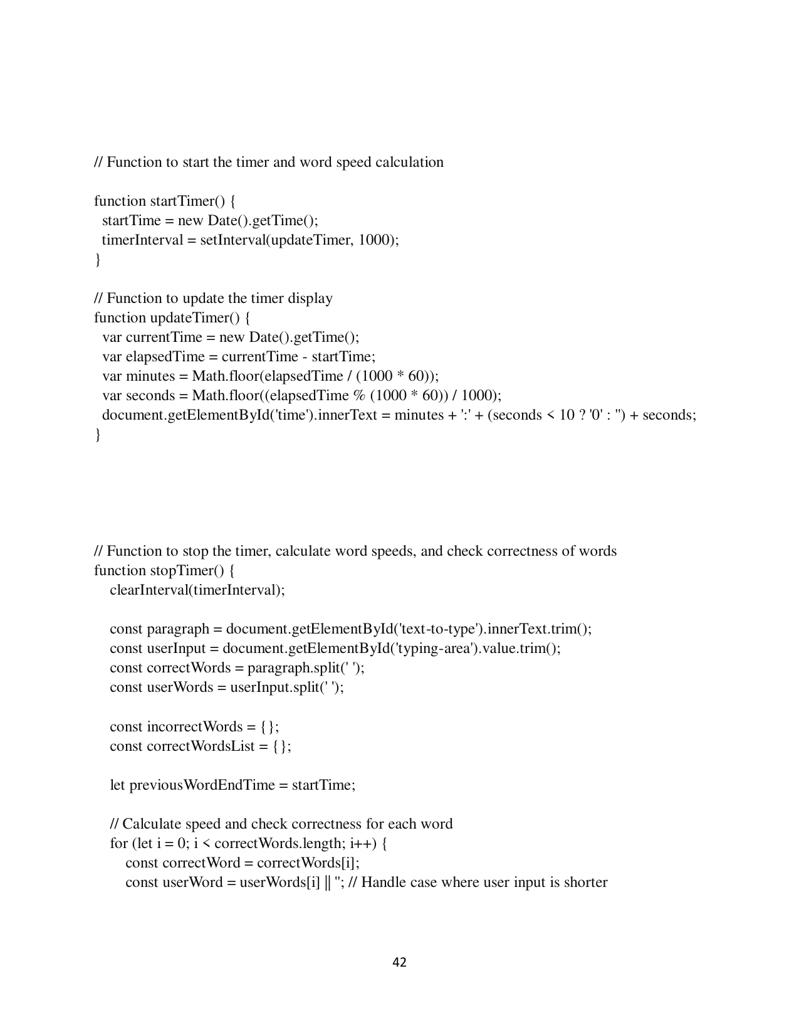

Page 43

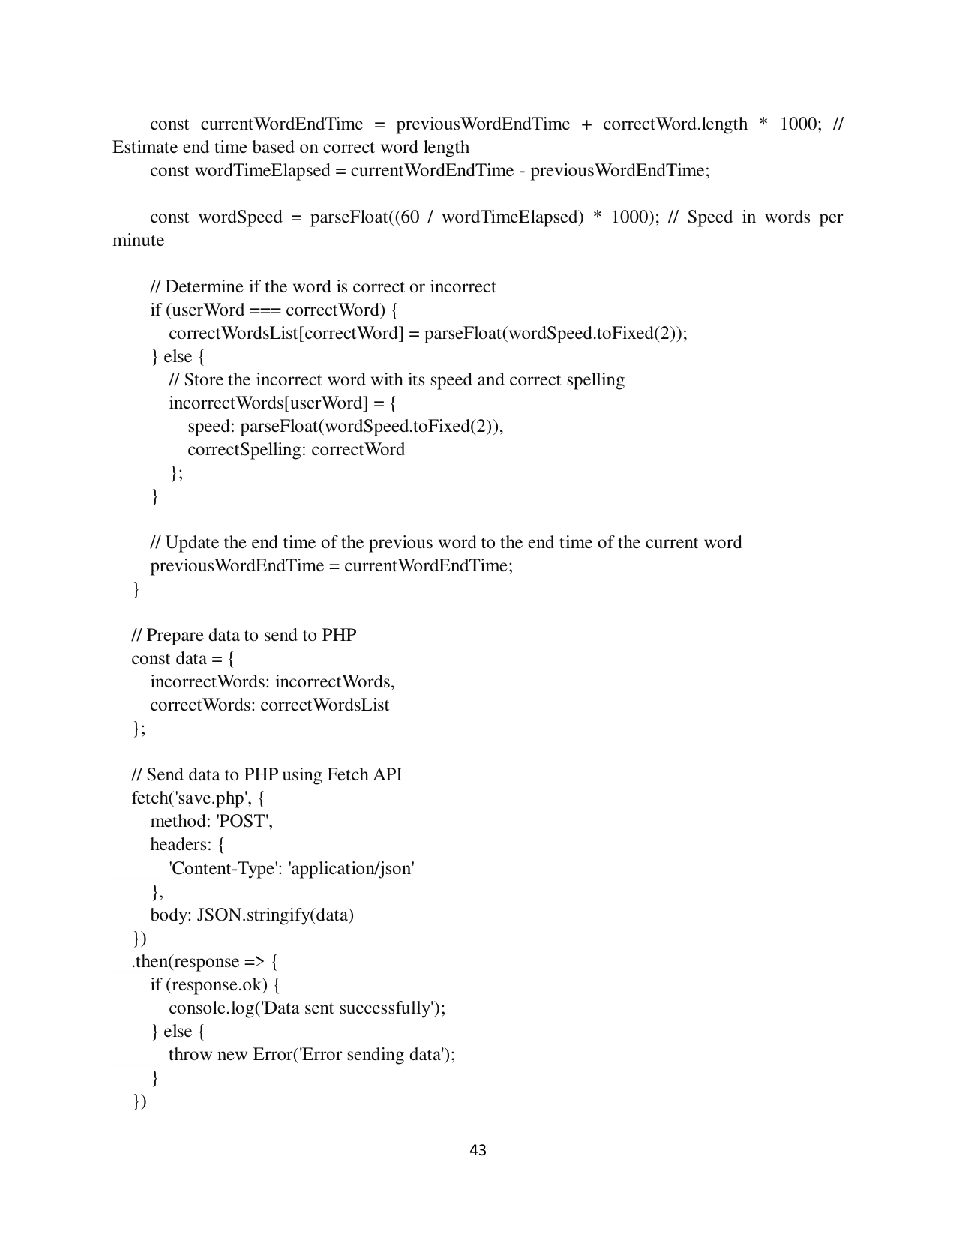

Page 44

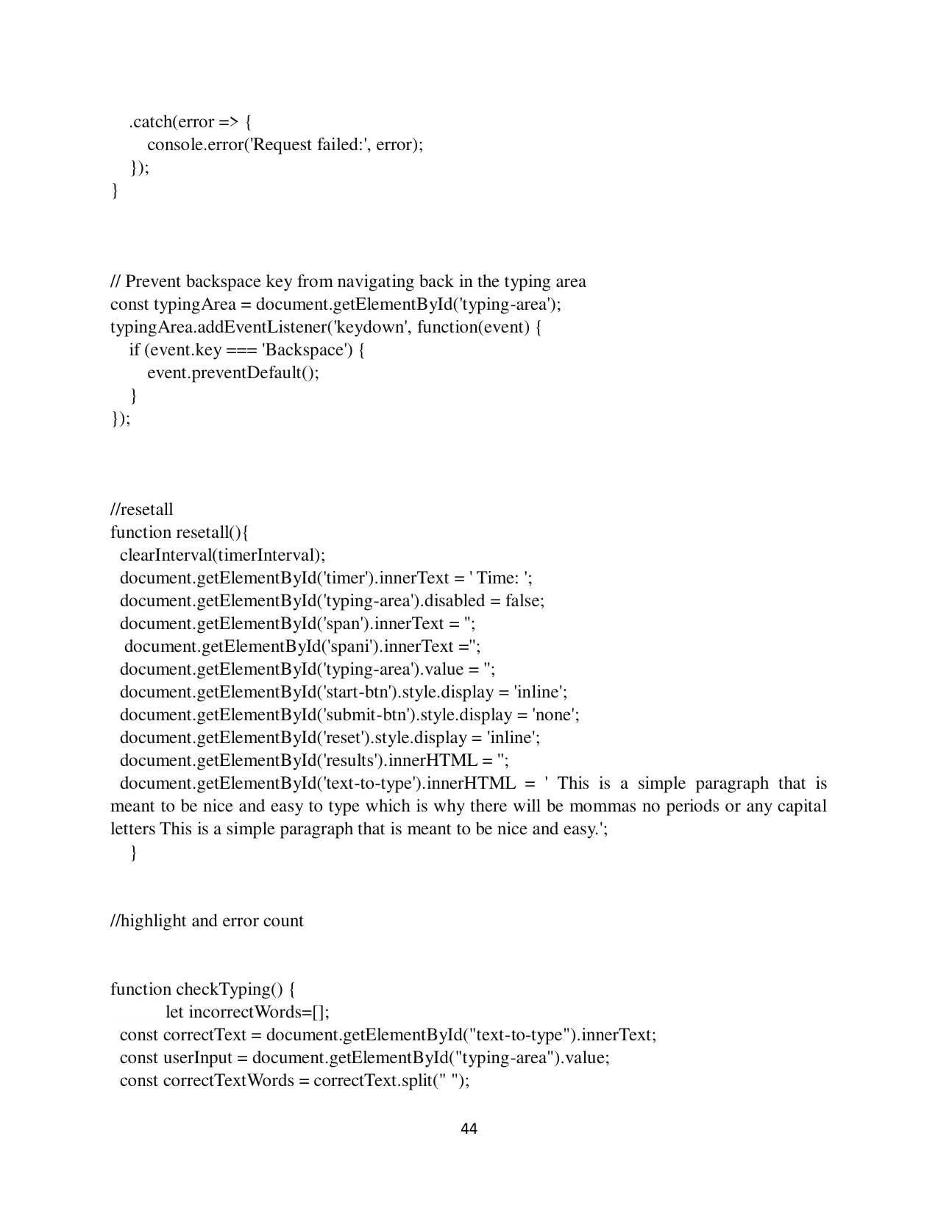

Page 45

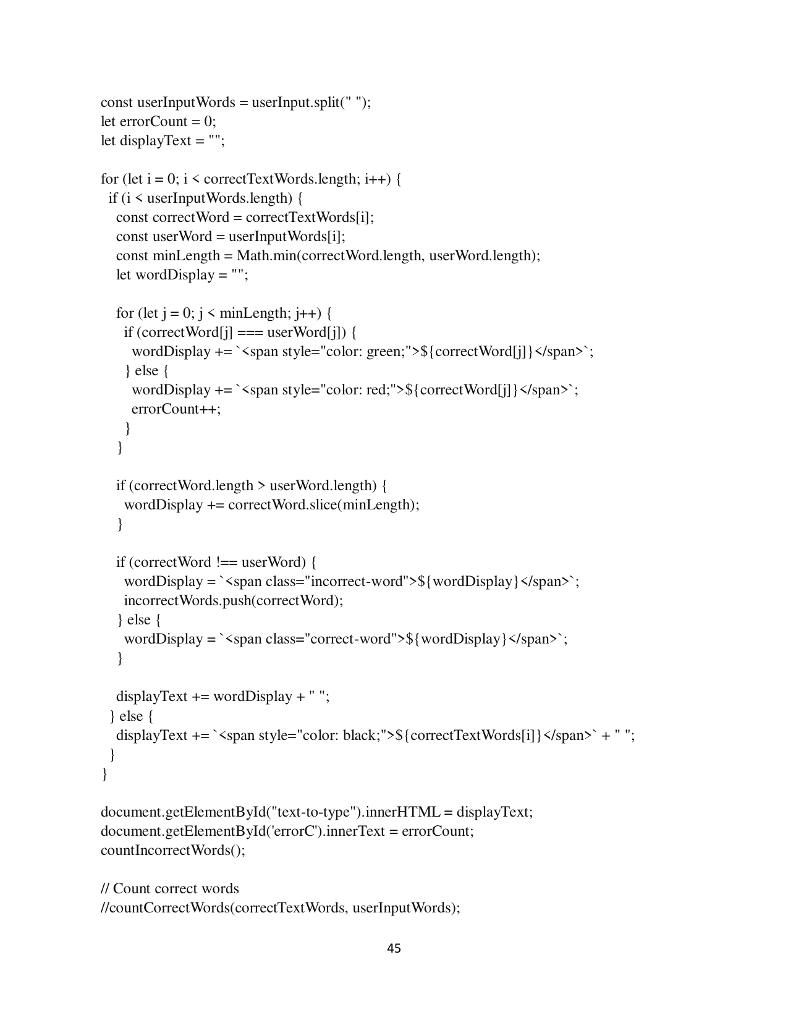

Page 46

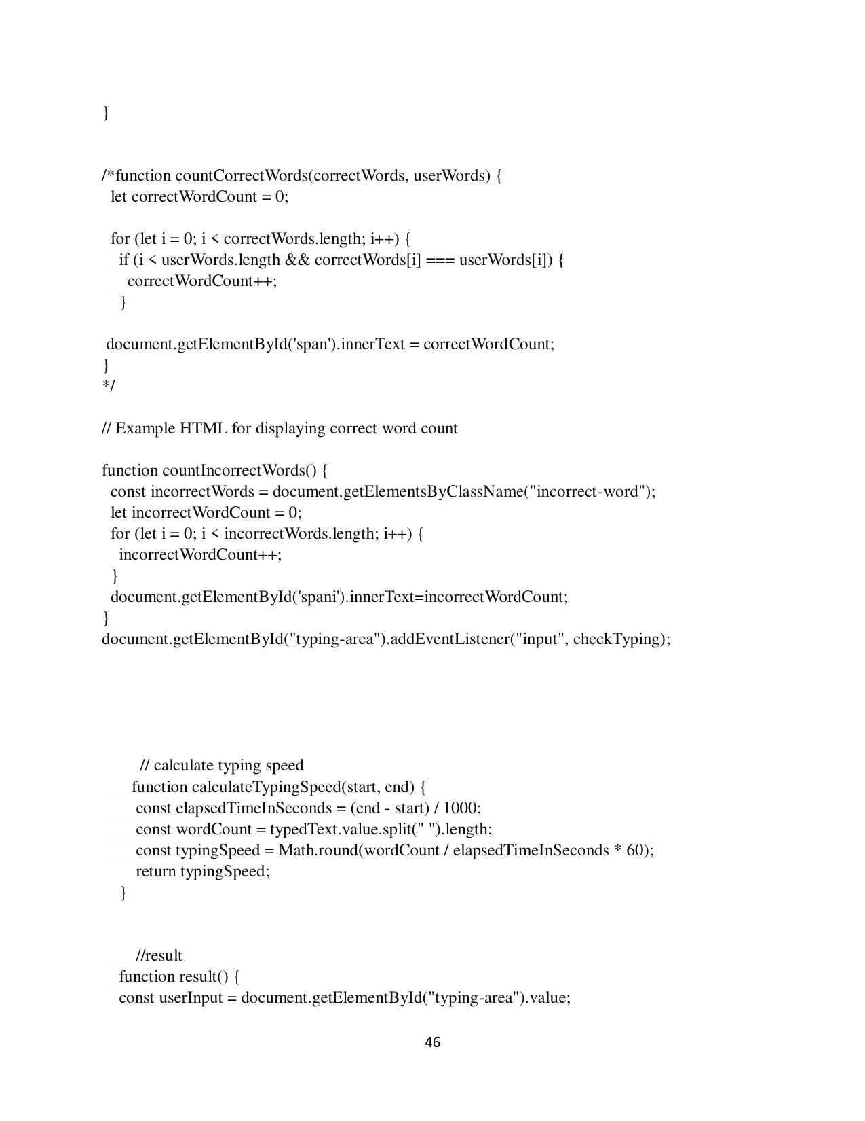

Page 47

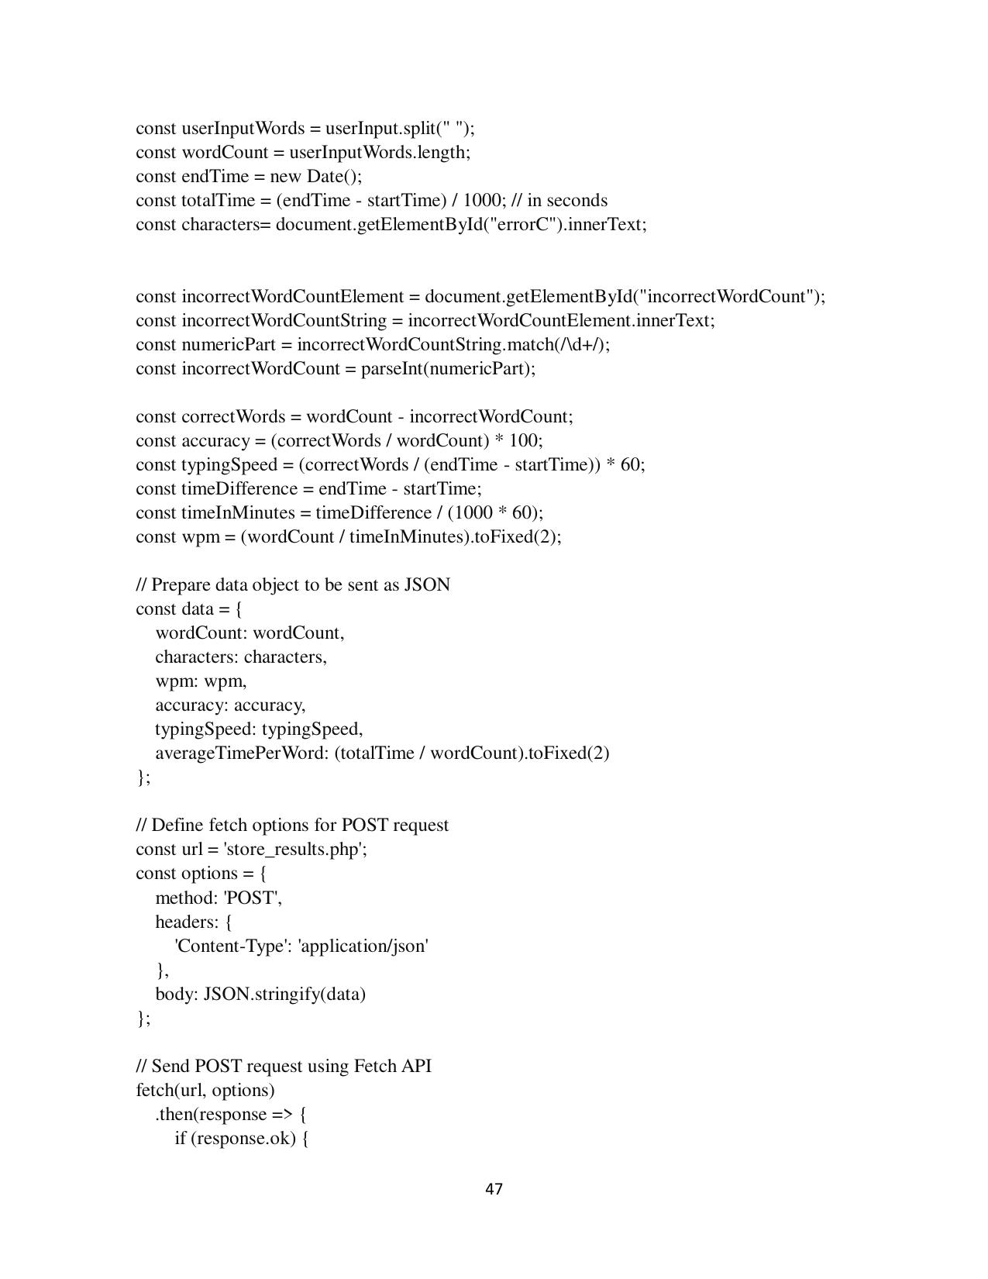

Page 48

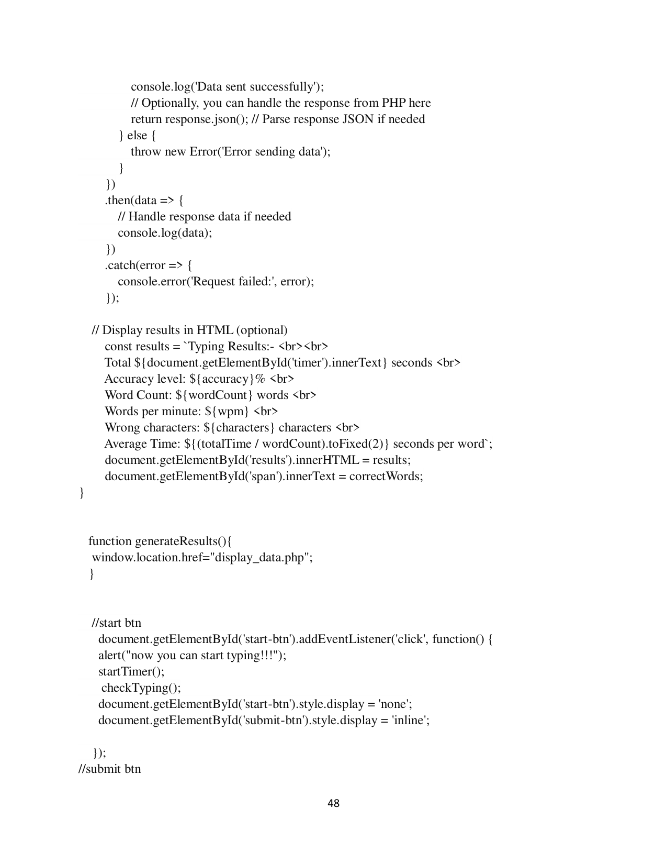

Page 49

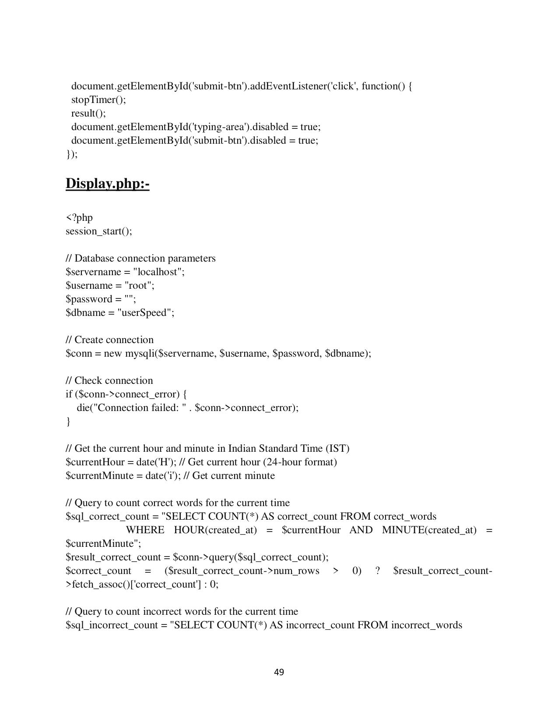

Page 50

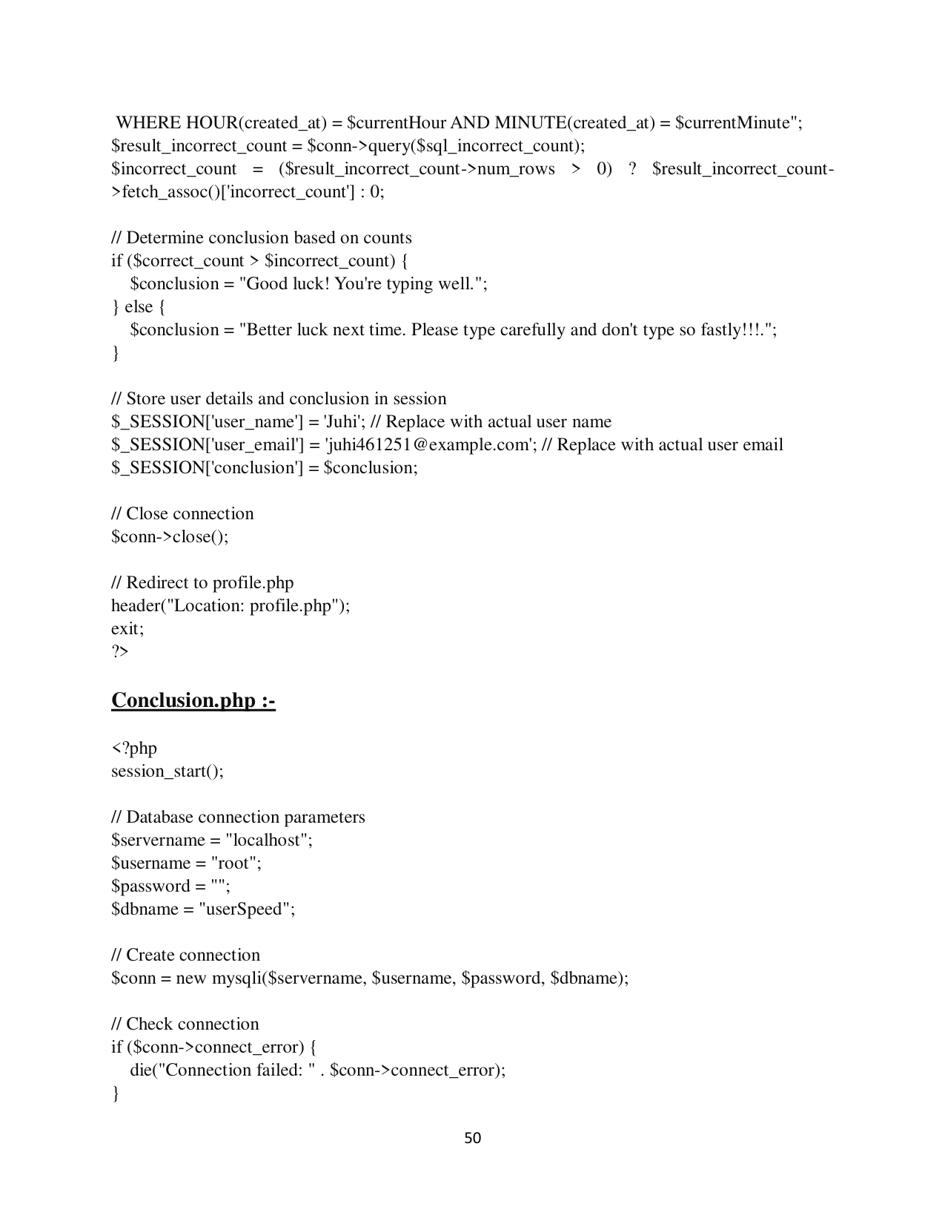

Page 51

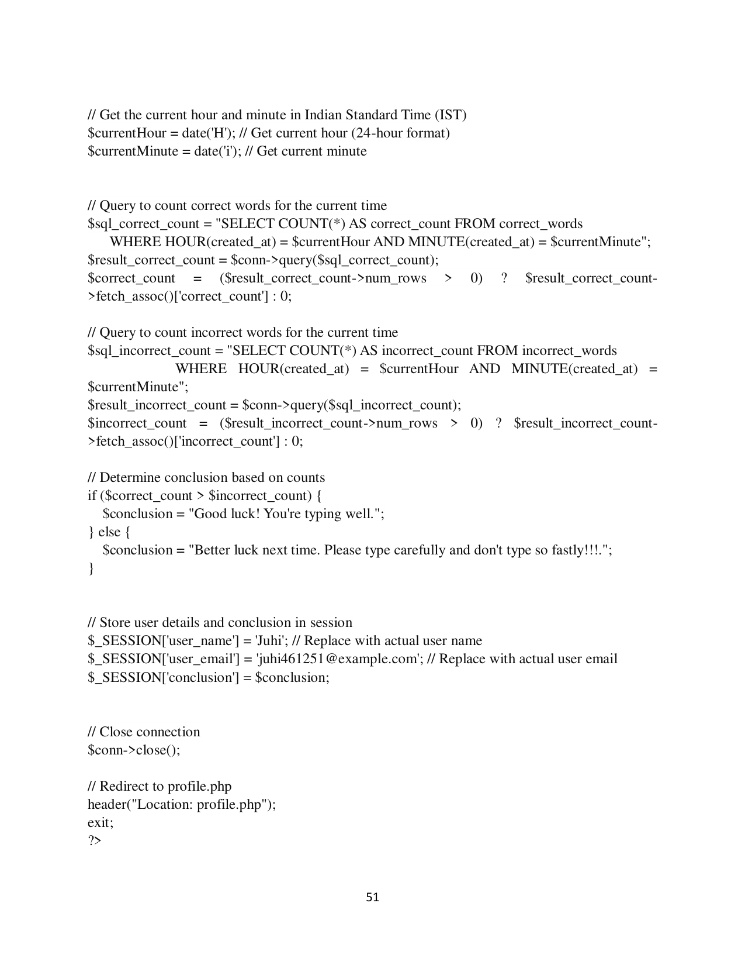

Page 52

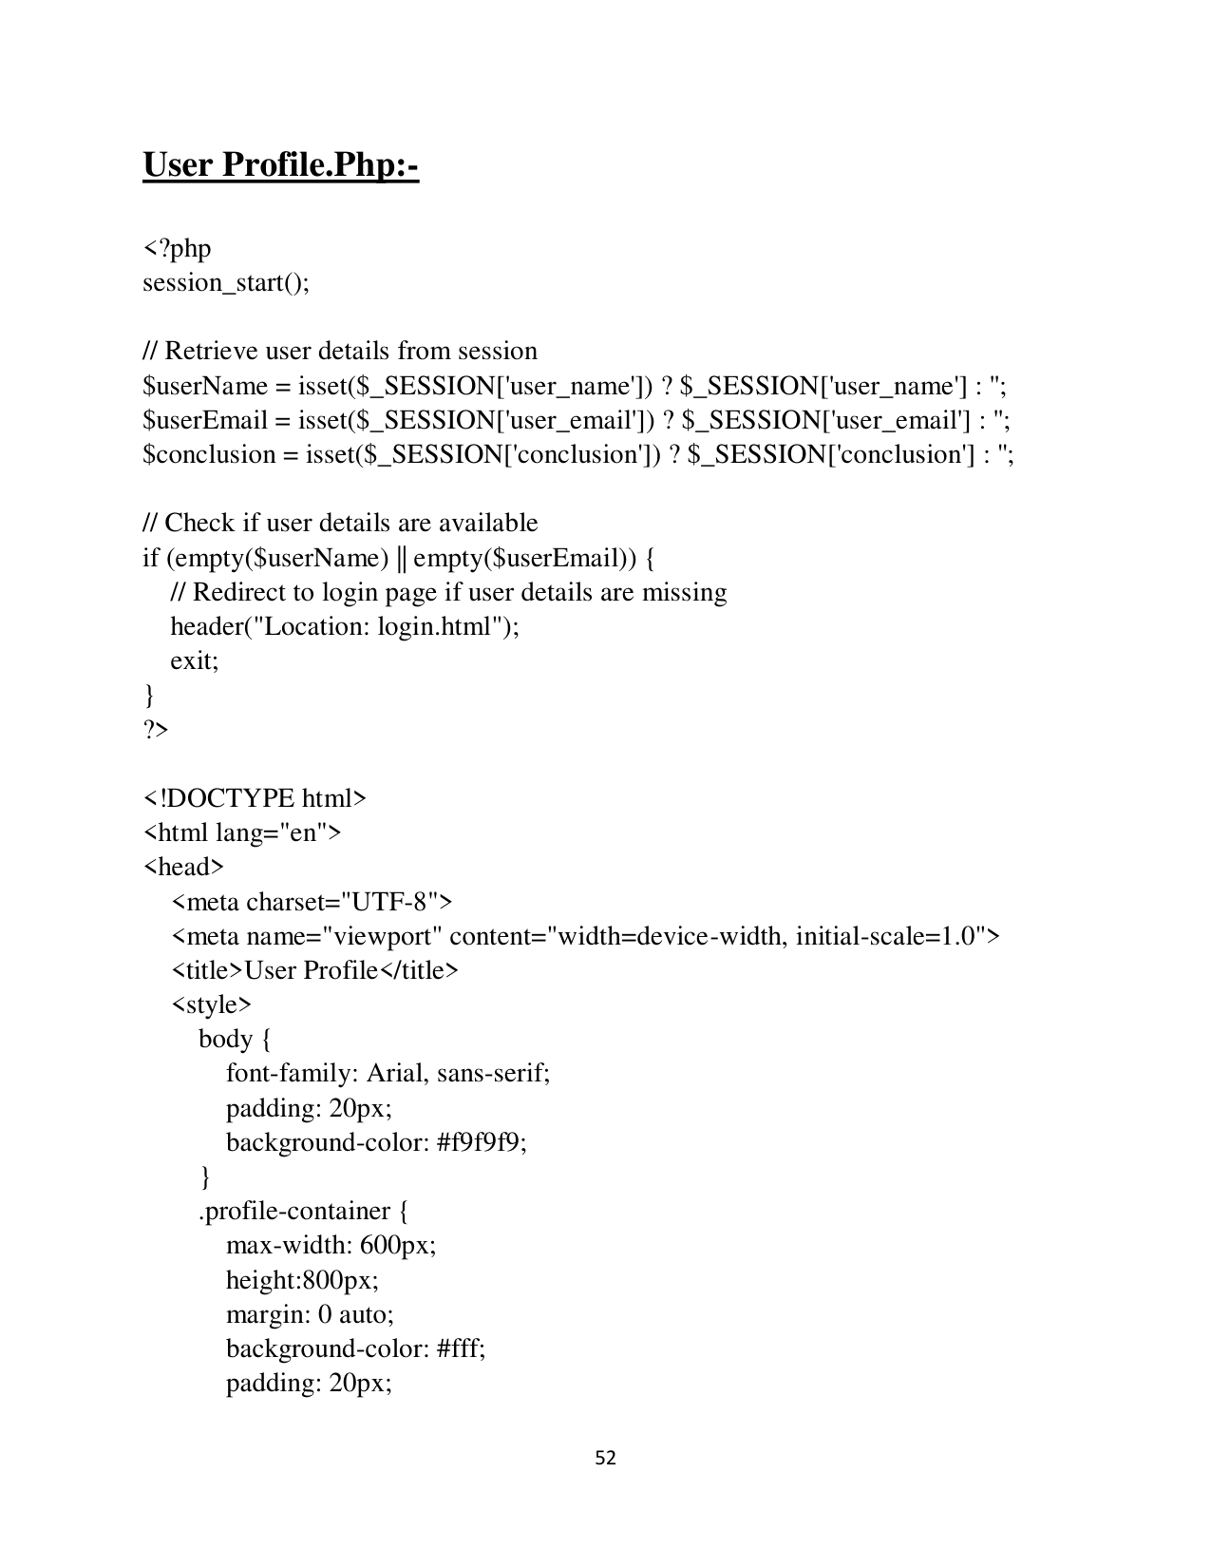

Page 53

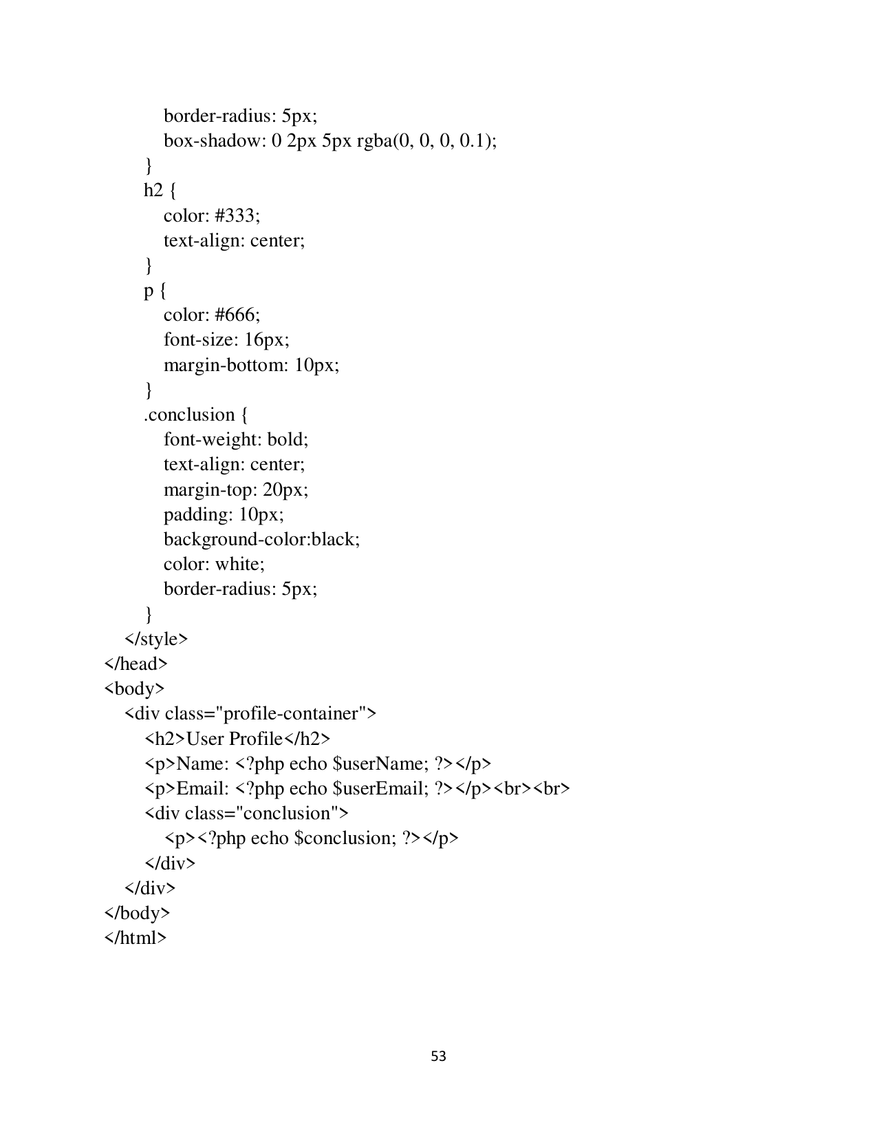

Page 54

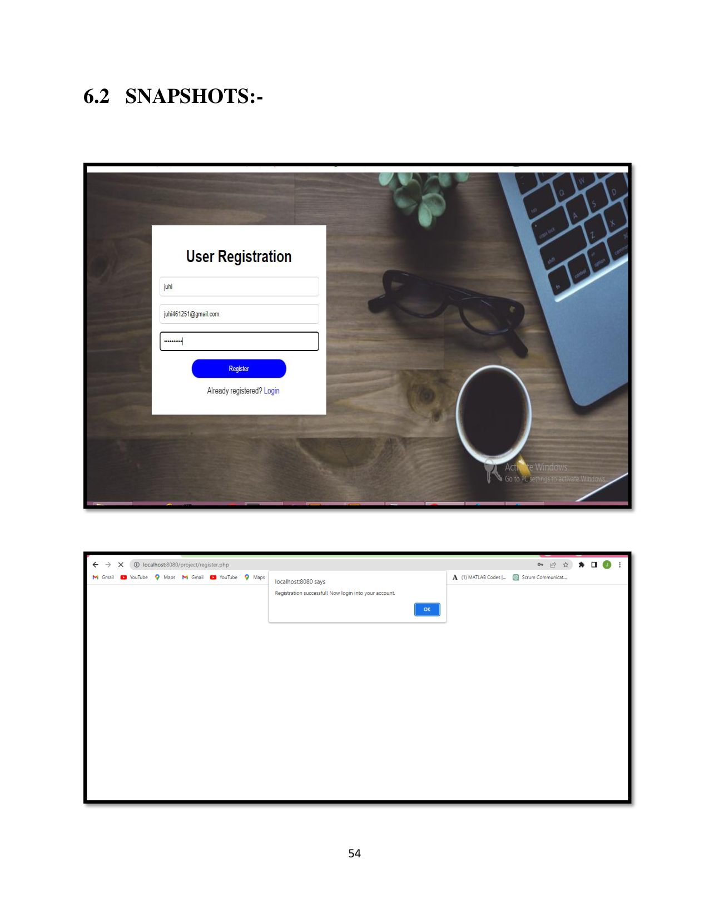

Page 55

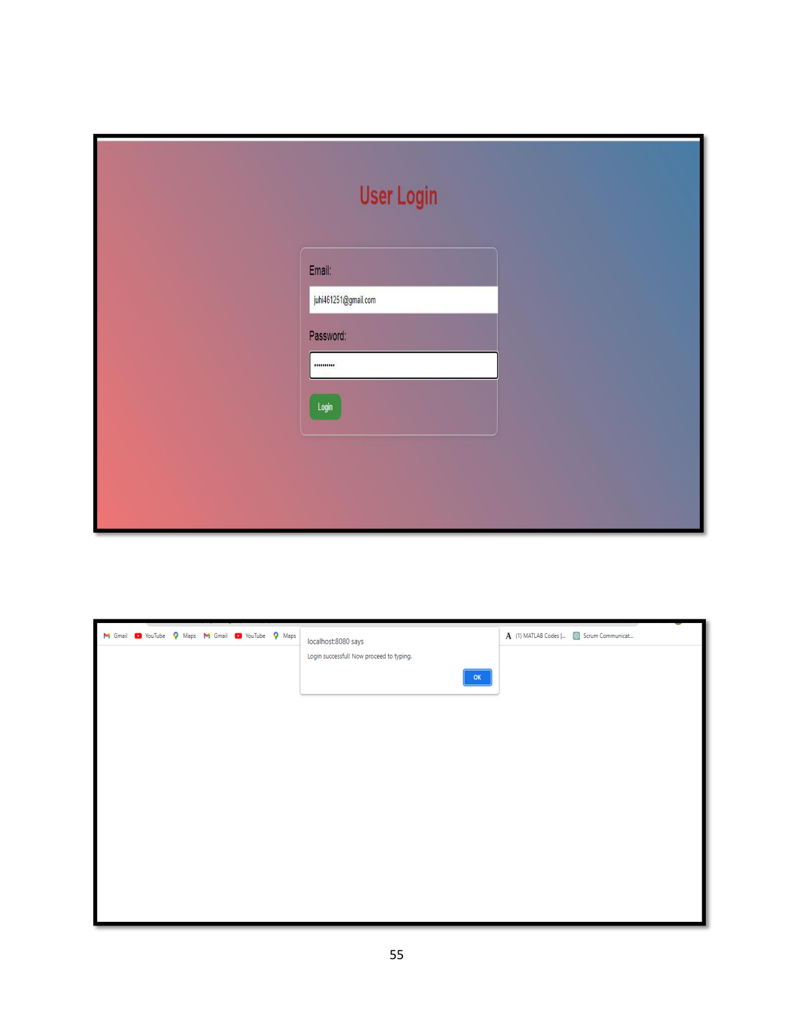

Page 56

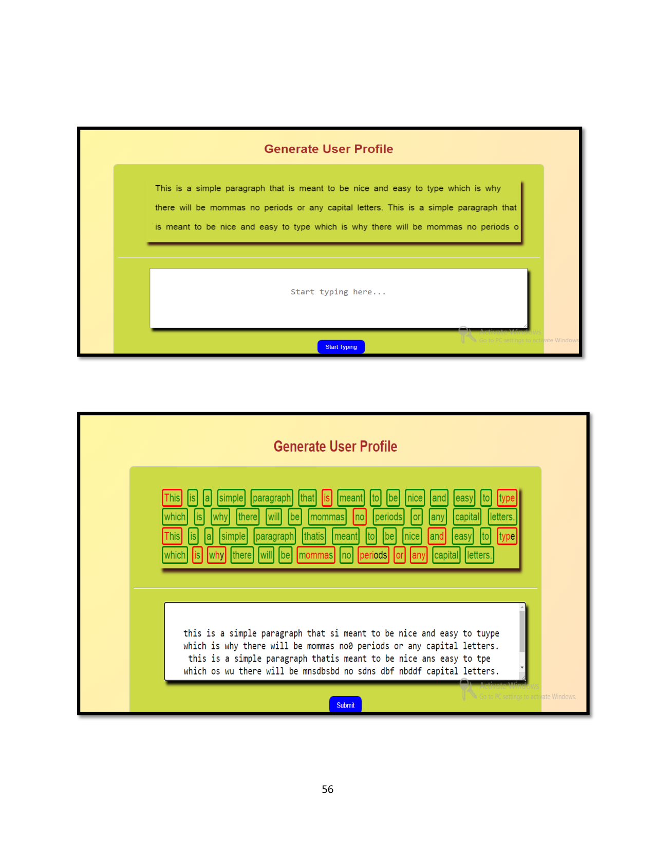

Page 57

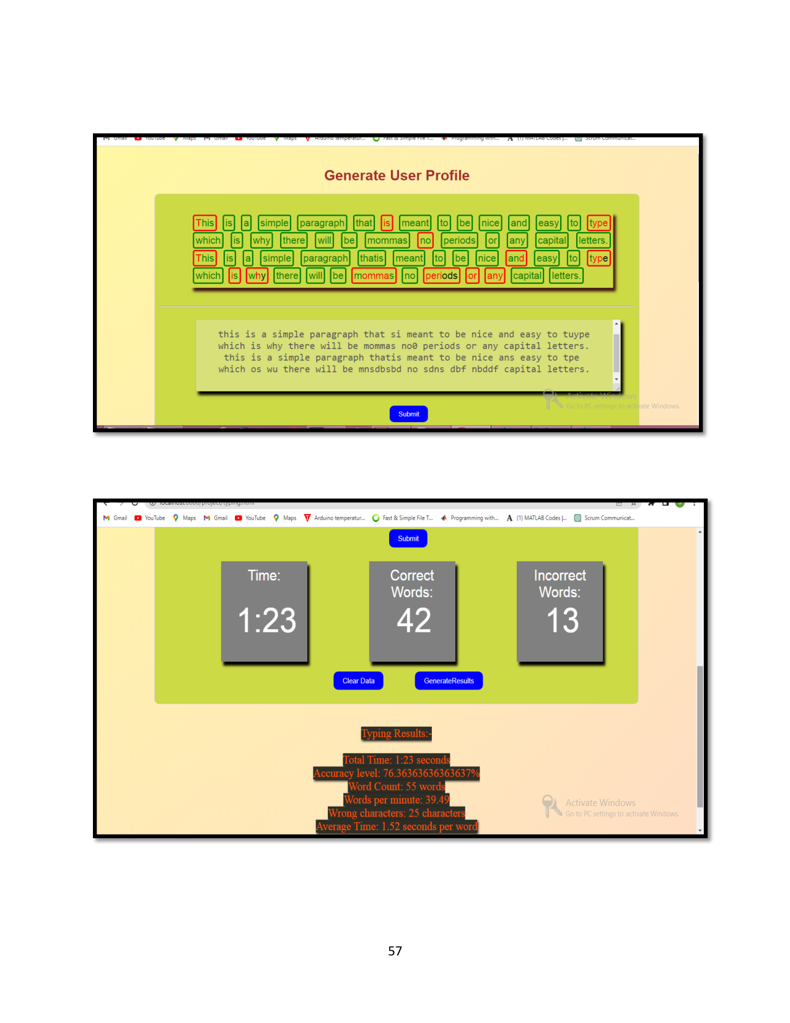

Page 58

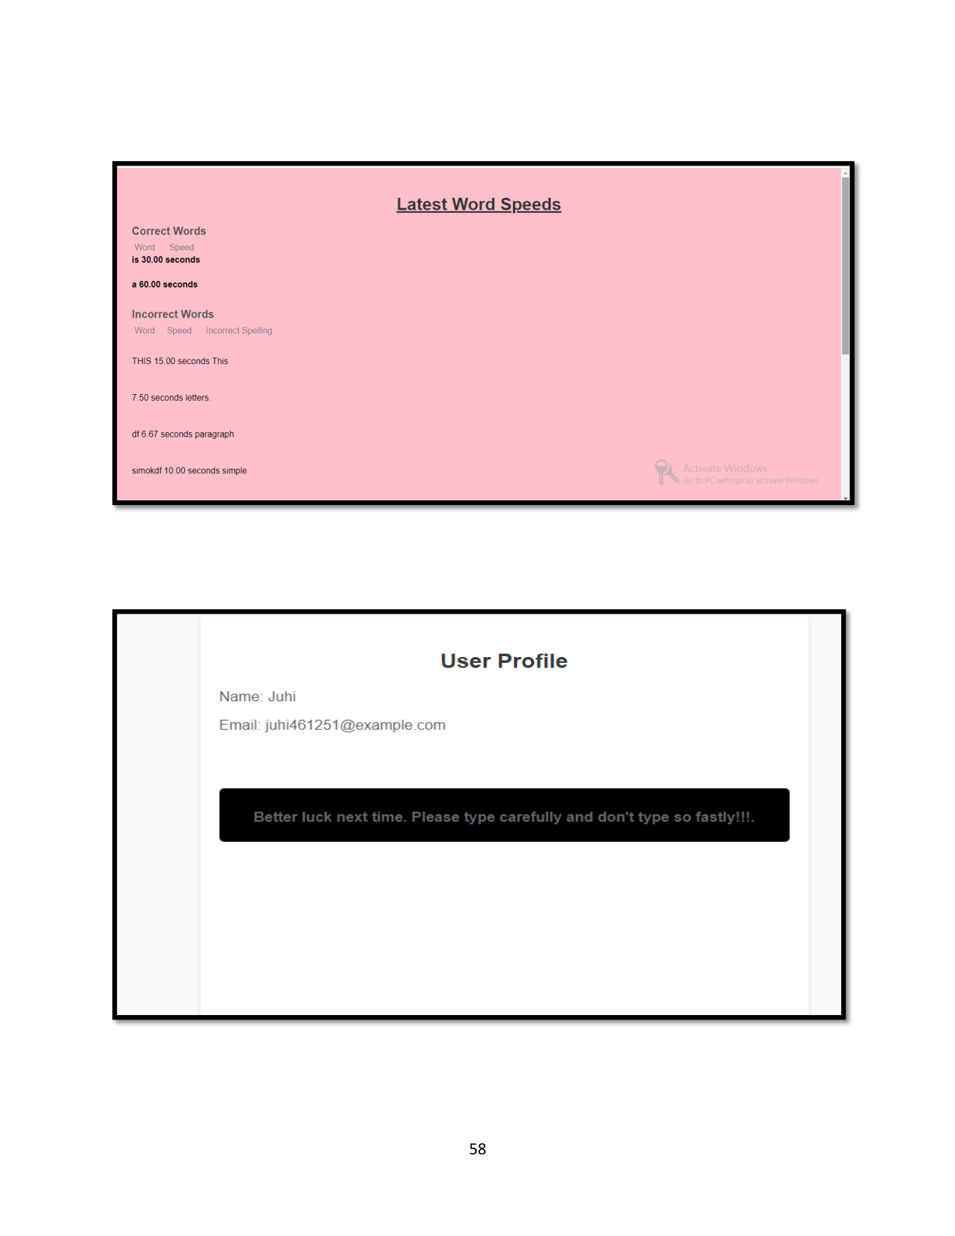

Page 59



Page 60

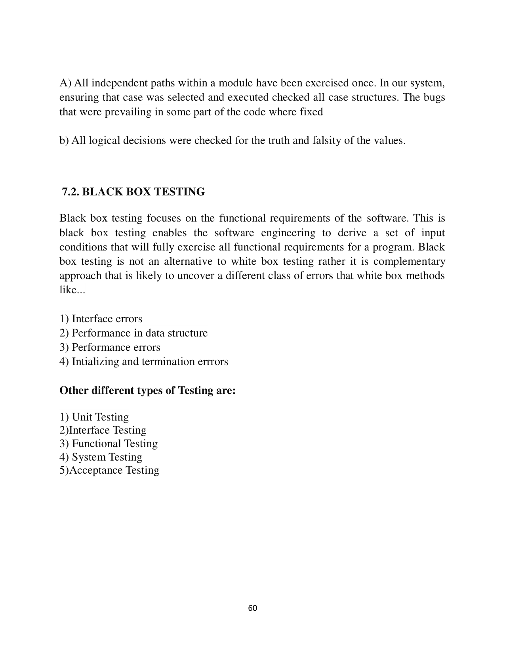

Page 61

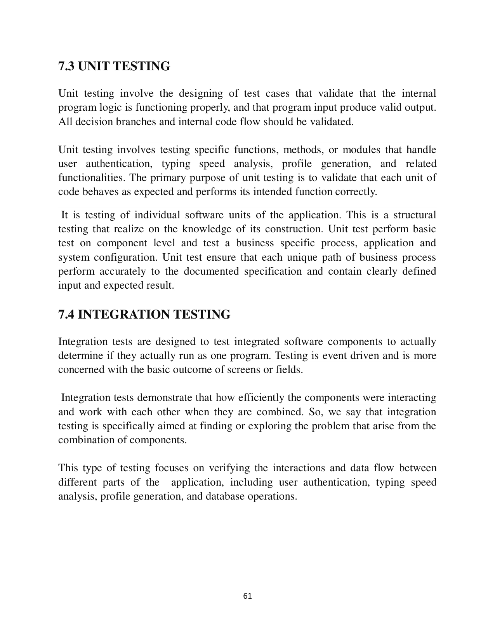

Page 62

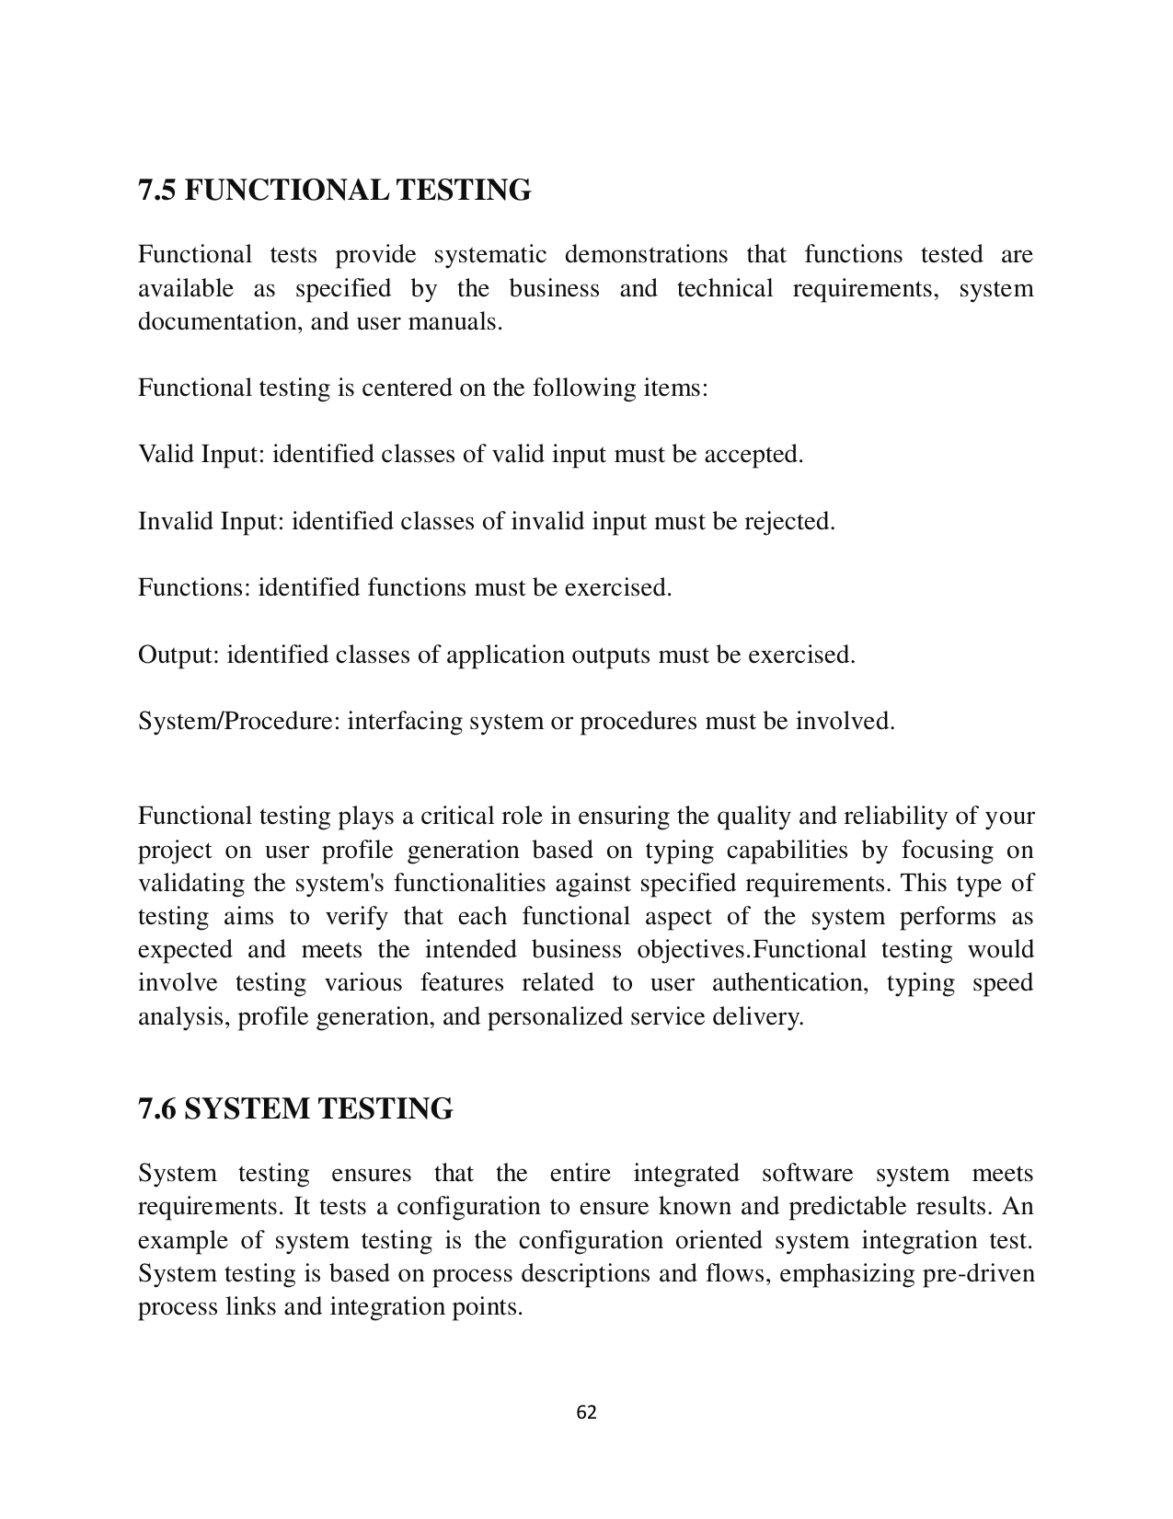

Page 63

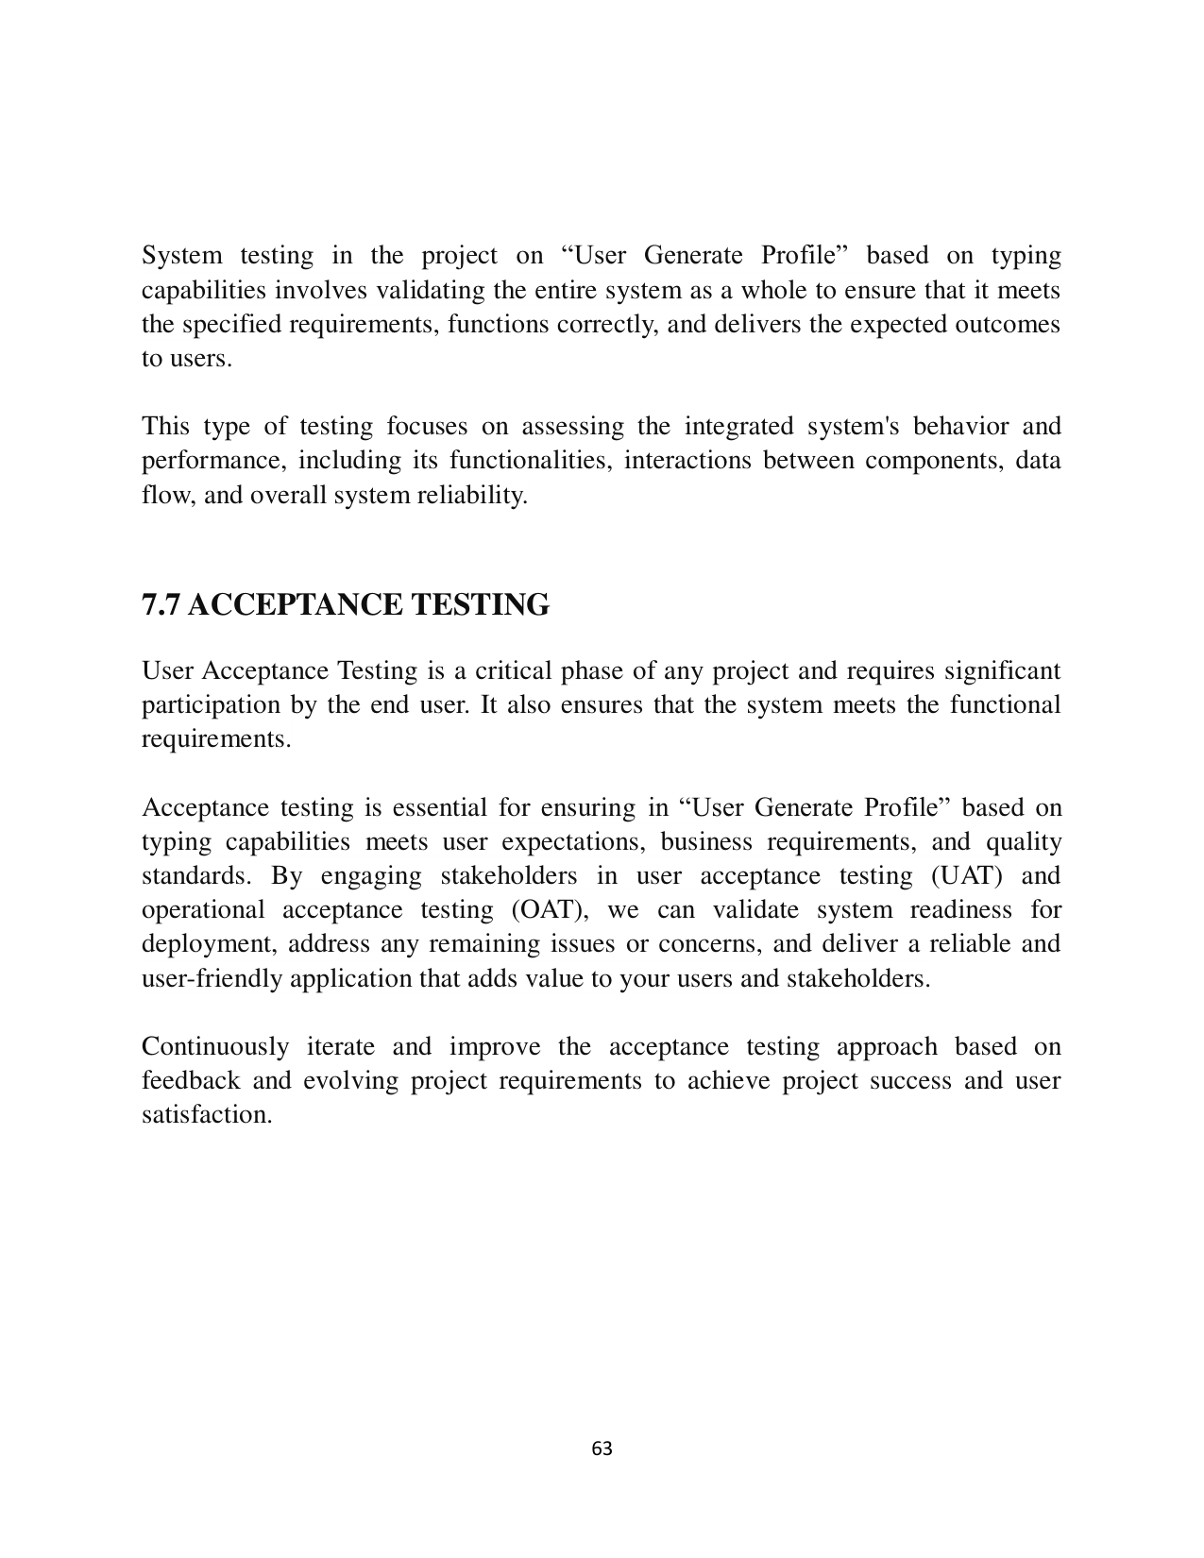

Page 64



Page 65



1   
A   
PROJECT REPORT   
ON   
USER GENERATE PROFILE   
Submitted in partial fulfillment of the   
Requirement for the award of the   
DEGREE   
OF   
MASTER OF COMPUTER APPLICATIONS   
(2023 -2025)   
   
   
   
Under the supervision of: Submitted by:   
Dr. Sukhvinder Singh Deora Juhi   
Assistant Professor MCA - 2ndSem   
DCSA MDU, Rohtak Roll No - 23170   
   
   
DEPARTMENT OF COMPUTER SCIENCE AND APPLICATIONS   
MAHARSHI DAYANAND UNIVERSITY, ROHTAK - 124001

2 DEPARTMENT OF COMPUTER SCIENCE & APPLICATIONS   
MAHARSHI DAYANAND UNIVERSITY ,ROHTAK   
(www.mdurohtak.ac.in )   
(NAAC Accredited ‘A+’ Grade Haryana State University)   
   
   
   
Dr.Preeti Gulia No. MDU/DCS/24/   
HEAD OF DEPARTMENT Date:   
   
CERTIFICATE -cum-DECLARATION   
I, Juhi, hereby declare that the work presented in the Project Report titled “User   
Generate Profile” and submitted as Industry Internship/Project -I as part of MCA   
2nd Semester to Department of Computer Science & Applications, M. D.   
University, Rohtak for the partial fulfillment of the requirement of the award of   
degree od Master Of Computer Science & Applications is an authentic record of   
my work carried out during the MCA 2nd semester (Jan -June, 2024) under the   
supervision of Dr.Sukhvinder Singh Deora, Asst. Professor , Department of   
Computer Science & Applications.   
Further, I also undertake that the matter embodied in this Project Report is my   
own work and has not been submitted by me or by any other candidate for the   
award of any other degree anywhere else.   
   
   
   
   
   
   
Countersigned by Internal Supervisor   
Name: Dr. Sukhvinder Singh Deora   
Designation Asst.Professor, DCSA   
   
 Forwarded by:   
(Head of Department) Student Name – Juhi   
Class: - MCA -2nd Semester   
Roll_No. -23170

3 ACKNOWLEDGEMENT   
   
Acknowledgement is not mere formality but a genuine opportunity to thank all   
those people without that active support in this project would not be able to be   
possible I am thankful to my guide “ Dr.Sukhvinder Singh Deora(Asst.   
Professor), DCSA, MDU, ROHTAK” for his valuable time, exemplary   
guidance, monitoring and constant encouragement throughout the course of this   
thesis. The blessing, help and guidance given by his time to time shall carry me   
a long way in the journey of life on which I am about to embark.   
   
   
I would like to express my sincere gratitude to Dr.Preeti Gulia . Her golden   
words always gave me the inspiration to come out of my tough times,   
professionally as well as personally as well as personally. I also take this   
opportunity to express a deep sense of gratitude to All faculty members of   
Department of Computer Science & Applications , M.D.U, Rohtak for their   
cordial support, valuable information and guidance, which helped me in   
completing this task through various stages.   
   
   
Finally, I also would like to thank my friends and family for always supporting   
me. I’m also grateful to everyone for their unwavering support in all of my   
endeavors .   
   
   
Signature of the student   
Juhi   
MCA 2nd sem   
Roll no. 23170

4 ABSTRACT   
   
This document is meant for describing all the features and procedures   
that were followed while developing the system.   
This document specially mentions the detail of the project how it was   
developed, the primary required as well as various features and   
functionalities of the project and the procedure followed in achieving   
these objectives.   
   
The “USER GENERATE PROFILE” consists of Graphical User   
Interface(GUI), and implemented using Sublime3.0(text editor).   
   
This project of mine is being developed to help users/learners as well   
as beginners to increase their typing capability and enhanced their   
performance as well as reduce the human errors.

5 TABLE OF CONTENTS   
   
   
Chapter Page No.   
1. Introduction to the project 7   
1.1 . Project Introduction 7   
1.2 . Hardware configuration 8   
1.3 . Software Configuration 8   
2. Software Requirement Specifications 9   
2.1. Introduction 9   
2.2. Functional Requirement 10   
2.3. Non- Functional Requirement 11   
3. Feasibility Analysis 12   
3.1. Technical Feasibility 12   
3.2. Economic Feasibility 12   
3.3. Operational Feasibility 13   
4. System Analysis 14   
4.1. System Requirements 14   
4.2. Existing System 15   
4.3. Proposed System 16   
5. System Design 17   
5.1 Database design 20   
5.2 Data flow Diagram 22   
5.3 E-R diagram 24   
6. System Implementation 25   
6.1 Coding 53   
6.2 Snapshot 58

6   
Chapter Page No.   
7. Software Testing 59   
7.1 White box testing 59   
7.2 Black box testing 60   
7.3 Unit testing 61   
7.4 Integration testing 61   
7.5 Functional testing 62   
7.6 System Testing 62   
7.7 Acceptance testing 63   
8. Conclusion 64   
Bibliography 65

7   
   
 CHAPTER -1   
   
 INTRODUCTION OF PROJECT   
   
1.1. PROJECT INTRODUCTION   
   
   
In the realm of user authent ication and profile generation, leveraging typing   
speed as a biometric measure p resents an innovative approach. This project   
aims to explore the feasibility and effectiveness of using typing speed as a   
unique identifier for user authentication and subsequently generating user   
profiles.   
   
In the contemporary landscape of user authentication and personalized digital   
experiences, the project "User Prof ile Generation " seeks to innovate by leveraging   
typing speed as a unique identifier for user profiles.   
   
This project integrates the conventional method of email and password   
authentication with an advanced behavioral biometric approach, focusing on the   
distinctive typing capabilities of individuals to create tailored user profiles.   
   
The motivation behind this project arises from the growing need for enhanced user   
authentication methods that prioritize both security and user convenience.   
Traditional authe ntication systems reliant solely on email and password   
combinations often encounter security vulnerabilities such as password theft and   
phishing attacks.   
   
It represents an individual's cognitive and neuromuscular patterns, inherently   
difficult to replicate or forge. By harnessing this distinct characteristic, the project   
aims to provide a secure and seamless authentication experience while generating   
meaningful user profiles for personalized services.

8   
   
   
1.2. Minimum Hardware Configuration   
   
   
• Processor : Intel Core i3 or equivalent.   
• RAM : 4GB minimum   
• Hard Disk : 20GB   
• Storage : 250GB HDD or 128GB SSD minimum.   
• Monitor : 15.6” Color Monitor   
• Screen Resolution : 1280x 1024 or larger   
   
   
   
 1.3. Minimum Software Configuration   
   
• Operating System : Window 7 or above Version   
• Languages : HTML, CSS, JAVASCRIPT, PHP   
• Text Editor : Visual Studio Code

9   
   
 CHAPTER -2   
   
 SOFTWARE REQUIRMENT SPECIFICATION   
   
4.1- Software Requirement Specification   
   
A Software requirements specification (SRS), a requirements specification for a   
software system, is a complete description of the behaviour of system to be   
developed and may include a set of use cases that describe interactions the users   
will have with software. In addition it al so contains non -functional requirements.   
Non-functional requirements impose constraints on the design standards.   
   
   
• Introduction: -   
   
The Software Requirements Specification (SRS) outlines the detailed functional   
and non -functional requirements for the development of the "User Generate   
Profile " project. This document serves as a comprehensive guide for   
stakeholders, developers, and testers involved in the software development   
lifecycle.   
   
   
   
• Purpose: -   
   
The project aims to develop a system that automatically generates distinct user   
profiles based on users' typing capabilities and patterns. By analyzing typing   
speed, rhythm, accuracy, and other behavioral biometrics, the system will create   
personalized profiles for ea ch user. This approach leverages unique typing   
characteristics as a form of behavioral authentication and a basis for tailoring   
digital experiences.

10   
   
• Scope: -   
   
The scope of this project includes implementing a secure and efficient   
user authentication syste m that incorporates typing speed analysis to   
generate personalized user profiles. The system will capture, analyze,   
and utilize typing speed data for user identification and profile   
creation, enhancing security and user experience.   
   
   
4.2-Hardware and Software Specification   
   
 Hardware Specification   
   
 Server Side   
   
• Processor : 1.0 GHz   
• RAM : 512 MB   
• Hard Disk : 20GB Free Space   
   
 Client Side   
   
• Processor : 2.0 GHz   
• RAM : 4 GB   
• Hard Disk : 20GB Free Space

11   
   
   
 Software Specification   
   
   
 Server Side   
   
• Operating System : Window Server 2008 or newer   
• Front End : HTML,CSS,JAVASCRIPT   
• Back End : PHP MYSQL   
• Other Tools : Visual Studio, Notepad, MS Office   
   
   
   
Client Side   
   
• Operating System : Window 10 newer/older

12   
   
 CHAPTER -3   
   
 FEASIBILITY ANALYSIS   
   
   
Whatever we think need not be feasible. It is wise to think about the feasibility of   
any problem we undertake. Feasibility is the study of impact, which happens in the   
organization by the development of a system. The impact can be either positive or   
negative. When the positives nominate the negatives, then the system is considered   
feasible. Here the feas ibility study can be performed in two ways such as technical   
feasibility and Economical Feasibility.   
   
3.1 TECHNICAL FEASIBILITY   
   
We can strongly say that it is technically feasible, since there will not be much   
difficulty in getting required resources for the development and maintaining the   
system as well. All the resources needed for the development of the software as   
well as the maintenance of the same is available in the organization here we are   
utilizing the resources which are available already.   
   
The technic al feasibility of "User Gener ate Profile " is promising, leveraging   
modern technologies and algorithms to capture, analyze, and utilize typing speed   
data for enhanced user authentication and personalized services. By addressing key   
considerations and challenges, the project can be implemented effectively to   
deliver secure, efficient, and user -centric experiences based on dynamic behavioral   
biometrics   
   
   
3.2 ECONOMICAL FEASIBILITY   
   
From an economic perspective, the project can be deemed feasible given the   
relatively low upfront costs associated with software development and integration   
of typing speed analysis algorithms. The primary investments would include

13   
 development resources for building the authentication sys tem, frontend interface,   
and backend services, as well as ongoing maintenance and operational costs.   
   
   
However, the potential benefits in terms of enhanced user experiences, improved   
security, and personalized service delivery can justify these investment s.   
   
Additionally, leveraging existing open -source libraries and cloud computing   
platforms can optimize costs while ensuring scalability and performance. Overall,   
the economical feasibility hinges on the project's ability to deliver tangible value   
through efficient use of resources and alignment with strategic business objectives.   
   
   
3.3 OPERATION FEASIBILITY :   
   
No doubt the proposed system is fully GUI based that is very user friendly and all   
inputs to be taken all self -explanatory even to a layman. The operation feasibility   
of "User Geenrate Profile " is promising, with considerations for smooth   
integration, user adoption, maintenance, scalability, and security.   
   
By addressing these operational aspects effectively, the project can be successfully   
implemented and integrated into existing operations, contributing to improved user   
experiences and enhanced security measures.

14   
   
 CHAPTER -4   
   
 SYSTEM ANALYSIS   
   
   
   
4.1 SYSTEM REQUIREMENTS   
   
 This system can be used in Windows 98, Windows 2000, Windows XP and   
 Windows NT, supported for other platform.   
   
 The system must be running at least on Windows 98, Windows 98 or Windows   
 NT4.0 operating system and must meet the following hardware requirements.   
   
• For Windows 95 based computers, a 486/66 MHz or higher processor with   
8MB   
   
• For Windows 98 b ased computers. a 500/88MHz or higher processor with   
32 Mb of RAM   
   
• For Windows NT based computers, a 488/66 MHz or higher processor with   
16 MB of RAM   
   
• For Windows 200 based computers, a 700/850 MHz or higher processor   
with 512 MB of RAM

15   
   
4.2 EXISTING SYSTEM   
   
System Analysis is a detailed study of the various operations performed by a   
system and their relationships within and outside of the system. Here the key   
question is - what all problems exist in the present system? What must be done to   
solve the problem? Analysis begins when a user or manager begins a study of the   
program using existing system.   
   
During analysis, data collected on the various files, decision points and   
transactions handled by the present system. The common ly used tools in the   
system are Data Flow Diagram, interviews, etc. Training, experience and common   
sense are required for collection of relevant information needed to develop the   
system.   
   
The success of the system depends largely on how clearly the probl em is defined,   
thoroughly investigated and properly carried out through the choice of solution. A   
good analysis model should provide not only the mechanisms of problem   
understanding but also the frame work of the solution. Thus it should be studied   
thoroug hly by collecting data about the system. Then the proposed system should   
be analyzed thoroughly in accordance with the needs.   
   
• System analysis can be categorized into four parts.   
   
• System planning and initial investigation   
   
• Information Gathering   
   
• Applying a nalysis tools for structured analysis   
   
• Feasibility study   
   
• Cost/Benefit analysis.

16   
   
Our previous user profile generation system, while functional, had several notable   
limitations that hindered its effectiveness and user experience. One of the primary   
issues with the legacy system was its reliance on static user inputs and the absence   
of dynamic behavioral biometrics, such as typing speed, to create personalized   
profiles.   
   
The older system operated on conventional authentication methods like email and   
password combinations, which, although widely used, lacked the sophistication   
needed to deliver truly personalized experiences. User profiles were primarily   
generated based on static information provided during registration, resulting in   
generic profiles th at did not adequately reflect individual user behaviors or   
preferences.   
   
   
4.3 PROPOSED SYSTEM   
   
The project aims to create a secure and pers onalized user generate profile system   
based on typing speed analysis. It involves integrating traditional email/password   
authentication with behavioral biometrics (typing speed) to generate unique user   
profiles for personalized digital experiences.   
   
   
• User Authentication   
• Typing Speed An alysis   
• Usser Profile Generation   
• User Dashboard   
   
The system analysis of "User Profile Generation Based on Typing Speed" outlines   
the functional and non -functional requirements, system components, data flow, and   
architecture necessary for its successful impl ementation.   
   
By addressing these aspects comprehensively, the project can deliver a secure,   
efficient, and user -centric authentication system integrated with personalized user   
profiles based on typing speed characteristics .

17   
   
   
 CHAPTER -5   
   
 SYSTEM DESIGN   
   
INPUT DESIGN   
   
Input design is the process of converting user -oriented input to a computer based   
format. Input design is a part of overall system design, which requires very careful   
attention. Often the collection of input data is the most expensive part of the   
system. The main objectives of the input design are   
   
1. Produce cost effective method of input   
   
2. Achieve highest possible level of accuracy   
   
3. Ensure t hat the input is acceptable to and understood by the staff.   
   
Input Data   
   
The goal of designing input data is to make enter easy, logical and free from errors   
as possible. The entering data entry operators need to know the allocated space for   
each field; fi eld sequence and which must match with that in the source document.   
The format in which the data fields are entered should be given in the input form.   
Here data entry is online; it makes use of processor that accepts commands and   
data from the operator thr ough a key board. The input required is analyzed by the   
processor. It is then accepted or rejected. Input stages include the following   
processes.   
   
• Data Recording   
   
• Data Transcription   
   
• Data Conversion

18   
   
• Data Verification   
   
• Data Control   
   
• Data Transmission   
   
• Data Correction   
   
   
One of the aims of the system analyst must be to select data capture method and   
devices, which reduce the number of stages so as to reduce both the changes of   
errors and the cost. Input types, can be characterized as.   
   
• External   
   
• Internal   
   
• Operational   
   
• Computerized   
   
• Interactive   
   
Input files can exist in document form before being input to the computer. Input   
design is rather complex since it involves procedures for capturing data as well as   
inputting it to the computer.

19   
   
   
OUTPUT DESIGN   
   
   
Outputs from computer systems are required primarily to communicate the results   
of processing to users. They are also used to provide a permanent copy of these   
result for latter consultation. Computer output is the most important and direct   
source of information to the users. Designing computer output should proceed in   
an organized well throughout the manner. The right output must be available for   
the people who find the system easy to use. The outputs have been defined during   
the logical design st age. If not, they should have defined at the beginning of the   
output designing terms of types of output connect, format, response etc.   
   
Various types of outputs are   
   
• External outputs   
   
• Internal outputs   
   
• Operational outputs   
   
• Interactive outputs   
   
• Turn around outputs   
   
All screens are informative and interactive in such a way that the user can full fill   
his requirements through asking queries.

20   
   
   
   
 5.1-DATABASE DESIGN   
   
   
The general theme behind a database is to handle information as an integrated   
whole. A database is a collection of interrelated data stored with minimum   
redundancy to serve many users quickly and effectively. After designing input and   
output, the analyst must concentrate on database design or how data should be   
organized around user requirements. The general objective is to make information   
access, easy quick, inexpensive and flexible for other users. During database   
design the follo wing objectives are concerned: -   
   
• Controlled Redundancy   
   
• Data independence   
   
• Accurate and integrating   
   
• More information at low cost   
   
• Recovery from failure   
   
• Privacy and security   
   
• Performance   
   
• Ease of learning and use

21   
   
   
   
The database is essential for your project as it serves as the central repository for   
user-related data, typing speed metrics, and generated profiles. It enables secure   
authentication, personalized services, data analysis, and compliance with   
regulatory requirements. By leveraging the database effectively, your project can   
deliver a robust and user -centric solution for user profile g eneration based on   
typing capabilities while ensuring data security, integrity, and scalability.   
   
   
   
   
   
   
   
   
   
   
   
 PHP DATABASE

22   
   
   
   
 5.2-DFD(Data Flow Diagram)   
   
   
DFD illustrates the flow of data and processes in your project, emphasizing user   
authentication, typing speed analysis, profile generation, and data storage in the   
database.   
   
 It provides a structured view of how the system components interact and how data   
moves through the system to achieve the goal of generating user profiles based on   
typing capabilities. Customize this DFD further based on specific processes,   
interactions, a nd data flows relevant to your project's requirements and   
functionalities.

23   
   
   
   
   
   
 In the above representation:   
   
• User: Represents the external entity (user) interacting with the system.   
• Authentication Process: Validates user credentials and captures typing speed   
data.   
• Typing Speed Analysis Process: Analyzes typing speed data to extract   
behavioral biometrics.   
• Database: Stores user data, typing speed metrics, and generated profiles.

24   
 5.3-E-R DIAGRAM   
   
   
ER diagram illustrates the structure of the database schema for your project,   
highlighting the entities (User, TypingSession, UserProfile) and their attributes.   
The relationships (one -to-many and one -to-one) between entities define how data   
is organized and linked within the database.   
   
 Customiz e this ER diagram based on specific requirements and additional   
attributes relevant to your project's functionalities and data storage needs. You can   
use software tools like Microsoft Visio, Lucidchart, or draw.io to create a visual   
representation of this ER diagram for better understanding and documentation of   
your database design.

25   
   
 CHAPTER -6   
   
 SYSTEM IMPLEMENTATION   
   
Registration.html :-   
   
   
<!DOCTYPE html>   
<html lang="en">   
<head>   
 <meta charset="UTF -8">   
 <meta name="viewport" content="width=device -width, initial -scale=1.0">   
 <title>User Registration</title>   
 <link rel="stylesheet" href="Registration.css">   
 <script>   
 function showAlertAndRedirect(event) {   
 event.preventDefault(); // Prevent default form submission   
   
 // Get form inputs   
 var fullNameInput = document.querySelector('input[name="fullname"]');   
 var emailInput = document.querySelector('input[name="email"]');   
 var password Input = document.querySelector('input[name="password"]');   
   
 // Validate form inputs   
 if (fullNameInput.value.trim() === '' || emailInput.value.trim() === '' ||   
 passwordInput.value.trim() === '') {   
 alert("Please fill in all the fields.");   
 return;   
 }   
   
 // Validate password requirements   
 var passwordValue = passwordInput.value.trim();   
 if (passwordValue.length < 8 || !containsUpperCase(passwordValue) ||   
 !containsLowerCase(passwordValue)) {

26   
 alert("Password must be at least 8 characters long and contain both uppercase   
and   
 lowercase letters.");   
 return;   
 }   
   
 // Check if the email is already registered (Client -side validation)   
 var registeredEmails = JSON.parse(localStorage.getItem('registeredEmails')) ||   
[];   
 if (registeredEmails.includes(emailInput.value.trim())) {   
 alert("Ema il already registered. Please use a different email address.");   
 return;   
 }   
   
 // Store the email in local storage to simulate registered emails (For   
demonstration)   
 registeredEmails.push(emailInput.value.trim());   
 localStorage.setItem('registeredEmails', JSON.stringify(registeredEmails));   
   
 // Registration success message and redirect to login page   
 alert("Registration successful! Now login into your account.");   
 window.location.href = "login.html" ;   
 }   
   
 // Helper function to check if string contains at least one uppercase letter   
 function containsUpperCase(str) {   
 return /[A -Z]/.test(str);   
 }   
   
 // Helper function to check if string contains at least one lowercase letter   
 function containsLowerCase(str) {   
 return /[a -z]/.test(str);   
 }   
 </script>   
</head>   
<body>   
 <div class="container">

27   
 <h1>User Registration</h1>   
 <form id="registrationForm" action="Regist ration .php" method="post">   
 <input type="text" name="fullname" placeholder="Full Name" required>   
 <input type="email" name="email" placeholder="Email" required>   
 <input type="password" name="password" placeholder="Password"   
required>   
 <button type="submit" >Register</button>   
 <p>Already registered? <a href="login.html">Login</a></p>   
 </form>   
 </div>   
</body>   
</html>   
   
   
Registration.css :-   
   
body {   
 font-family: Arial, sans -serif;   
 margin: 0;   
 padding: 0;   
   
 background -image: url("images.jpeg");   
 background -repeat: no -repeat;   
 background -size: cover;   
 width:100%;   
 height: 100%;   
}   
   
.container {   
 max-width: 400px;   
 margin: 100px auto;   
 background -color: #fff;   
 padding: 20px;   
 border -radius: 8px solid black;   
 box-shadow: 0 0 10px rgba(0, 0, 0, 0.1);   
 float:left;   
 margin -left:12%;

28   
 }   
   
h1 {   
 text-align: center;   
 margin -bottom: 20px;   
}   
   
input[type="text"],   
input[type="email"],   
input[type="password"],   
button {   
 width: 95%;   
 padding: 10px;   
 margin -bottom: 15px;   
 border: 1px solid #ccc;   
 border -radius: 5px;   
}   
   
button {   
 background -color: blue;   
 color: #fff;   
 cursor: pointer;   
 border -radius: 20px;   
 width:60%;   
 margin -left: 20%;   
}   
   
button:hover {   
 background -color:brown;   
}   
   
.hidden {   
 display: none;   
}   
   
#successMessage {   
 text-align: center;

29   
 background -color: #28a745;   
 color: #fff;   
 padding: 10px;   
 border -radius: 5px;   
 margin -bottom: 15px;   
}   
p{   
 font-family: Arial, sans -serif;   
 margin -left: 30%;   
 margin -top: 0%;   
}   
a{   
 text-decoration:none;   
 color:blue;   
}   
   
p{   
 font-family: Arial, sans -serif;   
}   
   
Registration.php :-   
   
<?php   
// Check if form is submitted via POST method   
if ($_SERVER["REQUEST_METHOD"] == "POST") {   
 // Retrieve and sanitize form data   
 $fullname = isset($_POST['fullname']) ? htmlspecialchars($_POST['fullname'])   
: '';   
 $email = isset($_POST['email']) ? htmlspecialchars($_POST['email']) : '';   
 $passwo rd = isset($_POST['password']) ? $_POST['password'] : '';   
   
 // Validate form inputs   
 if (empty($fullname) || empty($email) || empty($password)) {   
 die("Please fill in all the fields.");   
 header("Location: registration.html");   
 }

30   
 // Validate email format   
 if (!filter_var($email, FILTER_VALIDATE_EMAIL)) {   
 die("Invalid email format.");   
 header("Location: registration.html");   
 }   
   
 // Validate password requirements (at least 8 characters with uppercase,   
 lowercase, and numeric characters)   
   
 if (strlen($password) < 8 || !preg_match("#[A -Z]+#", $password) ||   
 !preg_match("#[a -z]+#", $password) || !preg_match("#[0 -9]+#", $password))   
{   
 die("Password must be at least 8 characters long and contain uppercase,   
 lowercase, and numeric characters.");   
 header("Location: registration.html");   
 }   
   
 // Database connection parameters   
 $servername = "localhost";   
 $username = "root";   
 $dbpassword = ""; // Replace with your database password   
 $dbname = "userdatabase"; // Replace with your desired database name   
   
 // Create connection   
 $conn = new mysqli($servername, $username, $ dbpassword, $dbname);   
   
 // Check connection   
 if ($conn ->connect_error) {   
 die("Connection failed: " . $conn ->connect_error);   
 }   
   
 // Hash the password for security   
 $hashedPassword = password_hash($password, PASSWORD_DEFAULT);   
   
 // Prepare and execute SQL statement to insert data into the 'users' table   
 $sqlInsertUser = "INSERT INTO users (fullname, email, password) VALUES   
 (?, ?, ?)";

31   
 $stmtInsert = $conn ->prepare($sqlInsertUser);   
 $stmtInsert ->bind_param("sss", $fullname, $email, $hashedPassword);   
   
 if ($stmtInsert ->execute()) {   
 // Registration successful   
 echo "Registration successful! Now login into your account.";   
   
 // Close prepared statement and database connection   
 $stmtInsert ->close();   
 $conn ->close();   
   
 // Use JavaScript to show alert and redirect   
 echo '<script>alert("Registration successful! Now login into your account.");   
 window.location.href = "login .html";</script>';   
 exit; // Stop further PHP execution   
   
 }   
 else {   
 // Error in SQL query   
 echo "Error: " . $stmtInsert ->error;   
 }   
   
 // Close prepared statement and database connection   
 $stmtInsert ->close();   
 $conn ->close();   
 }   
 else {   
 // Redirect to the registration page if accessed directly without form submission   
 header("Location: registration.html");   
 exit;   
 }   
 ?>

32   
 Login.html :-   
   
<!DOCTYPE html>   
<html lang="en">   
<head>   
 <meta charset="UTF -8">   
 <meta name="viewport" content="width=device -width, initial -scale=1.0">   
 <title>User Login</title>   
 <link rel="stylesheet" href="login.css">   
 </head>   
 <body>   
 <h2><center>User Login</center></h2>   
 <form action="login -process.php" method="post">   
 <div>   
 <label for="email">Email:</label>   
 <input type="email" id="email" name="email" required>   
 </div>   
 <div>   
 <label for="password">Password:</label>   
 <input type="password" id="password" name="password" required>   
 </div>   
 <button type="submit">Login</button>   
 </form>   
 </body>   
 </html>   
   
   
 Login.css :-   
   
   
 body {   
 font-family: Arial, sans -serif;   
 background:linear -gradient(45deg,rgba(245,70,66,0.75),rgba(8,80,136,0.75));   
 background -size:cover;   
 background -repeat: no -repeat;   
 background -attachment: fixed;   
}

33   
 form {   
 font-size: 18px;   
 width: 30%;   
 margin: 50px auto;   
 padding: 20px;   
 border: 1px solid #ccc;   
 border -radius: 10px;   
 box-shadow: 0 0 10px rgba(0, 0, 0, 0.1);   
   
}   
   
label {   
 display: block;   
 margin -bottom: 10px;   
}   
h2{   
 color:brown;   
 font-size: 34px;   
 margin -bottom: 5px;   
}   
input[type="email"], input[type="password"] {   
 width: 100%;   
 padding: 10px;   
 margin -bottom: 20px;   
 border: 1px solid #ccc;   
}   
   
button {   
 background -color: #3e8e41;   
 color: #fff;   
 padding: 10px 20px;   
 border: none;   
 border -radius: 10px;   
 cursor: pointer;   
}   
   
button:hover {   
 background -color: red ;   
}

34   
 Login -Process.php: -   
   
   
<?php   
// Database connection parameters   
$servername = "localhost";   
$username = "root";   
$password = ""; // Replace with your database password   
$dbname = "userdatabase"; // Replace with your desired database name   
   
// Create connection   
$conn = new mysqli($servername, $username, $password, $dbname);   
   
// Check connection   
if ($conn ->connect_error) {   
 die("Connection failed: " . $conn ->connect_error);   
}   
   
// Check if form is submitted via POST method   
if ($_SERVER["REQUEST_METHOD"] == "POST") {   
 // Retrieve form data   
 $email = isset($_POST['email']) ? $_POST['email'] : '';   
 $password = isset( $_POST['password']) ? $_POST['password'] : '';   
   
 // Validate email and password   
 if (empty($email) || empty($password)) {   
 die("Please enter both email and password.");   
 }   
   
 // Fetch user record from database based on email   
 $sql = "SELECT * FROM users WHERE email = ?";   
 $stmt = $conn ->prepare($sql);   
 $stmt ->bind_param("s", $email);   
 $stmt ->execute();   
 $result = $stmt ->get_result();   
   
 if ($result ->num_rows > 0) {   
 // User found, verify password   
 $row = $result ->fetch_assoc();   
 $storedPassword = $row['password'];   
   
 // Verify password   
 if ($password === $storedPassword) {

35   
 // Password is correct, login successful   
 session_start();   
 $_SESSION['user_id'] = $row['id']; // Store user ID in session (if needed)   
 echo '<script>alert("Login successful! Now proceed to typing."); window.location.href =   
 "typing.html";</script>';   
 exit;   
 }   
 else {   
 // Incorrect password   
 echo "Incorrect email or password. Please try again.";   
 }   
 }   
 else {   
 // User not found   
 echo "User with this email does not exist.";   
 }   
   
 $stmt ->close();   
 }   
 else {   
 // Redirect to login page if accessed directly   
 header("Location: login.html");   
 exit;   
}   
   
$conn ->close();   
?>   
   
TYPING.HTML :-   
   
<!DOCTYPE html>   
<html lang="en">   
<head>   
 <meta charset="UTF -8">   
 <meta name="viewport" content="width=device -width, initial -scale=1.0">   
 <title>Type Writer</title>   
 <link rel="stylesheet" href="styles.css">   
</head>   
<body>   
 <div><br>   
 <h1><center> Generate User Profile </center></h1>   
 <div class="container">   
 <div class="typing -container">

36   
 <p id="text -to-type"><marquee>This is a simple paragraph that is meant to be nice and easy   
to type which is why </marquee> <marquee>there will be mommas no periods or any capital   
letters. This is a simple paragraph that </marquee><marquee> is meant to be nice and easy to   
type which is why there will be mommas no periods or any capital letters.</marquee>   
 </p>   
 <hr id="hr">   
 <div id="inputText"></div>   
 <textarea id="typing -area" placeholder="Start typing here..."></textarea>   
 </div><br>   
 <button id="start -btn">Start Typing</button>&nbsp;&nbsp;   
 <button id="submit -btn" style="display: none;">Submit</button> &nbsp;&nbsp;   
 <br><br>   
 <div id="timer">Time:<br><br>   
 <span id ="time"> </span>   
 </div>   
 <span id="correctWordCount">Correct Words:<br>   
 <span id="span"></span></span>   
 <span id="incorrectWordCount">Incorrect Words:<br>   
 <span id="spani"></span></span>   
 <button id="reset" onclick="resetall()">Clear Data </button> &nbsp;&nbsp;   
 <button id="generateProfile" onclick="generateResults() " >GenerateResults </button>   
<br><br>   
   
 </div>   
<br><br>   
<p id="resu lts">   
 <br>   
 <div id="resultsContainer">   
 <div id="incorrect -words -container"></div>   
 <div id="correct -words -container"></div>   
 <div id="correctSpelling"></div>   
 </div>   
 </p>   
 <div id="errorC"></div>   
</div>   
   
<scrip t src="typing.js"></script>   
</body>   
</html>

37   
 TYPING.CSS :-   
   
 body {   
 font-family: Arial, sans -serif;   
 background: radial -gradient(circle, #4facfe, #00f2fe);   
 background: linear -gradient(135deg, #f6d365 0%, #fda085 100%),   
 radial -gradient(circle at top left, #f6d365 0%, #fda085 100%);   
 background -blend -mode: screen;   
   
 color: white;   
 text-align: center;   
   
   
   
}   
   
.container {   
 width: 80%;   
 height:70%;   
 margin: 10px auto;   
 padding: 10px;   
 border: 1px solid #ccc;   
 background -color: #ccda46;   
   
   
   
   
 border -radius: 10px;   
 box-shadow: 1 1 10px rgba(151, 62, 62, 0.1);   
   
}   
   
textarea {   
 padding: 50px;   
 width: 80%;   
 text-align: center;   
 height: 60px;   
 box-shadow: black 6px 8px 6px;   
 margin -left: 50px;   
 font-size: 22px;   
 margin -top:20px;   
   
}

38   
   
#timer,#correctWordCount,#incorrectWordCount {   
 background -color: grey;   
 height: 180px;   
 width: 170px;   
 margin -left: 13%;   
 padding: 12px;   
 box-shado w: black 5px 8px 5px;   
 font-size: 30px;   
 margin -bottom: 10px;   
 float:left;   
 border -radius: 5px solid red;   
 margin -top: 10px;   
}   
   
button {   
 padding: 10px 20px;   
 background -color:blue;   
 color: #fff;   
 margin -left: 5%;   
 border: none;   
 cursor: pointer;   
 display: inline;   
 align -items: center;   
 font-size:15px;   
 margin -top: 10px;   
 border -radius: 10px;   
}   
   
#start -btn{   
display:inline;   
align -items: center;   
margin -left:8%;   
}   
   
button:hover {   
 background -color: red;   
}   
   
#text -to-type{   
 background -color:transparent;   
 margin -left: 70px;   
 text-align: justify;

39   
 color: black;   
 font-size: 22px;   
 height:160px;   
 width: 88%;   
 word -spacing: 5px;   
 padding:5px;   
 margin -top:30px;   
 margin -bottom:40px;   
 line-height: 39.5px;   
 box-shadow: rgb(61, 20, 20) 6px 8px 6px;   
}   
#hr{   
 color:rgba(8, 117, 136, 0.521);   
   
}   
   
#results{   
 color: #ff5500;   
 font-family:'cursive';   
 font-size: 24px;   
 background -color: #2d2e27;   
 box-shadow: black 2px 3px 5px;   
 margin -bottom: 10px;   
 border -radius: 8px solid red;   
 display: inline;   
 overflow: hidden;   
   
}   
   
   
.correct -word {   
 padding: 3px;   
 border -radius: 5px ;   
 border: 3px solid green;   
 margin -top: 2px;   
 margin -bottom: 2px;   
 border -collapse: collapse;   
}   
.incorrect -word {   
 border -radius: 5px ;   
 border: 3px solid red;   
 padding: 3px;   
 margin -top:2px;

40   
 margin -bottom: 2px;   
   
}   
h1{   
 font-style: bold;   
   
 color: brown;   
}   
   
   
#resultsContainer {   
 margin -top: 20px;   
 padding: 10px;   
 width: 75%;   
 text-align: left;   
 font-size:20px;   
 color:white;   
 margin -left:12%;   
}   
#incorrectWords{   
 float:left;   
 font-size:0px;   
   
}   
   
#correctSpelling{   
 float:right;   
 font-size:0px;   
}   
   
   
   
   
#errorC{   
height: 5px;   
 width: 2px;   
 margin -left:6%;   
 padding: 10px;   
 font-size: 0px;   
}   
   
#time{   
 height: 180px;

41   
 width: 170px;   
 margin -left:6%;   
 padding: 12px;   
 font-size: 70px;   
   
}   
   
#spani{   
 height: 180px;   
 width: 170px;   
 margin -left:6%;   
 padding: 12px;   
 font-size: 70px;   
   
}   
   
#span{   
 height: 180px;   
 width: 170px;   
 margin -left:6%;   
 padding: 12px;   
 font-size: 70px;   
   
}   
   
#correct -words -container{   
 font-size:10px;   
}   
#incorrect -words -container{   
 font-size:10px;   
}   
   
   
TYPING.JS :-   
   
   
var textToType = document.getElementById('text -to-type').innerText.trim();   
var typedText = document.getElementById('typing -area');   
const generateProfileBtn = document.getElementById("GenerateProfile");   
const errorFeedback = document.getElementById("errorCount");   
var timerInterval;   
var startTime;   
var CorrectWords=0;

42   
   
   
   
// Function to start the timer and word speed calculation   
   
function startTimer() {   
 startTime = new Date().getTime();   
 timerInterval = setInterval(updateTimer, 1000);   
}   
   
// Function to update the timer display   
function updateTimer() {   
 var currentTime = new Date().getTime();   
 var elapsedTime = currentTime - startTime;   
 var minutes = Math.floor(elapsedTime / (1000 * 60));   
 var seconds = Math.floor((elapsedTime % (1000 * 60)) / 1000);   
 document.getElementById('time').innerText = minu tes + ':' + (seconds < 10 ? '0' : '') + seconds;   
}   
   
   
   
   
   
// Function to stop the timer, calculate word speeds, and check correctness of words   
function stopTimer() {   
 clearInterval(timerInterval);   
   
 const paragraph = document.getElementById('text -to-type').innerText.trim();   
 const userInput = document.getElementById('typing -area').value.trim();   
 const correctWords = paragraph.split(' ');   
 const userWords = userInput.split(' ');   
   
 const incorrectWords = {};   
 const correctWordsList = {} ;   
   
 let previousWordEndTime = startTime;   
   
 // Calculate speed and check correctness for each word   
 for (let i = 0; i < correctWords.length; i++) {   
 const correctWord = correctWords[i];   
 const userWord = userWords[i] || ''; // Handle case where user input is shorter

43   
 const currentWordEndTime = previousWordEndTime + correctWord.length * 1000; //   
Estimate end time based on correct word length   
 const wordTimeElapsed = c urrentWordEndTime - previousWordEndTime;   
   
 const wordSpeed = parseFloat((60 / wordTimeElapsed) * 1000); // Speed in words per   
minute   
   
 // Determine if the word is correct or incorrect   
 if (userWord === correctWord) {   
 correctWordsList[correctWord] = parseFloat(wordSpeed.toFixed(2));   
 } else {   
 // Store the incorrect word with its speed and correct spelling   
 incorrectWords[userWord] = {   
 speed: parseFloat(wordSpeed. toFixed(2)),   
 correctSpelling: correctWord   
 };   
 }   
   
 // Update the end time of the previous word to the end time of the current word   
 previousWordEndTime = currentWordEndTime;   
 }   
   
 // Prepare data to send to PHP   
 const data = {   
 incorrectWords: incorrectWords,   
 correctWords: correctWordsList   
 };   
   
 // Send data to PHP using Fetch API   
 fetch('save.php', {   
 method: 'POST',   
 headers: {   
 'Content -Type': 'application/json'   
 },   
 body: JSON.stringify(data)   
 })   
 .then(response => {   
 if (response.ok) {   
 console.log('Data sent successfully');   
 } else {   
 throw new Error('Error se nding data');   
 }   
 })

44   
 .catch(error => {   
 console.error('Request failed:', error);   
 });   
}   
   
   
   
// Prevent backspace key from navigating back in the typing area   
const typingArea = document.getElementById('typing -area');   
typingArea.addEve ntListener('keydown', function(event) {   
 if (event.key === 'Backspace') {   
 event.preventDefault();   
 }   
});   
   
   
   
//resetall   
function resetall(){   
 clearInterval(timerInterval);   
 document.getElementById('timer').innerText = ' Time: ';   
 document.getElementById('typing -area').disabled = false;   
 document.getElementById('span').innerText = '';   
 document.getElementById('spani').innerText ='';   
 document.getElementById('typing -area').value = '';   
 document.getElementById('start -btn').styl e.display = 'inline';   
 document.getElementById('submit -btn').style.display = 'none';   
 document.getElementById('reset').style.display = 'inline';   
 document.getElementById('results').innerHTML = '';   
 document.getElementById('text -to-type').innerHTML = ' This is a simple paragraph that is   
meant to be nice and easy to type which is why there will be mommas no periods or any capital   
letters This is a simple paragraph that is meant to be nice and easy.';   
 }   
   
   
//highlight and error count   
   
   
function checkTyp ing() {   
 let incorrectWords=[];   
 const correctText = document.getElementById("text -to-type").innerText;   
 const userInput = document.getElementById("typing -area").value;   
 const correctTextWords = correctText.split(" ");

45   
 const userInputWords = userInput.split(" ");   
 let errorCount = 0;   
 let displayText = "";   
   
 for (let i = 0; i < correctTextWords.length; i++) {   
 if (i < userInputWords.length) {   
 const correctWord = correctTextWords[i];   
 const userWord = u serInputWords[i];   
 const minLength = Math.min(correctWord.length, userWord.length);   
 let wordDisplay = "";   
   
 for (let j = 0; j < minLength; j++) {   
 if (correctWord[j] === userWord[j]) {   
 wordDisplay += `<span style="color: gr een;">${correctWord[j]}</span>`;   
 } else {   
 wordDisplay += `<span style="color: red;">${correctWord[j]}</span>`;   
 errorCount++;   
 }   
 }   
   
 if (correctWord.length > userWord.length) {   
 wordDisplay += correctWord.slice(minLength);   
 }   
   
 if (correctWord !== userWord) {   
 wordDisplay = `<span class="incorrect -word">${wordDisplay}</span>`;   
 incorrectWords.push(correctWord);   
 } else {   
 wordDisplay = `<span class="correct -word">${wordDisplay}</span>`;   
 }   
   
 displayText += wordDisplay + " ";   
 } else {   
 displayText += `<span style="color: black;">${correctTextWords[i]}</span>` + " ";   
 }   
 }   
   
 document.getElement ById("text -to-type").innerHTML = displayText;   
 document.getElementById('errorC').innerText = errorCount;   
 countIncorrectWords();   
   
 // Count correct words   
 //countCorrectWords(correctTextWords, userInputWords);

46   
 }   
   
   
/*function countCorrectWords(correctWo rds, userWords) {   
 let correctWordCount = 0;   
   
 for (let i = 0; i < correctWords.length; i++) {   
 if (i < userWords.length && correctWords[i] === userWords[i]) {   
 correctWordCount++;   
 }   
   
 document.getElementById('span').innerText = correctWord Count;   
}   
*/   
   
// Example HTML for displaying correct word count   
   
function countIncorrectWords() {   
 const incorrectWords = document.getElementsByClassName("incorrect -word");   
 let incorrectWordCount = 0;   
 for (let i = 0; i < incorrectWords.length; i++) {   
 incorrectWordCount++;   
 }   
 document.getElementById('spani').innerText=incorrectWordCount;   
}   
document.getElementById("typing -area").addEventListener("input", checkTyping);   
   
   
   
   
   
 // calculate typing speed   
 function calculateTypingSpeed(start, end) {   
 const elapsedTimeInSeconds = (end - start) / 1000;   
 const wordCount = typedText.value.split(" ").length;   
 const typingSpeed = Math.round(wordCount / elapsedTimeInSeconds * 60);   
 return typingSpeed;   
 }   
   
   
 //result   
 function result() {   
 const userInput = document.getElementById("typing -area").value;

47   
 const userInputWords = userInput.split(" ");   
 const wordCount = userInputWords.length;   
 const endTime = new Date();   
 const totalTime = (endTime - startTime) / 1000; // in seconds   
 const characters= document.getElementById("errorC").innerText;   
   
   
 const incorrectWordCountElement = document.getElementById("incorrectWordCount");   
 const incorrectWordCountString = incorrectWordCountElement.innerText;   
 const numericPart = incorrectWordCountString.match(/ \d+/);   
 const incorrectWordCount = parseInt(numericPart);   
   
 const correctWords = wordCount - incorrectWordCount;   
 const accuracy = (correctWords / wordCount) * 100;   
 const typingSpeed = (correctWords / (endTime - startTime)) * 60;   
 const timeDifference = endTime - startTime;   
 const timeInMinutes = timeDifference / (1000 * 60);   
 const wpm = (wordCount / timeInM inutes).toFixed(2);   
   
 // Prepare data object to be sent as JSON   
 const data = {   
 wordCount: wordCount,   
 characters: characters,   
 wpm: wpm,   
 accuracy: accuracy,   
 typingSpeed: typingSpeed,   
 averageTimePerWord: (totalTime / wordCount).toFixed(2)   
 };   
   
 // Define fetch options for POST request   
 const url = 'store_results.php';   
 const options = {   
 method: 'POST',   
 headers: {   
 'Content -Type': 'applicati on/json'   
 },   
 body: JSON.stringify(data)   
 };   
   
 // Send POST request using Fetch API   
 fetch(url, options)   
 .then(response => {   
 if (response.ok) {

48   
 console.log('Data sent successfully');   
 // Optionally, you can handle the response from PHP here   
 return response.json(); // Parse response JSON if needed   
 } else {   
 throw new Error('Error sending data');   
 }   
 })   
 .then(data => {   
 // Handle response data if needed   
 console.log(data);   
 })   
 .catch(error => {   
 console.error('Request failed:', error);   
 });   
   
 // Display results in HTML (optional)   
 const results = `Typing Results: - <br><br>   
 Total ${document.getElementById('timer').innerText} seconds <br>   
 Accuracy level: ${accuracy}% <br>   
 Word Count: ${wordCount} words <br>   
 Words per minute: ${wpm} <br>   
 Wrong characters: ${characters} characters <br>   
 Average Time: ${(totalTime / wordCount).toFixed(2)} seconds per word`;   
 document.getElementById('results').innerHTML = results;   
 document.getElementById('span').innerText = correctWords;   
}   
   
   
 function generateResults(){   
 window.location.href="display_data.php";   
 }   
   
   
 //start btn   
 document.getElementById('start -btn').addEventListener('click', function() {   
 alert("now you can start typing!!!");   
 startTimer();   
 checkTyping();   
 document.getElementById('start -btn').style.display = 'none';   
 document.getElementById('submit -btn').style.display = 'inline';   
   
 });   
//submit btn

49   
   
 document.getElementById('submit -btn').addEventListener('click', function() {   
 stopTimer();   
 result();   
 document.getElementById('typing -area').disabled = true;   
 document.getElementById('submit -btn').disabled = true;   
});   
   
Display.php :-   
   
<?php   
session_start();   
   
// Database connection parameters   
$servername = "localhost";   
$username = "root";   
$password = "";   
$dbname = "userSpeed";   
   
// Create connection   
$conn = new mysqli($servername, $username, $password, $dbname);   
   
// Check connection   
if ($conn ->connect_error) {   
 die("Connection failed: " . $conn ->connect_error);   
}   
   
// Get the current hour and minute in Indian Standard Time (IST)   
$currentHour = date('H'); // Get current hour (24 -hour format)   
$currentMinute = date('i'); // Get current mi nute   
   
// Query to count correct words for the current time   
$sql_correct_count = "SELECT COUNT(*) AS correct_count FROM correct_words   
 WHERE HOUR(created_at) = $currentHour AND MINUTE(created_at) =   
$currentMinute";   
$result_correct_coun t = $conn ->query($sql_correct_count);   
$correct_count = ($result_correct_count ->num_rows > 0) ? $result_correct_count -  
>fetch_assoc()['correct_count'] : 0;   
   
// Query to count incorrect words for the current time   
$sql_incorrect_count = "SELECT COUNT(*) AS inc orrect_count FROM incorrect_words

50   
 WHERE HOUR(created_at) = $currentHour AND MINUTE(created_at) = $currentMinute";   
$result_incorrect_count = $conn ->query($sql_incorrect_count);   
$incorrect_count = ($result_incorrect_count ->num_rows > 0) ? $result_incorrect_count -  
>fetch_assoc()['incorrect_count'] : 0;   
   
// Determine conclusion based on counts   
if ($correct_count > $incorrect_count) {   
 $conclusion = "Good luck! You're typing well.";   
} else {   
 $conclusion = "Better luck next time. Please t ype carefully and don't type so fastly!!!.";   
}   
   
// Store user details and conclusion in session   
$_SESSION['user_name'] = 'Juhi'; // Replace with actual user name   
$_SESSION['user_email'] = 'juhi461251@example.com'; // Replace with actual user email   
$_SESSION['conclusion'] = $conclusion;   
   
// Close connection   
$conn ->close();   
   
// Redirect to profile.php   
header("Location: profile.php");   
exit;   
?>   
   
Conclusion.php : -   
   
<?php   
session_start();   
   
// Database connection parameters   
$servername = "localhost";   
$username = "root";   
$password = "";   
$dbname = "userSpeed";   
   
// Create connection   
$conn = new mysqli($servername, $username, $password, $dbname);   
   
// Check connection   
if ($conn ->connect_error) {   
 die("Connection failed: " . $conn ->connect_error);   
}

51   
   
// Get the current hour and minute in Indian Standard Time (IST)   
$currentHour = date('H'); // Get current hour (24 -hour format)   
$currentMinute = date('i'); // Get current minute   
   
   
// Query to count correct words for the current time   
$sql_correct_count = "SELE CT COUNT(*) AS correct_count FROM correct_words   
 WHERE HOUR(created_at) = $currentHour AND MINUTE(created_at) = $currentMinute";   
$result_correct_count = $conn ->query($sql_correct_count);   
$correct_count = ($result_correct_count ->num_rows > 0) ? $result_correct_count -  
>fetch_assoc()['correct_count'] : 0;   
   
// Query to count incorrect words for the current time   
$sql_incorrect_count = "SELECT COUNT(*) AS incorrect_count FROM incorrect_words   
 WHERE HOUR(created_at) = $currentHou r AND MINUTE(created_at) =   
$currentMinute";   
$result_incorrect_count = $conn ->query($sql_incorrect_count);   
$incorrect_count = ($result_incorrect_count ->num_rows > 0) ? $result_incorrect_count -  
>fetch_assoc()['incorrect_count'] : 0;   
   
// Determine conclusion b ased on counts   
if ($correct_count > $incorrect_count) {   
 $conclusion = "Good luck! You're typing well.";   
} else {   
 $conclusion = "Better luck next time. Please type carefully and don't type so fastly!!!.";   
}   
   
   
// Store user details and conclusion in session   
$_SESSION['user_name'] = 'Juhi'; // Replace with actual user name   
$_SESSION['user_email'] = 'juhi461251@example.com'; // Replace with actual user email   
$_SESSION['conclusion'] = $conclusion;   
   
   
// Close connection   
$conn ->close();   
   
// Redirect to pro file.php   
header("Location: profile.php");   
exit;   
?>

52   
 User Profile.Php: -   
   
<?php   
session_start();   
   
// Retrieve user details from session   
$userName = isset($_SESSION['user_name']) ? $_SESSION['user_name'] : '';   
$userEmail = isset($_SESSION['user_email']) ? $_SESSION['user_email'] : '';   
$conclusion = isset($_SESSION['conclusion']) ? $_SESSION['conclusion'] : '';   
   
// Check if user details are available   
if (empty($userName) || empty($userEmail)) {   
 // Redirect to login page if user details are missing   
 header("Location: login.html");   
 exit;   
}   
?>   
   
<!DOCTYPE html>   
<html lang="en">   
<head>   
 <meta charset="UTF -8">   
 <meta name="viewport" content="width=device -width, initial -scale=1.0">   
 <title>User Profile</title>   
 <style>   
 body {   
 font-family: Arial, sans -serif;   
 padding: 20px;   
 background -color: #f9f9f9;   
 }   
 .profile -container {   
 max-width: 600px;   
 height:800px;   
 margin: 0 auto;   
 background -color: #fff;   
 padding: 20px;

53   
 border -radius: 5px;   
 box-shadow: 0 2px 5px rgba(0, 0, 0, 0.1);   
 }   
 h2 {   
 color: #333;   
 text-align: center;   
 }   
 p {   
 color: #666;   
 font-size: 16px;   
 margin -bottom: 10px;   
 }   
 .conclusion {   
 font-weight: bold;   
 text-align: center;   
 margin -top: 20px;   
 padding: 10px;   
 background -color:black;   
 color: white;   
 border -radius: 5px;   
 }   
 </style>   
</head>   
<body>   
 <div class="profile -container">   
 <h2>User Profile</h2>   
 <p>Name: <?php echo $userName; ?></p>   
 <p>Email: <?php echo $userEmail; ?></p>< br><br>   
 <div class="conclusion">   
 <p><?php echo $conclusion; ?></p>   
 </div>   
 </div>   
</body>   
</html>

54   
 6.2 SNAPSHOTS: -

55

56

57

58

59   
 CHAPTER -7   
   
 SYSTEM TESTING   
   
   
System testing in the project on “User Generate Profile” based on typing   
capabilities involves verifying and validating the entire system to ensure it meets   
the specified requirements and functions correctly. This type of testing focuses on   
testing the system as a whole, including its integrated components, fun ctionalities,   
performance, security, and usability.   
   
The purpose of the system testing is to consider all the likely variations to which it   
will be suggested and push the systems to limits.   
   
The testing process focuses on the logical intervals of the software ensuring that all   
statements have been tested and on functional interval is conducting tests to   
uncover errors and ensure that defined input will produce actual results that agree   
with the required results. Program level testing. modules level tes ting integrated   
and carried out.   
   
   
There are two major type of testing they are   
   
1) White Box Testing.   
   
2) Black Box Testing.   
   
   
7.1. WHITE BOX TESTING   
   
White box sometimes called "Glass box testing is a test case design uses the   
control structure of the pr ocedural design to drive test case.   
   
   
   
Using white box testing methods, the following tests were made on the system

60   
   
A) All independent paths within a module have been exercised once. In our system,   
ensuring that case was selected and executed checked all case structures. The bugs   
that were prevailing in some part of the code where fixed   
   
b) All logical decisions were checked for the truth and falsity of the values.   
   
   
   
 7.2. BLACK BOX TESTING   
   
Black box testing focuses on the functional requirements of the software. This is   
black box testing enables the software engineering to derive a set of input   
conditions that will fully exercise all functional requirements for a program. Black   
box testing is not an alternative to white box testing rather it is complemen tary   
approach that is likely to uncover a different class of errors that white box methods   
like...   
   
1) Interface errors   
2) Performance in data structure   
3) Performance errors   
4) Intializing and termination errrors   
   
Other different types of Testing are:   
   
1) Unit Testing   
2)Interface Testing   
3) Functional Testing   
4) System Testing   
5)Acceptance Testing

61   
 7.3 UNIT TESTING   
   
Unit testing involve the designing of test cases that validate that the internal   
program logic is functioning properly, and that program input produce valid output.   
All decision branches and internal code flow should be validated.   
   
Unit testing involves testing specific functions, methods, or modules that handle   
user authentication, typing speed analysis, profile generation, and related   
functionalities. The primary purpose of unit testing is to validate that each unit of   
code behaves as expected and performs its intended function correctly.   
   
 It is testing of individual software units of the application. This is a structural   
testing that realize on the knowledge of its construction. Unit test perform basic   
test on component level and test a business specific process, application and   
system configuration. Unit test ensure that each unique path of business process   
perform accurately to the documented specification and contain clearly defined   
input and expected result.   
   
7.4 INTEGRATION TESTING   
   
Integration tests are designed to test integrated software components to actually   
determine if they actually run as one program. Testing is event driven and is more   
concerned with the basic outcome of screens or fields.   
   
 Integration tests demonstrate that how efficiently the components were interacting   
and work with each other when they are combined. So, we say that integration   
testing is spe cifically aimed at finding or exploring the problem that arise from the   
combination of components.   
   
This type of testing focuses on verifying the interactions and data flow between   
different parts of the application, including user authentication, typing speed   
analysis, profile generation, and database operations.

62   
   
7.5 FUNCTIONAL TESTING   
   
Functional tests provide systematic demonstrations that functions tested are   
available as specified by the business and technical requirements, system   
documentation, and user manuals.   
   
Functional testing is centered on the following items:   
   
Valid Input: identified classes of valid input must be accepted.   
   
Invalid Input: identified classes of invalid input must be rejected.   
   
Functions : identified functions must be exercised.   
   
Output : identified classes of application outputs must be exercised.   
   
System/Procedure: interfacing system or procedures must be involved.   
   
   
Functional testing plays a critical role in ensuring the quality and reliability of y our   
project on user profile generation based on typing capabilities by focusing on   
validating the system's functionalities against specified requirements. This type of   
testing aims to verify that each functional aspect of the system performs as   
expected an d meets the intended business objectives. Functional testing would   
involve testing various features related to user authentication, typing speed   
analysis, profile generation, and personalized service delivery.   
   
   
7.6 SYSTEM TESTING   
   
System testing ensures that the entire integrated software system meets   
requirements. It tests a configuration to ensure known and predictable results. An   
example of system testing is the configuration oriented system integration test.   
System testing is based on process descript ions and flows, emphasizing pre -driven   
process links and integration points.

63   
   
   
   
System testing in the project on “User Generate Profile” based on typing   
capabilities involves validating the entire system as a whole to ensure that it meets   
the specified requirements, functions correctly, and delivers the expected outcomes   
to users.   
   
This type of testing focuses on assessing the integrated s ystem's behavior and   
performance, including its functionalities, interactions between components, data   
flow, and overall system reliability.   
   
   
7.7 ACCEPTANCE TESTING   
   
User Acceptance Testing is a critical phase of any project and requires significant   
participation by the end user. It also ensures that the system meets the functional   
requirements.   
   
Acceptance testing is essential for ensuring in “User Generate Profile” based on   
typing capabilities meets user expectations, business requirements, and quality   
standards. By engaging stakeholders in user acceptance testing (UAT) and   
operation al acceptance testing (OAT), we can validate system readiness for   
deployment, address any remaining issues or concerns, and deliver a reliable and   
user-friendly appli cation that adds value to your users and stakeholders.   
   
Continuously iterate and impr ove the acceptance testing approach based on   
feedback and evolving project requirements to achieve project success and user   
satisfaction.

64   
   
 Chapter -8   
 CONCLUSION   
   
   
   
In conclusion, the project focused on “User Generate Profile” based on typing   
capabilities is aimed at providing a personalized and efficient user experience by   
leveraging behavioral biometrics. By incorporating functionalities such as user   
authentication, typing speed analysis, and profile generation, the system aims to   
accurately capture and analyze typing patterns to generate tailored user profiles.   
   
Through systematic testing and validation, potential issues are identified and   
addressed early in the de velopment lifecycle, leading to a robust and user -friendly   
application. By delivering a solution that meets business requirements and user   
expectations, the project aims to enhance user engagement and satisfaction,   
ultimately contributing to the success an d adoption of the user profile generation   
system. Ongoing refinement and adaptation based on feedback and evolving needs   
will further enhance the system's effectiveness and value to its users.

65   
   
   
 BIBLIOGRAPHY   
   
   
   
Books:   
• Smith, John. Behavioral Biometrics: Theory, Methods, and Applications. Publisher, Year.   
• Johnson, Sarah. User Authentication Techniques: A Comprehensive Guide. Publisher,   
Year.   
   
Research Papers:   
• Doe, Jane et al. "Typing Speed Analysis for User Profiling." Journal of User Experience,   
vol. 10, no. 2, Year, pp. 50 -65.   
• Brown, Michael. "Secure User Authentication Practices in Web Applications."   
Proceedings of the International Conference on Cybersecurity, Year, pp. 120 -135.   
   
Online Resources:   
• https://cheatsheetseries.owasp.org/cheatsheets/Authentication_Cheat_Sheet.html   
• www.Google.com   
• www.Youtube.com   
• www.w3Schools.com   
• www.stackoverflow.com   
• www.tutorialspoint.com

# Question: List the tools used in automation.

No file uploaded because question was skipped.

# Question: Describe test case automation steps.

No file uploaded due to no selected response type.

# Question: What are benefits of automation?

No file uploaded due to no selected response type.

# Question: List challenges in automation documentation.

No file uploaded due to no selected response type.